[](https://www.oasis-open.org/)

CSAF Common Vulnerability Reporting Framework (CVRF) Version 1.2

Committee Specification Draft 01 /  
Public Review Draft 01

31 May 2017

Specification URIs

This version:

<http://docs.oasis-open.org/csaf/csaf-cvrf/v1.2/csprd01/csaf-cvrf-v1.2-csprd01.pdf> (Authoritative)

<http://docs.oasis-open.org/csaf/csaf-cvrf/v1.2/csprd01/csaf-cvrf-v1.2-csprd01.html>

<http://docs.oasis-open.org/csaf/csaf-cvrf/v1.2/csprd01/csaf-cvrf-v1.2-csprd01.docx>

Previous version:

N/A

Latest version:

<http://docs.oasis-open.org/csaf/csaf-cvrf/v1.2/csaf-cvrf-v1.2.pdf> (Authoritative)

<http://docs.oasis-open.org/csaf/csaf-cvrf/v1.2/csaf-cvrf-v1.2.html>

<http://docs.oasis-open.org/csaf/csaf-cvrf/v1.2/csaf-cvrf-v1.2.docx>

Technical Committee:

[OASIS Common Security Advisory Framework (CSAF) TC](https://www.oasis-open.org/committees/csaf/)

Chair:

Omar Santos ([os@cisco.com](mailto:os@cisco.com)), [Cisco Systems](http://www.cisco.com/)

Editor:

Stefan Hagen ([stefan@hagen.link](mailto:stefan@hagen.link)), Individual

Additional artifacts:

This prose specification is one component of a Work Product that also includes:

* XML schemas: <http://docs.oasis-open.org/csaf/csaf-cvrf/v1.2/csprd01/schemas/>

Related work:

This specification replaces or supersedes:

* *The Common Vulnerability Reporting Framework (CVRF) Version 1.1*., ICASI, ICASI CVRF Working Group, Mike Schiffman, Editor, May 2012, <http://www.icasi.org/the-common-vulnerability-reporting-framework-cvrf-v1-1/>.

Declared XML namespaces:

* <http://docs.oasis-open.org/csaf/ns/csaf-cvrf/v1.2/common>
* <http://docs.oasis-open.org/csaf/ns/csaf-cvrf/v1.2/cvrf>
* <http://docs.oasis-open.org/csaf/ns/csaf-cvrf/v1.2/prod>
* <http://docs.oasis-open.org/csaf/ns/csaf-cvrf/v1.2/vuln>

Abstract:

The CSAF Common Vulnerability Reporting Framework (CVRF) Version 1.2 is the definitive reference for the CSAF CVRF language which supports creation, update, and interoperable exchange of security advisories as structured information on products, vulnerabilities and the status of impact and remediation among interested parties.

Status:

This document was last revised or approved by the OASIS Common Security Advisory Framework (CSAF) TC on the above date. The level of approval is also listed above. Check the “Latest version” location noted above for possible later revisions of this document. Any other numbered Versions and other technical work produced by the Technical Committee (TC) are listed at <https://www.oasis-open.org/committees/tc_home.php?wg_abbrev=csaf#technical>.

TC members should send comments on this specification to the TC’s email list. Others should send comments to the TC’s public comment list, after subscribing to it by following the instructions at the “[Send A Comment](https://www.oasis-open.org/committees/comments/index.php?wg_abbrev=csaf)” button on the TC’s web page at <https://www.oasis-open.org/committees/csaf/>.

This Committee Specification Public Review Draft is provided under the [Non-Assertion](https://www.oasis-open.org/policies-guidelines/ipr#Non-Assertion-Mode) Mode of the [OASIS IPR Policy](https://www.oasis-open.org/policies-guidelines/ipr), the mode chosen when the Technical Committee was established. For information on whether any patents have been disclosed that may be essential to implementing this specification, and any offers of patent licensing terms, please refer to the Intellectual Property Rights section of the TC’s web page (<https://www.oasis-open.org/committees/csaf/ipr.php>).

Note that any machine-readable content (aka Computer Language Definitions) declared Normative for this Work Product is provided in separate plain text files. In the event of a discrepancy between any such plain text file and display content in the Work Product's prose narrative document(s), the content in the separate plain text file prevails.

Citation format:

When referencing this specification the following citation format should be used:

[CVRF-v1.2]

*CSAF Common Vulnerability Reporting Framework (CVRF) Version 1.2*. Edited by Stefan Hagen. 31 May 2017. <http://docs.oasis-open.org/csaf/csaf-cvrf/v1.2/csprd01/csaf-cvrf-v1.2-csprd01.html>. Latest version: <http://docs.oasis-open.org/csaf/csaf-cvrf/v1.2/csaf-cvrf-v1.2.html>.

Notices

Copyright © OASIS Open 2017. All Rights Reserved.

All capitalized terms in the following text have the meanings assigned to them in the OASIS Intellectual Property Rights Policy (the "OASIS IPR Policy"). The full [Policy](https://www.oasis-open.org/policies-guidelines/ipr) may be found at the OASIS website.

This document and translations of it may be copied and furnished to others, and derivative works that comment on or otherwise explain it or assist in its implementation may be prepared, copied, published, and distributed, in whole or in part, without restriction of any kind, provided that the above copyright notice and this section are included on all such copies and derivative works. However, this document itself may not be modified in any way, including by removing the copyright notice or references to OASIS, except as needed for the purpose of developing any document or deliverable produced by an OASIS Technical Committee (in which case the rules applicable to copyrights, as set forth in the OASIS IPR Policy, must be followed) or as required to translate it into languages other than English.

The limited permissions granted above are perpetual and will not be revoked by OASIS or its successors or assigns.

This document and the information contained herein is provided on an "AS IS" basis and OASIS DISCLAIMS ALL WARRANTIES, EXPRESS OR IMPLIED, INCLUDING BUT NOT LIMITED TO ANY WARRANTY THAT THE USE OF THE INFORMATION HEREIN WILL NOT INFRINGE ANY OWNERSHIP RIGHTS OR ANY IMPLIED WARRANTIES OF MERCHANTABILITY OR FITNESS FOR A PARTICULAR PURPOSE.

OASIS requests that any OASIS Party or any other party that believes it has patent claims that would necessarily be infringed by implementations of this OASIS Committee Specification or OASIS Standard, to notify OASIS TC Administrator and provide an indication of its willingness to grant patent licenses to such patent claims in a manner consistent with the IPR Mode of the OASIS Technical Committee that produced this specification.

OASIS invites any party to contact the OASIS TC Administrator if it is aware of a claim of ownership of any patent claims that would necessarily be infringed by implementations of this specification by a patent holder that is not willing to provide a license to such patent claims in a manner consistent with the IPR Mode of the OASIS Technical Committee that produced this specification. OASIS may include such claims on its website, but disclaims any obligation to do so.

OASIS takes no position regarding the validity or scope of any intellectual property or other rights that might be claimed to pertain to the implementation or use of the technology described in this document or the extent to which any license under such rights might or might not be available; neither does it represent that it has made any effort to identify any such rights. Information on OASIS' procedures with respect to rights in any document or deliverable produced by an OASIS Technical Committee can be found on the OASIS website. Copies of claims of rights made available for publication and any assurances of licenses to be made available, or the result of an attempt made to obtain a general license or permission for the use of such proprietary rights by implementers or users of this OASIS Committee Specification or OASIS Standard, can be obtained from the OASIS TC Administrator. OASIS makes no representation that any information or list of intellectual property rights will at any time be complete, or that any claims in such list are, in fact, Essential Claims.

The name "OASIS" is a trademark of [OASIS](https://www.oasis-open.org/), the owner and developer of this specification, and should be used only to refer to the organization and its official outputs. OASIS welcomes reference to, and implementation and use of, specifications, while reserving the right to enforce its marks against misleading uses. Please see <https://www.oasis-open.org/policies-guidelines/trademark> for above guidance.

Table of Contents

1 Introduction 9

1.0 IPR 9

1.1 Organization of CSAF CVRF 9

1.2 Terminology 9

1.2.1 Terms and Definitions 9

1.2.2 Abbreviated Terms 9

1.3 Normative References 10

1.4 Non-Normative References 10

1.5 Typographical Conventions 11

2 Design Considerations 12

2.1 Construction Principles 13

2.2 Domain Models 14

2.2.1 Date and Time Model 14

2.2.2 Note Type Model 15

2.2.2.1 Note Type Model — Description 15

2.2.2.2 Note Type Model — Details 15

2.2.2.3 Note Type Model — FAQ 15

2.2.2.4 Note Type Model — General 15

2.2.2.5 Note Type Model — Legal Disclaimer 15

2.2.2.6 Note Type Model — Other 16

2.2.2.7 Note Type Model — Summary 16

2.2.3 Product Branch Type Model 16

2.2.3.1 Product Branch Type Model — Architecture 16

2.2.3.2 Product Branch Type Model — Host Name 16

2.2.3.3 Product Branch Type Model — Language 16

2.2.3.4 Product Branch Type Model — Legacy 16

2.2.3.5 Product Branch Type Model — Patch Level 16

2.2.3.6 Product Branch Type Model — Product Family 17

2.2.3.7 Product Branch Type Model — Product Name 17

2.2.3.8 Product Branch Type Model — Product Version 17

2.2.3.9 Product Branch Type Model — Service Pack 17

2.2.3.10 Product Branch Type Model — Specification 17

2.2.3.11 Product Branch Type Model — Vendor 17

2.2.4 Product Relationship Type Model 17

2.2.4.1 Product Relationship Type Model — Default Component Of 18

2.2.4.2 Product Relationship Type Model — External Component Of 18

2.2.4.3 Product Relationship Type Model — Installed On 18

2.2.4.4 Product Relationship Type Model — Installed With 18

2.2.4.5 Product Relationship Type Model — Optional Component Of 18

2.2.5 Product Tree Models 18

2.2.5.1 Product Tree Model — Flat 19

2.2.5.2 Product Tree Model — Branch 19

2.2.5.3 Product Tree Model — Concatenated 19

2.2.5.4 Product Tree Model — Grouped: 19

2.2.6 Publisher Type Model 19

2.2.6.1 Publisher Type Model — Coordinator 19

2.2.6.2 Publisher Type Model — Discoverer 20

2.2.6.3 Publisher Type Model — Other 20

2.2.6.4 Publisher Type Model — User 20

2.2.6.5 Publisher Type Model — Vendor 20

2.2.7 Reference Type Model 20

2.2.7.1 Reference Type Model — External 20

2.2.7.2 Reference Type Model — Self 20

2.2.8 Status Type Model 20

2.2.8.1 Status Type Model — Draft 21

2.2.8.2 Status Type Model — Final 21

2.2.8.3 Status Type Model — Interim 21

2.2.9 Version Type Model 21

2.2.10 Vulnerability CVE Type Model 21

2.2.11 Vulnerability CVSS Version 2 Type Model 22

2.2.12 Vulnerability CVSS Version 3 Type Model 22

2.2.13 Vulnerability CWE Type Model 23

2.2.14 Vulnerability ID Type Model 23

2.2.15 Vulnerability Involvement Type Model 23

2.2.15.1 Vulnerability Involvement Type Model — Completed 24

2.2.15.2 Vulnerability Involvement Type Model — Contact Attempted 24

2.2.15.3 Vulnerability Involvement Type Model — Disputed 24

2.2.15.4 Vulnerability Involvement Type Model — In Progress 24

2.2.15.5 Vulnerability Involvement Type Model — Not Contacted 24

2.2.15.6 Vulnerability Involvement Type Model — Open 24

2.2.16 Vulnerability Product Affected Status Type Model 24

2.2.16.1 Vulnerability Product Affected Status Type Model — First Affected 25

2.2.16.2 Vulnerability Product Affected Status Type Model — Known Affected 25

2.2.16.3 Vulnerability Product Affected Status Type Model — Known Not Affected 25

2.2.16.4 Vulnerability Product Affected Status Type Model — First Fixed 25

2.2.16.5 Vulnerability Product Affected Status Type Model — Fixed 25

2.2.16.6 Vulnerability Product Affected Status Type Model — Recommended 25

2.2.16.7 Vulnerability Product Affected Status Type Model — Last Affected 25

2.2.17 Vulnerability Remediation Type Model 25

2.2.17.1 Vulnerability Remediation Type Model — Workaround 26

2.2.17.2 Vulnerability Remediation Type Model — Mitigation 26

2.2.17.3 Vulnerability Remediation Type Model — Vendor Fix 26

2.2.17.4 Vulnerability Remediation Type Model — None Available 26

2.2.17.5 Vulnerability Remediation Type Model — Will Not Fix 26

2.2.18 Vulnerability Threat Type Model 26

2.2.18.1 Vulnerability Threat Type Model — Impact 27

2.2.18.2 Vulnerability Threat Type Model — Exploit Status 27

2.2.18.3 Vulnerability Threat Type Model — Target Set 27

3 CSAF CVRF Model Tree Map 28

4 Document (Context) Schema Elements 30

4.1 Document 30

4.2 Document Title 30

4.3 Document Type 31

4.4 Document Publisher 32

4.4.1 Document Publisher – Contact Details 33

4.4.2 Document Publisher – Issuing Authority 33

4.5 Document Tracking 34

4.5.1 Document Tracking – Identification 35

4.5.1.1 Document Tracking – Identification – ID 35

4.5.1.2 Document Tracking – Identification – Alias 35

4.5.2 Document Tracking – Status 35

4.5.3 Document Tracking – Version 36

4.5.4 Document Tracking – Revision History 37

4.5.4.1 Document Tracking – Revision History – Revision 37

4.5.4.1.1 Document Tracking – Revision History – Revision – Number 37

4.5.4.1.2 Document Tracking – Revision History – Revision – Date 37

4.5.4.1.3 Document Tracking – Revision History – Revision – Description 37

4.5.5 Document Tracking – Initial Release Date 38

4.5.6 Document Tracking – Current Release Date 38

4.5.7 Document Tracking – Generator 39

4.5.7.1 Document Tracking – Generator – Engine 39

4.5.7.2 Document Tracking – Generator – Date 39

4.6 Document Notes 41

4.6.1 Document Notes – Note 42

4.7 Document Distribution 43

4.8 Aggregate Severity 43

4.9 Document References 44

4.9.1 Document References – Reference 44

4.9.1.1 Document References – Reference – URL 44

4.9.1.2 Document References – Reference – Description 45

4.10 Acknowledgements 45

4.10.1 Acknowledgements – Acknowledgement 46

4.10.1.1 Acknowledgements – Acknowledgement – Name 47

4.10.1.2 Acknowledgements – Acknowledgement – Organization 47

4.10.1.3 Acknowledgements – Acknowledgement – Description 47

4.10.1.4 Acknowledgements – Acknowledgement – URL 47

5 Product Tree Schema Elements 48

5.1 Product Tree 48

5.1.1 Product Tree – Branch 51

5.1.2 Product Tree – Full Product Name 53

5.1.3 Product Tree – Relationship 54

5.1.4 Product Tree – Product Groups 55

5.1.4.1 Product Tree – Product Groups – Group 57

5.1.4.1.1 Product Tree – Product Groups – Group – Description 57

5.1.4.1.2 Product Tree – Product Groups – Group – Product ID 57

6 Vulnerability Schema Elements 59

6.1 Vulnerability 60

6.2 Vulnerability – Title 61

6.3 Vulnerability – ID 62

6.4 Vulnerability – Notes 63

6.4.1 Vulnerability – Notes – Note 63

6.5 Vulnerability – Discovery Date 64

6.6 Vulnerability – Release Date 64

6.7 Vulnerability – Involvements 65

6.7.1 Vulnerability – Involvements – Involvement 65

6.7.1.1 Vulnerability – Involvements – Involvement – Description 65

6.8 Vulnerability – CVE 66

6.9 Vulnerability – CWE 66

6.10 Vulnerability – Product Statuses 67

6.10.1 Vulnerability – Product Statuses – Status 67

6.10.1.1 Vulnerability – Product Statuses – Status – Product ID 67

6.11 Vulnerability – Threats 68

6.11.1 Vulnerability – Threats – Threat 69

6.11.1.1 Vulnerability – Threats – Threat – Description 70

6.11.1.2 Vulnerability – Threats – Threat – Product ID 71

6.11.1.3 Vulnerability – Threats – Threat – Group ID 71

6.12 Vulnerability – CVSS Score Sets 72

6.12.1 Vulnerability – CVSS Score Sets – Score Set V2 73

6.12.1.1 Vulnerability – CVSS Score Sets – Score Set V2 – Base Score V2 73

6.12.1.2 Vulnerability – CVSS Score Sets – Score Set V2 – Temporal Score V2 73

6.12.1.3 Vulnerability – CVSS Score Sets – Score Set V2 – Environmental ScoreV2 73

6.12.1.4 Vulnerability – CVSS Score Sets – Score Set V2 – Vector V2 74

6.12.1.5 Vulnerability – CVSS Score Sets – Score Set V2 – Product ID 75

6.12.2 Vulnerability – CVSS Score Sets – Score Set V3 75

6.12.2.1 Vulnerability – CVSS Score Sets – Score Set V3 – Base Score V3 75

6.12.2.2 Vulnerability – CVSS Score Sets – Score Set V3 – Temporal Score V3 75

6.12.2.3 Vulnerability – CVSS Score Sets – Score Set V3 – Environmental ScoreV3 76

6.12.2.4 Vulnerability – CVSS Score Sets – Score Set V3 – Vector V3 76

6.12.2.5 Vulnerability – CVSS Score Sets – Score Set V3 – Product ID 77

6.13 Vulnerability – Remediations 77

6.13.1 Vulnerability – Remediations – Remediation 79

6.13.1.1 Vulnerability – Remediations – Remediation – Description 79

6.13.1.2 Vulnerability – Remediations – Remediation – Entitlement 79

6.13.1.3 Vulnerability – Remediations – Remediation – URL 80

6.13.1.4 Vulnerability – Remediations – Remediation – Product ID 80

6.13.1.5 Vulnerability – Remediations – Remediation – Group ID 81

6.14 Vulnerability – References 81

6.14.1 Vulnerability – References – Reference 83

6.14.1.1 Vulnerability – References – Reference – URL 83

6.14.1.2 Vulnerability – References – Reference – Description 83

6.15 Vulnerability – Acknowledgements 84

6.15.1 Vulnerability – Acknowledgements – Acknowledgement 85

6.15.1.1 Vulnerability – Acknowledgements – Acknowledgement – Name 85

6.15.1.2 Vulnerability – Acknowledgements – Acknowledgement – Organization 85

6.15.1.3 Vulnerability – Acknowledgements – Acknowledgement – Description 85

6.15.1.4 Vulnerability – Acknowledgements – Acknowledgement – URL 85

7 Conformance 87

7.1 Conformance as a CSAF CVRF version 1.2 document 87

Appendix A. Acknowledgments 88

Appendix B. Table of XML Elements and Attributes 89

Appendix C. List of Figures 91

Appendix D. Demo of a Document Schema Migration 92

D.1 Transform A — Producer transports CVSSv3 in v1.1 ScoreSet 92

D.1.1 The actual CVSS Score Set V2/3 transform procedure 92

D.2 Transform B — Empty v1.1 Acknowledgement/Organization 92

D.2.1 The actual removal transform procedure 92

Appendix E. Complete Examples 93

E.1 Sample Security Advisory A 93

E.2 Sample Security Advisory B 95

E.3 Sample Security Advisory C 99

E.4 Sample Security Advisory D 101

E.5 Sample Security Advisory E 102

Appendix F. Index 106

Appendix G. Revision History 107

# Introduction

## IPR

This Committee Specification Draft is being developed under the [Non-Assertion](https://www.oasis-open.org/policies-guidelines/ipr#Non-Assertion-Mode) Mode of the [OASIS IPR Policy](https://www.oasis-open.org/policies-guidelines/ipr), the mode chosen when the Technical Committee was established.

For information on whether any patents have been disclosed that may be essential to implementing this specification, and any offers of patent licensing terms, please refer to the Intellectual Property Rights section of the TC’s web page (<https://www.oasis-open.org/committees/csaf/ipr.php>).

## Organization of CSAF CVRF

The specification is split into seven chapters.

## Terminology

The key words “MUST”, “MUST NOT”, “REQUIRED”, “SHALL”, “SHALL NOT”, “SHOULD”, “SHOULD NOT”, “RECOMMENDED”, “MAY”, and “OPTIONAL” in this document are to be interpreted as described in [RFC2119].

### Terms and Definitions

For the purposes of this document, the following applies:

**Advisory** — as in ISO/IEC 29147 [ISO29147]

**Coordinator** — as in ISO/IEC 29147 [ISO29147]

**Finder** — as in ISO/IEC 29147 [ISO29147]

**Online Services** — as in ISO/IEC 29147 [ISO29147]

**Product** — as in ISO/IEC 29147 [ISO29147]

**Remediation** — as in ISO/IEC 29147 [ISO29147]

**Service** — as in ISO/IEC 29147 [ISO29147]

**Vendor** — as in ISO/IEC 29147 [ISO29147]

**Vulnerability** — as in ISO/IEC 29147 [ISO29147]

**Date Time Value —** as defined in section 2.2.1 Date and Time

**Positive Integer —** integer number > 0 (xs:positiveInteger) cf. [XML-Schema-2]

**Cardinality Range —** minimal and maximal occurrence noted as mathematical closed   
 interval with the special symbol (∞) for infinity to indicate no   
 upper limit.

**Enumeration Set —** a finite set of domain values (case-sensitive string literals)  
 implemented via enumerations on (xs:token)   
 cf. [XML-Schema-2]

### Abbreviated Terms

**CCE** — Common Configuration Enumeration

**CSAF**  — Common Security Advisory Framework

**CPE** — Common Platform Enumeration [CPE23-N]

**CSIRT** — Computer Security Incident Response Team

**CVE** — Common Vulnerabilities and Exposures [CVE]

**CVRF**  — Common Vulnerability Reporting Framework

**CVSS** — Common Vulnerability Scoring System [CVSS]

**CWE** — Common Weakness Enumeration [CWE]

**ICASI** — Internet Consortium for Advancement of Security on the Internet, <http://www.icasi.org/>

**ID** — Identifier

**OASIS** — Organization for the Advancement of Structured Information Standards,   
 <https://www.oasis-open.org/>

**PSIRT** — Product Security Incident Response Team

**URL** — Uniform Resource Locator

**UTC** — Coordinated Universal Time (Acronym: Universal Time Coordinated) [ISO8601]

## Normative References

[RFC2119] Bradner, S., “Key words for use in RFCs to Indicate Requirement Levels”, BCP 14, RFC 2119, March 1997. <http://www.ietf.org/rfc/rfc2119.txt>.

[XML] Extensible Markup Language (XML) 1.0 (Fifth Edition), T. Bray, J. Paoli, M. Sperberg-McQueen, E. Maler, F. Yergeau, Editors, W3C Recommendation, November 26, 2008, <http://www.w3.org/TR/2008/REC-xml-20081126/>.   
Latest version available at <http://www.w3.org/TR/xml>.

[XML-Schema-1] W3C XML Schema Definition Language (XSD) 1.1 Part 1: Structures, S. Gao, M. Sperberg-McQueen, H. Thompson, N. Mendelsohn, D. Beech, M. Maloney, Editors, W3C Recommendation, April 5, 2012,   
<http://www.w3.org/TR/2012/REC-xmlschema11-1-20120405/>.   
Latest version available at <http://www.w3.org/TR/xmlschema11-1/>.

[XML-Schema-2] W3C XML Schema Definition Language (XSD) 1.1 Part 2: DatatypesW3C XML Schema Definition Language (XSD) 1.1 Part 2: Datatypes, D. Peterson, S. Gao, A. Malhotra, M. Sperberg-McQueen, H. Thompson, Paul V. Biron, Editors, W3C Recommendation, April 5, 2012,   
<http://www.w3.org/TR/2012/REC-xmlschema11-2-20120405/>.   
Latest version available at <http://www.w3.org/TR/xmlschema11-2/>.

## Non-Normative References

[CPE23-N] Common Platform Enumeration: Naming Specification Version 2.3, B. Cheikes, D. Waltermire, K. Scarfone, Editors, NIST Interagency Report 7695, August 2011, <http://dx.doi.org/10.6028/NIST.IR.7695>.

[CPE23-M] Common Platform Enumeration: Naming Matching Specification Version 2.3, M. Parmelee, H. Booth, D. Waltermire, K. Scarfone, Editors, NIST Interagency Report 7696, August 2011,<http://dx.doi.org/10.6028/NIST.IR.7696>.

[CPE23-D] Common Platform Enumeration: Dictionary Specification Version 2.3, P. Cichonski, D. Waltermire, K. Scarfone, Editors, NIST Interagency Report 7697, August 2011, <http://dx.doi.org/10.6028/NIST.IR.7697>.

[CPE23-A] Common Platform Enumeration: Applicability Language Specification Version 2.3 (NISTIR 7698), D. Waltermire, P. Cichonski, K. Scarfone, Editors, NIST Interagency Report 7698, August 2011, <http://dx.doi.org/10.6028/NIST.IR.7698>.

[CVE] Common Vulnerability and Exposures (CVE) – The Standard for Information Security Vulnerability Names, MITRE, 1999, <https://cve.mitre.org/about/>.

[CVE-NF] Common Vulnerability and Exposures (CVE) – The Standard for Information Security Vulnerability Names - CVE ID Syntax Change, MITRE, January 01, 2014, <https://cve.mitre.org/cve/identifiers/syntaxchange.html>.

[CVRF-1-1] The Common Vulnerability Reporting Framework (CVRF) Version 1.1, M. Schiffman, Editor, May 2012, Internet Consortium for Advancement of Security on the Internet (ICASI),   
<http://www.icasi.org/the-common-vulnerability-reporting-framework-cvrf-v1-1/>.

[CVSS2] A Complete Guide to the Common Vulnerability Scoring System Version 2.0, P. Mell, K. Scarfone, S. Romanosky, Editors, First.org, Inc., June 2007, <https://www.first.org/cvss/cvss-v2-guide.pdf>.

[CVSS3] Common Vulnerability Scoring System v3.0: Specification Document, FIRST.Org, Inc., December 2015, <https://www.first.org/cvss/cvss-v30-specification-v1.7.pdf>.

[CWE] Common Weakness Enumeration (CWE) – A Community-Developed List of Software Weakness Types, MITRE, 2005, <http://cwe.mitre.org/about/>.

[DCMI11] DCMI Metadata Terms v1.1, Dublin Core Metadata Initiative, DCMI Rec., June 14, 2012, <http://dublincore.org/documents/2012/06/14/dcmi-terms/>.  
Latest version available at <http://dublincore.org/documents/dcmi-terms/>.

[ISO8601] Data elements and interchange formats — Information interchange — Representation of dates and times, International Standard, ISO 8601:2004(E), December 1, 2004, <https://www.iso.org/standard/40874.html>.

[ISO29147] Information technology — Security techniques — Vulnerability disclosure, International Standard, ISO 29147:2014(E), February 15, 2014,  
<https://www.iso.org/standard/45170.html>.

[SCAP12] The Technical Specification for the Security Content Automation Protocol (SCAP): SCAP Version 1.2, D. Waltermire, S. Quinn, K. Scarfone, A. Halbardier, Editors, NIST Spec. Publ. 800‑126 rev. 2, September 2011,   
<http://dx.doi.org/10.6028/NIST.SP.800-126r2>.

## Typographical Conventions

Keywords defined by this specification use this monospaced font.

Normative source code uses this paragraph style.

Text following the special symbol («) – an opening Guillemet (or French quotation mark) – within this specification identifies conformance statements. Every conformance statement is separated from the following text with the special end symbol (») – a closing Guillemet, and has been assigned a reference that follows that end symbol in the format [CSAF-section#-local#].

Some sections of this specification are illustrated with non-normative examples.

Example 1: text describing an example uses this paragraph style

Non-normative examples use this paragraph style.

All examples in this document are non-normative and informative only.

Representation-specific text is indented and marked with vertical lines.

Representation-Specific Headline

Normative representation-specific text

All other text is normative unless otherwise labeled e.g. like:

Non-normative Comment:

This is a pure informative comment that may be present, because the information conveyed is deemed useful advice or common pitfalls learned from implementer or operator experience and often given including the rationale.

# Design Considerations

The Common Security Advisory Framework’s (CSAF) Common Vulnerability Reporting Framework (CVRF) is a language to exchange Security Advisories formulated in XML.

Non-normative comment:

CVRF version 1.1 has been contributed to OASIS for future enhancement by its Common Security Advisory Framework (CSAF) Technical Committee (TC).

The term Security Advisory as used in this document describes any notification of security issues in products of and by providers. Anyone providing a product is considered in this document as a vendor, i.e. developers or maintainers of information system products or services. This includes all authoritative product vendors, Product Security Incident Response Teams (PSIRTs), and product resellers and distributors, including authoritative vendor partners.

A security issue is not necessarily constraint to a problem statement, the focus of the term is on the security aspect impacting (or **not** impacting) specific product-platform-version combinations. Information on **presence** or **absence** of work-arounds is also considered part of the security issue.

This document is the definitive reference for the language elements of CSAF CVRF version 1.2. The encompassing XML schema files noted in the Additional Artifacts section of the title page shall be taken as normative in the case a gap or an inconsistency in this explanatory document becomes evident.

The version 1.2 of the CSAF CVRF allows the users to transition from Common Vulnerability Scoring System (CVSS) version 2 to version 3 as it supports both CVSS versions. Please note that CSAF CVRF 1.2 is **not** backward compatible with CVRF 1.1 published by ICASI [CVRF-1-1] and contributed to OASIS for future evolution by the Common Security Advisory Framework (CSAF) TC.

The following presentation is grouped by schema, and is not simply derivative documentation from the schema documents themselves. The information contained aims to be more descriptive and complete. Where applicable, common conventions are stated and known common issues in usage are pointed out informatively to support implementers of document producers and consumers alike.

« From a high-level perspective, any Security Advisory purported by a CSAF CVRF version 1.2 adhering document (inside the root cvrf:cvrfdoc element) MUST provide at least the following top-level elements in the displayed sequence (Format is “**Concept**: namespace:Element”): » [CSAF-2-1]

1. **Title**: cvrf:DocumentTitle
2. **Type**: cvrf:DocumentType
3. **Publisher**: cvrf:DocumentPublisher
4. **Tracking**: cvrf:DocumentTracking

This minimal required set does not provide any useful information on products, vulnerabilities, or security advisories, thus a maximal top-level set of elements is given here below:

1. **Title**: cvrf:DocumentTitle
2. **Type**: cvrf:DocumentType
3. **Publisher**: cvrf:DocumentPublisher
4. **Tracking**: cvrf:DocumentTracking
5. **Notes**: cvrf:DocumentNotes
6. **Distribution**: cvrf:DocumentDistribution
7. **Aggregate Severity**: cvrf:AggregateSeverity
8. **References**: cvrf:DocumentReferences
9. **Acknowledgements**: cvrf:Acknowledgements
10. **Product Tree**: prod:ProductTree
11. **Vulnerability**: vuln:Vulnerability

Care has been taken, to design the containers for product and vulnerability information to support fine-grained mapping of security advisories onto product and vulnerability and minimize data duplication through referencing.

The display of the elements representing **Product Tree** and **Vulnerability** information has been placed in the sections named accordingly.

As the XML format is not primarily targeting human readers but more programs parsing, validating and transforming no example is given in this introduction but instead examples derived from several real-world security advisories are stated in the non-normative Appendix E Complete Examples.

## Construction Principles

A Security Advisory defined as a CSAF CVRF document is the result of complex orchestration of many players and distinct and partially difficult to play schemas.

Historically the format was chosen as [XML] based on a small set of XSD ([XML-Schema-1], [XML-Schema-2]) schema files spanning a combined namespace anchored at a single root. This was even more so natural, as it aligned well with separation of concerns and shared the format family of information interchange utilized by the providers of product and vulnerability information.

The acronym CSAF, “Common Security Advisory Framework”, stands for the target of concerted mitigation and remediation accomplishment and the name part CVRF, “Common Vulnerability Reporting Framework”, reflects the origin of the orchestrating tasks.

Technically the use of XML allows validation and proof of model conformance (through established schema based validation) of the declared information inside CVRF documents.

The CSAF CVRF schema structures its derived documents into three main classes of the information conveyed:

1. The frame, aggregation, and reference information of the document
2. Product information considered relevant by the creator
3. Vulnerability information and its relation to the products declared in 2.

The prescribed sequence of ordered elements inside these main classes (containers) has been kept stable (e.g. no lexical sorting of sequences) to reduce the amount of changes required for upgrading.

Wherever possible repetition of data has been replaced by linkage through ID elements. Consistency on the content level thus is in the responsibility of the producer of such documents, to link e.g. vulnerability information to the matching product.

A dictionary like presentation of all defined schema elements is given in the following sections. Any expected relations to other elements (linkage) is described there. This linking relies on setting attribute values accordingly (mostly guided by industry best practice and conventions) and thus implies, that any deep validation on a semantic level is to be ensured by the producer and consumer of CSAF CVRF documents. It is out of scope for this specification.

Proven and intended usage patterns from practice are given where possible. Delegation to industry best practices technologies is used in referencing schemas for:

* **Document** **Metadata**:
  + Dublin Core (DC) Metadata Initiative Version 1.1 [DCMI11]
    - XML Namespace http://purl.org/dc/elements/1.1/
* **Platform** **Data**:
  + Common Platform Enumeration (CPE) Version 2.3 [CPE23_A]
    - XML Namespace http://cpe.mitre.org/language/2.0
* **Security** **Content** **Automation**:
  + Security Content Automation Protocol (SCAP) Version 1.2 [SCAP12]
    - XML Namespace http://scap.nist.gov/schema/scap-core/1.0
* **Vulnerability Scoring**:
  + Common Vulnerability Scoring System (CVSS) Version 3.0 [CVSS3]
    - XML Namespace https://www.first.org/cvss/cvss-v3.0.xsd
  + Common Vulnerability Scoring System (CVSS) Version 2.0 [CVSS2] [1]
    - XML Namespace http://scap.nist.gov/schema/cvss-v2/1.0

## Domain Models

### Date and Time Model

« All date time values inside a CSAF CVRF document MUST adhere to the ISO 8601 [ISO8601] basic or extended Format (as given there in section 4.3.2 “Complete representations” and with the addition of decimal fractions for seconds, similar to ibid. section 4.2.2.4 “Representations with decimal fraction” but with the full stop (.) being the preferred separator for CSAF CVRF). » [CSAF-2.2.1-1].

Many CSAF CVRF documents are considered to be shared messages with distributed incremental update and forwarding cycles. Coordinated Universal Time (UTC) is the best fit time system for world-wide exchanged and used date time information.

« To ensure maximal interoperability any date time literal having an empty zone designator MUST be treated as having UTC offset 0 or equivalently[2] as if the zone designator would have been the UTC designator (Z). » [CSAF-2.2.1-2]

The following CSAF CVRF date time literals expressed in the language of the ISO8601 abstract representations for digits of year(Y), month(M), day(D), hour(h), minute(m), seconds(s), and the special marker (T) are suggested for maximal interoperability in exchange:

Without fractional second digits (also no “full stop” separator):

YYYYMMDDThhmmssZ

YYYYMMDDThhmmss+hhmm

YYYY-MM-DDThh:mm:ssZ

YYYY-MM-DDThh:mm:ss+hh:mm

Including fractional second digits:

YYYYMMDDThhmmss.sZ

YYYYMMDDThhmmss.s+hhmm

YYYY-MM-DDThh:mm:ss.sZ

YYYY-MM-DDThh:mm:ss.s+hh:mm

« The T separator literal MUST be kept, as leaving it out it is not expected to safe significant space but instead challenge interoperability. » [CSAF-2.2.1-3]

Note: Time zone calculations are not considered to be in scope for this specification.

Example 2: Basic format results in April 30, 1985 at time 23:15:30.0 UTC (due to Z as zone designator for UTC)

19850430T231530.0Z

Example 3: Basic format results in April 30, 1985 at time 23:15:30.0 UTC (due to +0400 offset i.e. 4 hours’ positive difference between the time scale of local time and UTC)

19850501T031530.0+0400

Example 4: Extended format results in April 30, 1985 at time 23:15:30.0 UTC (due to Z as zone designator for UTC)

1985-04-30T23:15:30.0Z

Example 5: Extended format for April 30, 1985 at time 23:15:30.0 UTC (due to +01:00 offset i.e. 1 hour’ positive difference between the time scale of local time and UTC)

1985-05-01T00:15:30.0+01:00

### Note Type Model

In the scope of CSAF CVRF, a note is considered an element, that holds all manner of text blobs related to either a surrounding part of or the entire document.

A note is anything between a concise summary of the target area and a more compartmentalized and area-specific textual discussion.

The note SHOULD contain a compartmentalized textual discussion constrained by its Type attribute.

« Any value for the **Type** attribute of any CSAF CVRF Note element (regardless of its parent element) MUST be one of following seven categories:

Description  
Details  
FAQ  
General  
Legal Disclaimer  
Other  
Summary

» [CSAF-2.2.2-1]

A Note may also be annotated with a Title and an Audience attribute. These optional attributes are intended to give human readers context around what they are about to read; Title should be a concise description of what is contained in the text of the note, whereas Audience will indicate who is intended to read it.

Non-normative comment:

In the following sub sections the terms are presented in lexical order and annotated to support interoperable usage and as support for the reader.

#### Note Type Model — Description

The value Description of Note Type indicates the note is a description of something. The optional sibling attribute Title MAY have more information in this case.

#### Note Type Model — Details

The value Details of Note Type indicates the note is a low-level detailed discussion. The optional sibling attribute Title MAY have more information in this case.

#### Note Type Model — FAQ

The value FAQ of Note Type indicates the note is a list of frequently asked questions.

#### Note Type Model — General

The value General of Note Type indicates the note is a general, high-level note. The optional sibling attribute Title MAY have more information in this case.

#### Note Type Model — Legal Disclaimer

The value Legal Disclaimer of Note Type indicates the note represents any possible legal discussion, including constraints, surrounding the document.

#### Note Type Model — Other

The value Other of Note Type indicates the note is something that doesn’t fit the other categories. The optional sibling attribute Title SHOULD have more information to indicate clearly what kind of note to expect in this case.

#### Note Type Model — Summary

The value Summary of Note Type indicates the note is a summary of something. The optional sibling attribute Title MAY have more information in this case.

### Product Branch Type Model

To model **Product** **Branches** the **CSAF CVRF** chosen modellingoffers Type-Name annotation pairs to describe the characteristics of the labeled **Branch,** where the Type part is restricted to a fixed vocabulary (an enumeration) and the Name will contain the canonical descriptor or “friendly name” of the **Branch**.

Thus, the Type attribute will describe the category of the **Branch** in question.

« The following eleven categories MUST be used as values for **Branch Type** fields in CSAF CVRF –case-sensitive and including the space between the words if multi word term:

Architecture  
Host Name  
Language  
Legacy  
Patch Level

Product Family

Product Name

Product Version  
Service Pack  
Specification  
Vendor

» [CSAF-2.2.3-1]

Non-normative comment:

Short descriptions of these eleven values are given in the following subsections.

#### Product Branch Type Model — Architecture

The value Architecture of Branch Type indicates the architecture for which the product is intended.

#### Product Branch Type Model — Host Name

The value Host Name of Branch Type indicates the host name of a system/service.

#### Product Branch Type Model — Language

The value Language of Branch Type indicates the language of the product.

#### Product Branch Type Model — Legacy

The value Legacy of Branch Type indicates a nonspecific legacy entry.

#### Product Branch Type Model — Patch Level

The value Patch Level of Branch Type indicates the patch level of the product.

#### Product Branch Type Model — Product Family

The value Product Family of Branch Type indicates the product family that the product falls into.

#### Product Branch Type Model — Product Name

The value Produzct Name of Branch Type indicates the name of the product.

#### Product Branch Type Model — Product Version

The value Product Version of Branch Type indicates the product version, can be numeric or some other descriptor.

#### Product Branch Type Model — Service Pack

The value Service Pack of Branch Type indicates the service pack of the product.

#### Product Branch Type Model — Specification

The value Specification of Branch Type indicates the specification such as a standard, best common practice, etc.

#### Product Branch Type Model — Vendor

The value Vendor of Branch Type indicates the name of the vendor or manufacturer that makes the product.

### Product Relationship Type Model

The concept of a **Product Relationship Type** allows and guides security advisories to express situations with higher order dependencies of vulnerabilities on product combinations in CSAF CVRF documents.

**Relationships** live at the root of a **Product Tree**, and they have three mandatory attributes: ProductReferenceand RelatesToProductReferenceeach contain the *Product ID* token for the two products that will form the relationship, and the Typeattribute defines how the products are related.

« The following five categories MUST be used as values for **Product Relationship** Typeattributes in CSAF CVRF – exactly as written and including the space between words if multi word terms:

Default Component Of  
External Component Of  
Installed On  
Installed With  
Optional Component Of

» [CSAF-2.2.4-1]

Non-normative comment:

Situations with higher order dependencies of vulnerabilities on product combinations arise when a product is vulnerable only when installed together with another, or to describe operating system components. As such a **Relationship** connects two existing products with each other, there need to be at least two **Full Product Name** entries present in the **Product Tree** before a Relationship element can be created.

Once a **Relationship** element has been created, it is expected to be completed by adding one **Full Product Name** element to it, typically using a combination of the two related product names as a value.

Short descriptions of these eleven values are given in the following subsections, with examples based on the assumption, that two **Product IDs** are given as CVRFPID-0001 and CVRFPID-0002.

#### Product Relationship Type Model — Default Component Of

The value Default Component Of stored in Relationship Type indicates that the entity labeled with one Product ID (e.g. CVRFPID-0001) is a default component of an entity with another Product ID (e.g. CVRFPID-0002). These Product ID’s SHOULD NOT be identical to provide minimal redundancy.

#### Product Relationship Type Model — External Component Of

The value External Component Of stored in Relationship Type indicates that the entity labeled with one Product ID (e.g. CVRFPID-0001) is an external component of an entity with another Product ID (e.g. CVRFPID-0002). These Product ID’s SHOULD NOT be identical to provide minimal redundancy.

#### Product Relationship Type Model — Installed On

The value Installed On stored in Relationship Type indicates that the entity labeled with one Product ID (e.g. CVRFPID-0001) is installed on a platform entity with another Product ID (e.g. CVRFPID-0002). These Product ID’s SHOULD NOT be identical to provide minimal redundancy.

#### Product Relationship Type Model — Installed With

The value Installed With stored in Relationship Type indicates that the entity labeled with one Product ID (e.g. CVRFPID-0001) is installed alongside an entity with another Product ID (e.g. CVRFPID-0002). These Product ID’s SHOULD NOT be identical to provide minimal redundancy.

#### Product Relationship Type Model — Optional Component Of

The value Optional Component Of stored in Relationship Type indicates that the entity labeled with one Product ID (e.g. CVRFPID-0001) is an optional component of an entity with another Product ID (e.g. CVRFPID-0002). These Product ID’s SHOULD NOT be identical to provide minimal redundancy.

### Product Tree Models

To model the relationships among products their hosting platforms, versions thereof, and more the CSAF CVRF Product Tree allows for the description of various topological configurations both to ease mapping real-world scenarios and to minimize data duplication.

The **Product Tree** can be kept simple (flat) or made more detailed (branched out). It also supports concatenating products to describe relationships, such as components contained in a product or products installed on other products.

Four different configuration classes are supported: **Flat**, **Branched**, **Concatenated**, and **Grouped**.

Non-normative comment:

These classes are shortly described and motivated in the following subsections.

#### Product Tree Model — Flat

In the simplest case, a flat **Product Tree** identifies one or more **Full Product Name** elements at the root level, one for each product that needs to be described.

#### Product Tree Model — Branch

In a more detailed **Product Tree**, the root element would contain one or more **Branch** elements at the root level, one for each class/type/category of product, each of which again contains one or more **Branch** elements until all desired categories and subcategories are described to the satisfaction of the document issuer. Every open **Branch** element is terminated with the actual product item in the form of a **Full Product Name** element.

#### Product Tree Model — Concatenated

No matter whether a flat or branched structure is chosen, you may need to be able to describe the combination of two **Full Product Name** elements, such as when a product is only vulnerable when installed together with another, or to describe operating system components. To do that, a **Relationship** element is inserted at the root of the **Product Tree**, with attributes establishing a link between two existing **Full Product Name** elements, allowing the document producer to define a combination of two products that form a new **Full Product Name** entry.

#### Product Tree Model — Grouped:

Once **Full Product Name** elements are defined, they may be freely added to logical groups, which may then be used to refer to a group of products. Given that it is possible for a product to be a member of more than one logical group, some areas of the CVRF document may not allow references to product groups to avoid ambiguity.

### Publisher Type Model

« One of the following five categories MUST be used as values for **Publisher** fields in CSAF CVRF exactly as written:

Coordinator  
Discoverer  
Other  
User  
Vendor

» [CSAF-2.2.6-1]

For usage context see example for usage of Document Publisher attribute Type.

Non-normative comment:

In the following sub sections these five terms are presented in lexical order and annotated to foster interoperable usage and as support for the reader.

#### Publisher Type Model — Coordinator

The value Coordinator of Publisher fields indicates individuals or organizations that manage a single vendor’s response or multiple vendors’ responses to a vulnerability, a security flaw, or an incident. This includes all Computer Emergency/Incident Response Teams (CERTs/CIRTs) or agents acting on the behalf of a researcher.

#### Publisher Type Model — Discoverer

The value Discoverer of Publisher fields indicates individuals or organizations that find vulnerabilities or security weaknesses. This includes all manner of researchers.

#### Publisher Type Model — Other

The value Other of Publisher fields indicates a catchall for everyone else. Currently this includes editors, reviewers, forwarders, republishers, language translators, and miscellaneous contributors.

#### Publisher Type Model — User

The value User of Publisher fields indicates anyone using a vendor’s product.

#### Publisher Type Model — Vendor

The value Vendor of Publisher fields indicates developers or maintainers of information system products or services. This includes all authoritative product vendors, Product Security Incident Response Teams (PSIRTs), and product resellers and distributors, including authoritative vendor partners.

### Reference Type Model

In the scope of CSAF CVRF, a Reference holds any reference to conferences, papers, advisories, and other resources that are related and considered related to either a surrounding part of or the entire document and to be of value to the document consumer.

The reference SHOULD contain a compartmentalized textual discussion constrained by its Type attribute.

« Any value for the **Type** attribute of any CSAF CVRF Reference element (regardless of its parent element) MUST be one of the following two categories:

External  
Self

» [CSAF-2.2.7-1]

A Note may also be annotated with a Title and an Audience attribute. These optional attributes are intended to give human readers context around what they are about to read; Title should be a concise description of what is contained in the text of the note, whereas Audience will indicate who is intended to read it.

Non-normative comment:

In the following sub sections the terms are presented in lexical order and annotated to support interoperable usage and as support for the reader.

#### Reference Type Model — External

The value External of Reference Type fields indicates, that this document is an external reference to a document or vulnerability in focus (depending on scope).

#### Reference Type Model — Self

The value Self of Reference Type fields indicates, that this document is a reference to this same document or vulnerability (also depending on scope).

### Status Type Model

« The following three **Status** categories MUST be used to enumerate a status inside a CSAF CVRF document exactly as written:

Draft  
Interim  
Final

» [CSAF-2.2.8-1]

For usage context see example for usage of Status element inside Document Tracking element.

In the following sub sections the terms are presented in lexical order and annotated to support interoperable usage and as support for the reader.

#### Status Type Model — Draft

The value Draft of Status Type fields indicates, that this is a pre-release, intended for issuing party’s internal use only, or possibly used externally when the party is seeking feedback or indicating its intentions regarding a specific issue.

#### Status Type Model — Final

The value Final of Status Type fields indicates, that the issuing party asserts the content is unlikely to change.

#### Status Type Model — Interim

The value Interim of Status Type fields indicates, that the issuing party asserts the content is unlikely to change. “Final” status is an indication only, and does not preclude updates.

### Version Type Model

In CSAF CVRF versioning is represented with a simple hierarchical counter model. This is a numeric tokenized field of the format “nn” – “nn.nn.nn.nn”.

To label change, it may be incremented in either major (first field i.e. left-most component) or minor (second field i.e. second-to-left component) notation to denote clearly the evolution of the content of the document. The third and fourth number slot is conventionally interpreted as patch version and build number, i.e. with ever decreasing relevance for external interfaces.

« Issuing parties MUST ensure that this field is incremented appropriately, even for the editorial or grammatical changes. » [CSAF-2.2.9-1]

« The value MUST be completely matched by the following regular expression:

(0|[1-9][0-9]*)(\.(0|[1-9][0-9]*)){0,3}

» [CSAF-2.2.9-2]

Examples can be found in section 4.5.3 Document Tracking – Version.

### Vulnerability CVE Type Model

Vulnerability measures given as defined in the MITRE standard Common Vulnerabilities and Exposures (CVE) model and are expected to be in a specific form to enhance interoperability.

« The CVE value MUST be completely matched by the following regular expression:

CVE-[0-9\-]+

» [CSAF-2.2.10-1]

Non-normative comment:

The MITRE standard CVE tracking number for vulnerability naming provides improved tracking of vulnerabilities over time across different reporting sources. For more information about CVE cf. [CVE]

### Vulnerability CVSS Version 2 Type Model

The calculations of the numerical CVSS version 2 scores are out of scope for this document. Constraints on the possible values are mapped as follows:

« The BaseScoreV2, TemporalScoreV2, and EnvironmentalScoreV2 values MUST be single decimal values in the interval [0.0, 10.0] as enforced by the external CVSSv2 schema and thus must be elements of the following finite ordered set with 101 elements:

{0.0, 0.1, 0.2, 0.3, 0.4, 0.5, 0.6, 0.7, 0.9, 1.0, ... 9.9, 10.0}

» [CSAF-2.2.11-1]

The cvssVectorV2 value is a string which can be shorter than the version 3 counterpart (only up to 76 characters). This string encapsulates all input for CVSS score calculation and SHOULD be a valid CVSS vector. Note: This score offers no version prefix in CVSS v2.

« The cvssVectorV2 value MUST abide to the following length constraint:

length < 77 characters

» [CSAF-2.2.11-2]

The specific notation is expected to follow the guidelines set forth in the CVSS v2 documentation at [CVSS2] (cf. section 2.4 “Base, Temporal, Environmental Vectors” there).

Note the 76-character limitation in CSAF CVRF.

Non-normative comment:

The Common Vulnerability Scoring System version 2 (CVSSv2) aggregation for vulnerabilities provides uniform grading and improved tracking of vulnerabilities over time across different reporting sources. For more information about CVSS version 2 cf. [CVSS2]

### Vulnerability CVSS Version 3 Type Model

The calculations of the numerical CVSS version 3 scores are out of scope for this document. Constraints on the possible values are mapped as follows:

« The BaseScoreV3, TemporalScoreV3, and EnvironmentalScoreV3 values MUST be single decimal values in the interval [0.0, 10.0] as enforced by the external CVSSv3 schema and thus must be elements of the following finite ordered set with 101 elements:

{0.0, 0.1, 0.2, 0.3, 0.4, 0.5, 0.6, 0.7, 0.9, 1.0, ... 9.9, 10.0}

» [CSAF-2.2.12-1]

The cvssVectorV3 value is a string which can be longer than the version 2 counterpart (up to 133 characters, where 2 characters have been added to the theoretical 131 characters of such a vector to account for newline characters on any platform). This string encapsulates all input for CVSS score calculation.

« The cvssVectorV3 value MUST abide to the following length constraint ():

length < 133 characters

» [CSAF-2.2.12-2]

The specific notation is expected to follow the guidelines set forth in the CVSS v3 documentation at [CVSS3] (cf. section “Vector String” pp.17,18 there).

Note the 133-character limitation in CSAF CVRF to accommodate for the maximal length of 131 characters as derived from [CVSS3] plus accommodation for an added line end character notion for any platform.

Non-normative comment:

The Common Vulnerability Scoring System version 3 (CVSSv3) aggregation for vulnerabilities provides uniform grading and improved tracking of vulnerabilities over time across different reporting sources. For more information about CVSS version 3 cf. [CVSS3]

### Vulnerability CWE Type Model

Vulnerability measures given as defined in the Common Weakness Enumeration (CWE) model are expected to be in a specific form to enhance interoperability.

« Any CWE value MUST be completely matched by the following regular expression:

CWE-[1-9]\d{0,5}

» [CSAF-2.2.13-1]

Non-normative comment:

The CWE number for weakness enumeration provides improved tracking of weaknesses over time across different reporting sources. For more information about CWE cf. [CWE].

Citing from these MITRE CVE pages:   
“[CWE] is a formal list of software weakness types created to:   
- Serve as a common language for describing software security weaknesses in architecture,  
 design, or code.   
- Serve as a standard measuring stick for software security tools targeting these weaknesses.   
- Provide a common baseline standard for weakness identification, mitigation, and    
 prevention efforts.”

### Vulnerability ID Type Model

The Vulnerability ID gives the producer a place to publish a unique label or tracking ID for the vulnerability (if such information exists) that is part of the security advisory published in the CSAF CVRF document.

« An ID value MUST be an alphanumeric token. » [CSAF-2.2.14-1]

Non-normative comments:

General examples may include an identifier from a vulnerability tracking system that is available to customers, such as:   
- a Cisco bug ID,   
- an ID from a Bugzilla system, or   
- an ID from a public vulnerability database such as the X-Force Database.

The **ID** may be a vendor-specific value but is not to be used to publish the CVE tracking numbers (MITRE standard Common Vulnerabilities and Exposures), as these are specified inside the dedicated CVE element.

### Vulnerability Involvement Type Model

The vulnerability involvement attribute Status indicates the involvement or engagement of a party in the vulnerability identification, scoping, and remediation process.

« The following categories MUST be used to enumerate a **Vulnerability Involvement** Status attributeinside a CSAF CVRF document:

Completed  
Contact Attempted  
Disputed  
In Progress  
Not Contacted  
Open

» [CSAF-2.2.15-1]

Non-normative comments:

The final two status states, “Contact Attempted” and “Not Contacted,” are intended for use by document producers other than vendors (such as research or coordinating entities).

Each status is mutually exclusive—only one status is valid for a particular vulnerability at a particular time. As the vulnerability ages, a party’s involvement could move from state to state. However, in many cases, a document producer may choose not to issue CSAF CVRF documents at each state, or simply omit this element altogether. It is recommended, however, that vendors that issue CSAF CVRF documents indicating an open or in-progress Involvement should eventually expect to issue a document as Disputed or Completed.

In the following sub sections these six terms are presented in lexical order and annotated to support interoperable usage and as support for the reader.

#### Vulnerability Involvement Type Model — Completed

The vendor asserts that investigation of the vulnerability is complete. No additional information, fixes, or documentation from the vendor about the vulnerability should be expected to be released.

#### Vulnerability Involvement Type Model — Contact Attempted

The document producer attempted to contact the affected vendor.

#### Vulnerability Involvement Type Model — Disputed

This status indicates that the vendor disputes the vulnerability report in its entirety. Vendors should indicate this status when they believe that a vulnerability report regarding their product is completely inaccurate (that there is no real underlying security vulnerability) or that the technical issue being reported has no security implications.

#### Vulnerability Involvement Type Model — In Progress

This status indicates that some hotfixes, permanent fixes, mitigations, workarounds, or patches may have been made available by the vendor, but more information or fixes may be released in the future. The use of this status by a vendor indicates that future information from the vendor about the vulnerability is to be expected.

#### Vulnerability Involvement Type Model — Not Contacted

The document producer has not attempted to make contact with the  affected vendor.

#### Vulnerability Involvement Type Model — Open

This is the default status. It doesn’t indicate anything about the vulnerability remediation effort other than the fact that the vendor has acknowledged awareness of the vulnerability report. The use of this status by a vendor indicates that future updates from the vendor about the vulnerability are to be expected.

### Vulnerability Product Affected Status Type Model

To express the status of any product w.r.t. to being affected by a vulnerability,Status elements contain communicate this via a controlled vocabulary.

This Type attribute is an enumerated value that contains all the possible permutations of fixed, affected, and recommended versions of the products referenced inside the **Status** container.

« The following categories MUST be used to enumerate a **Vulnerability Product Affected Status** Type attributeinside a CSAF CVRF document:

First Affected  
Known Affected  
Known Not Affected  
First Fixed  
Fixed  
Recommended  
Last Affected

» [CSAF-2.2.16-1]

In the following sub sections these seven terms are presented in lexical order and annotated to support interoperable usage and as support for the reader.

#### Vulnerability Product Affected Status Type Model — First Affected

This is first version of the affected release known to be affected by the vulnerability.

#### Vulnerability Product Affected Status Type Model — Known Affected

This version is known to be affected by the vulnerability.

#### Vulnerability Product Affected Status Type Model — Known Not Affected

This version is known not to be affected by the vulnerability.

#### Vulnerability Product Affected Status Type Model — First Fixed

This version contains the first fix for the vulnerability but may not be the recommended fixed version.

#### Vulnerability Product Affected Status Type Model — Fixed

This version contains a fix for the vulnerability but may not be the recommended fixed version.

#### Vulnerability Product Affected Status Type Model — Recommended

This version has a fix for the vulnerability and is the vendor-recommended version for fixing the vulnerability.

#### Vulnerability Product Affected Status Type Model — Last Affected

This is the last version in a release train known to be affected by the vulnerability. Subsequently released versions would contain a fix for the vulnerability.

### Vulnerability Remediation Type Model

Specific details on how to handle (and presumably, fix) a vulnerability are communicated via **Remediation** containers inside a CSAF CVRF document and a controlled vocabulary is defined for values of the associated Type attribute.

A **Remediation** container can be tied to one or more specific products by referencing these products using either the **Product ID** or other means. If the **Remediation** is meant to be general or nonspecific for all products, any **Product ID** or other ID’s are to be omitted.

Optionally, **Remediation** can contain information and constraints about how to obtain fixes via the **Entitlement** element.

« The following categories MUST be used to enumerate a **Vulnerability Remediation** Type attributeinside a CSAF CVRF document:

Workaround  
Mitigation  
Vendor Fix  
None Available  
Will Not Fix

» [CSAF-2.2.17-1]

In the following sub sections these five terms are presented in lexical order and annotated to support interoperable usage and as support for the reader.

#### Vulnerability Remediation Type Model — Workaround

Workaround contains information about a configuration or specific deployment scenario that can be used to avoid exposure to the vulnerability. There may be none, one, or more workarounds available. This is typically the “first line of defense” against a new vulnerability before a mitigation or vendor fix has been issued or even discovered.

#### Vulnerability Remediation Type Model — Mitigation

Mitigation contains information about a configuration or deployment scenario that helps to reduce the risk of the vulnerability but that does not resolve the vulnerability on the affected product. Mitigations may include using devices or access controls external to the affected product. Mitigations may or may not be issued by the original author of the affected product, and they may or may not be officially sanctioned by the document producer.

#### Vulnerability Remediation Type Model — Vendor Fix

Vendor Fix contains information about an official fix that is issued by the original author of the affected product. Unless otherwise noted, it is assumed that this fix fully resolves the vulnerability.

#### Vulnerability Remediation Type Model — None Available

Currently there is no fix available. Description should contain details about why there is no fix.

#### Vulnerability Remediation Type Model — Will Not Fix

There is no fix for the vulnerability and there never will be one. This is often the case when a product has been orphaned, declared end-of-life, or otherwise deprecated. Description should contain details about why there will be no fix issued.

### Vulnerability Threat Type Model

To further detail the threat type over the evolution of a product vulnerability **Threat** containers can be tied to one or more specific products by referencing these products using either the **Product ID** or other ID’s. If the **Threat** is meant to be general or nonspecific for all products, the **Product ID** and other ID’s are to be omitted. The Type attribute takes its values from a proven controlled vocabulary.

« The following categories MUST be used to enumerate a **Vulnerability Threat** Type attributeinside a CSAF CVRF document:

Impact  
Exploit Status  
Target Set

» [CSAF-2.2.18-1]

In the following sub sections these three terms are presented in lexical order and annotated to support interoperable usage and as support for the reader.

#### Vulnerability Threat Type Model — Impact

Impact contains an assessment of the impact on the user or the target set if the vulnerability is successfully exploited. If applicable, for consistency and simplicity, this section can be a textual summary of the three CVSS impact metrics. These metrics measure how a vulnerability detracts from the three core security properties of an information system: Confidentiality, Integrity, and Availability.

#### Vulnerability Threat Type Model — Exploit Status

Exploit Status contains a description of the degree to which an exploit for the vulnerability is known. This knowledge can range from information privately held among a very small group to an issue that has been described to the public at a major conference or is being widely exploited globally. For consistency and simplicity, this section can be a mirror image of the CVSS “Exploitability” metric. However, it can also contain a more contextual status, such as “Weaponized” or “Functioning Code.”

#### Vulnerability Threat Type Model — Target Set

Target Set contains a description of the currently known victim population in whatever terms are appropriate. Such terms may include: operating system platform, types of products, user segments, and geographic distribution.

# CSAF CVRF Model Tree Map

To assist navigating the topology of the CSAF CVRF version 1.2 document schema, a graphical tree rendering of the parent-child-grandchild relations among the elements under the single cvrf:cvrfdoc root is provided in the following diagram, where children and grandchildren (inside the prod and vuln namespaces) are displayed as they relate to the root element of a CSAF CVRF document:

Figure 1: **CSAF CVRF Document Root** (cvrf:cvrfdoc) with children and grandchildren.

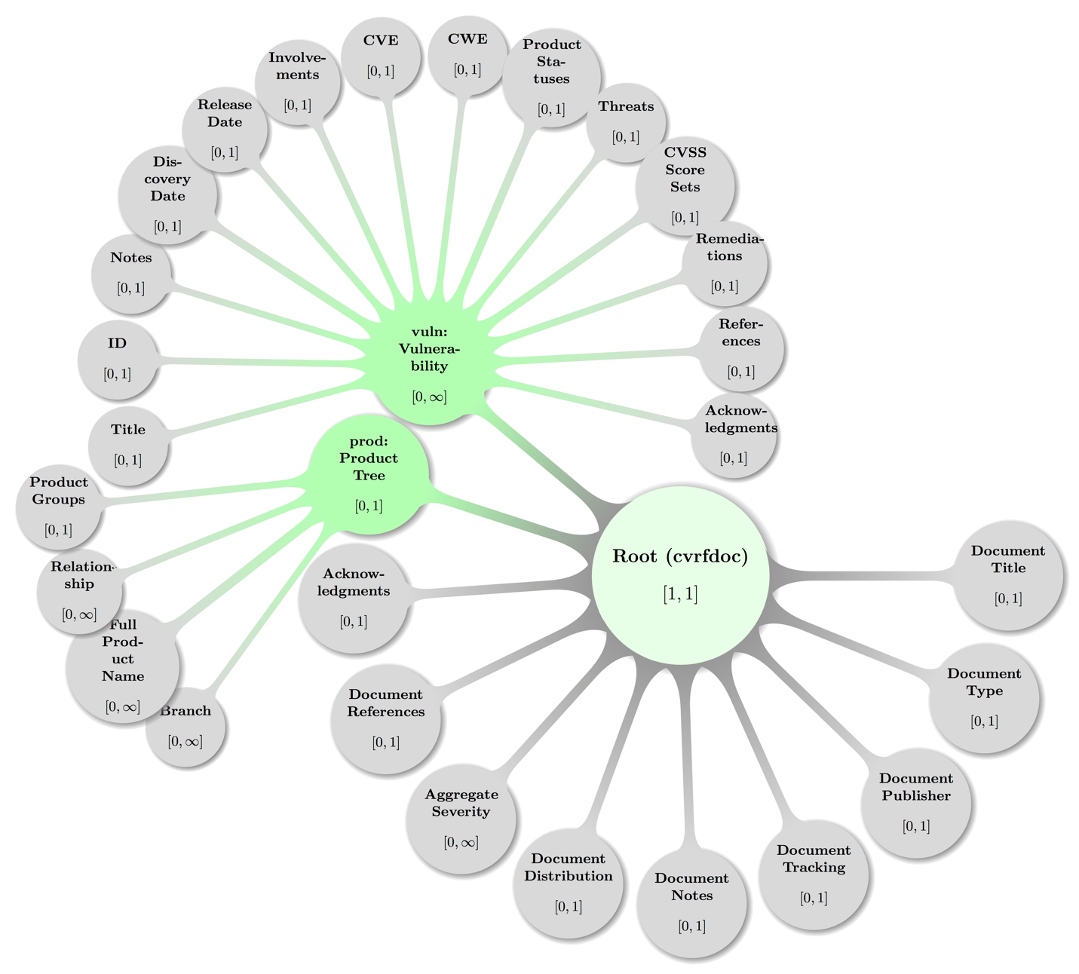

Next a map of some abstract but specific and valid **CSAF CVRF Document** configuration emphasizing the topology of the elements from the cvrf namespace:

Figure 2: A topologically valid **CSAF CVRF Document Root** configuration.

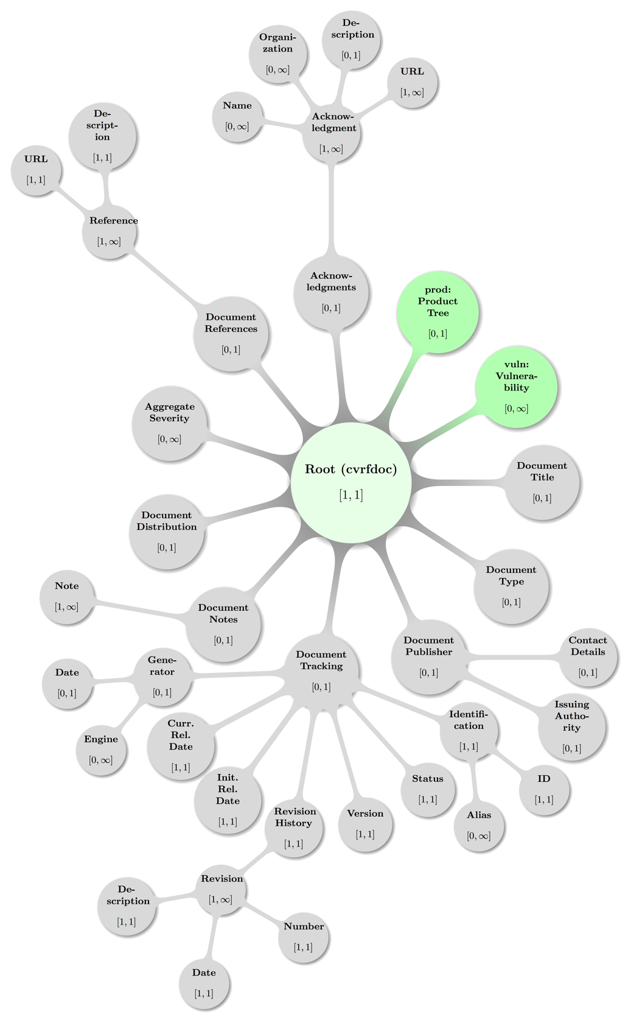

Some decent coloring has been applied to above graph to balance visual hints with accessibility. The mathematical closed interval notation has been used to annotate the minimum and maximum occurrences of elements, where the infinity symbol (∞) translates to the term unbounded in XML lingo.

# Document (Context) Schema Elements

« The nine top-level elements are defined in the cvrf XML schema file and if given MUST appear in the order listed below and as children of the cvrf:cvrfdoc single root element. » [CSAF-4-1]

These main constituents in sequence (Format is “**Concept**: namespace:Element”) are:

1. **Title**: cvrf:DocumentTitle
2. **Type**: cvrf:DocumentType
3. **Publisher**: cvrf:DocumentPublisher
4. **Tracking**: cvrf:DocumentTracking
5. **Notes**: cvrf:DocumentNotes
6. **Distribution**: cvrf:DocumentDistribution
7. **Aggregate Severity**: cvrf:AggregateSeverity
8. **References**: cvrf:DocumentReferences
9. **Acknowledgements**: cvrf:Acknowledgements

The remaining sub sections will describe the elements, requirements on them and state recommendations and examples.

## Document

Element cvrf:cvrfdoc

« The cvrf:cvrfdoc element is the root element of a CSAF CVRF Document and MUST contain the following child elements cvrf:DocumentTitle, cvrf:DocumentType, cvrf:DocumentPublisher, and cvrf:DocumentTracking all exactly once and in that order. » [CSAF-4.1-1]

« Following these child elements it MUST contain the elements cvrf:DocumentNotes, cvrf:DocumentDistribution, cvrf:AggregateSeverity, cvrf:DocumentReferences, cvrf:Acknowledgements, and prod:ProductTree all zero or once and in that order. » [CSAF-4.1-2]

« It MUST finally contain zero or more vuln:Vulnerability elements. » [CSAF-4.1-3]

## Document Title

Element cvrf:DocumentTitle

« The cvrf:DocumentTitle element is required exactly once as first child of cvrf:cvrfdoc and its sole content MUST be a non-empty string. » [CSAF-4.2-1]

This string SHOULD be a definitive canonical name for the document, providing enough descriptive content to differentiate from other similar documents, ideally providing a unique “handle”.

Non-normative Comment:

While this elements value – often just named “the title” – is largely up to the document producer, common usage brings some recommendations:

The title should be succinct and promptly give the reader an idea of what is expected document content.

If the document producer also publishes a human-friendly document that hand-in-hand with a CSAF CVRF document, it is recommended that both documents use the same title.

It is further recommended to include the manufacturer name with any product names mentioned in the title.

Example 6:

<DocumentTitle>Cisco IPv6 Crafted Packet Vulnerability</DocumentTitle>

Example 7:

<DocumentTitle>CERT Vulnerabilities in Kerberos 5 Implementation</DocumentTitle>

Example 8:

<DocumentTitle>Cisco Content Services Switch 11000 Series DNS Negative Cache of Information  Denial-of-Service Vulnerability</DocumentTitle>

Example 9:

<DocumentTitle>Symantec Brightmail AntiSpam Static Database Password</DocumentTitle>

Example 10:

<DocumentTitle>HPSBUX02697 SSRT100591 rev.1 - HP-UX Running Java, Remote Unauthorized Access, Disclosure of Information, and Other Vulnerabilities</DocumentTitle>

Example 11:

<DocumentTitle>Microsoft Vulnerability in the Microsoft Data Access Components (MDAC) Function Could Allow Code Execution</DocumentTitle>

Example 12:

<DocumentTitle>  
 Microsoft Vulnerability in Windows Explorer Could Allow  
 Remote Code  Execution  
</DocumentTitle>

## Document Type

Element cvrf:DocumentType

« The cvrf:DocumentType element is required exactly once inside cvrf:cvrfdoc and its sole content MUST be a non-empty string. » [CSAF-4.3-1]

Theelementcvrf:DocumentTypedefines a short canonical name, chosen by the document producer, which will inform the end user as to the type of document.

Non-normative comment:

This type label is expected to be aligned with the content conveyed: If it is a “Security Advisory”, it should be named so, likewise a pure “Vulnerability Report” (see following below examples).

Example 13:

<DocumentType>Vulnerability Report</DocumentType>

Example 14:

<DocumentType>Security Advisory</DocumentType>

Example 15:

<DocumentType>Security Notice</DocumentType>

## Document Publisher

Element cvrf:DocumentPublisher

« The cvrf:DocumentPublisher element is required exactly once inside cvrf:cvrfdoc, it MUST provide the Type attribute. » [CSAF-4.4-1]

It MAY provide the VendorID attribute.

It MAY contain zero or one cvrf:ContactDetails element and zero or one cvrf:IssuingAuthority element.

« These MUST appear in the order cvrf:ContactDetails and cvrf:IssuingAuthority If both child elements are given. » [CSAF-4.4-2]

Attribute Type

The value of Type is a token restricted by the set cvrf-common:PublisherEnumType defined in the common.xsd schema file and the values as given in section 2.2.2 Note Type Model.

Attribute VendorID

The value of VendorID is a string that SHOULD represent a unique identifier (OID) that a vendor uses as issued by FIRST under the auspices of IETF.

Map of some valid **Document Publisher** element level configuration including the parent node (**Root**):

Figure 3: A topologically valid **Document Publisher** configuration.

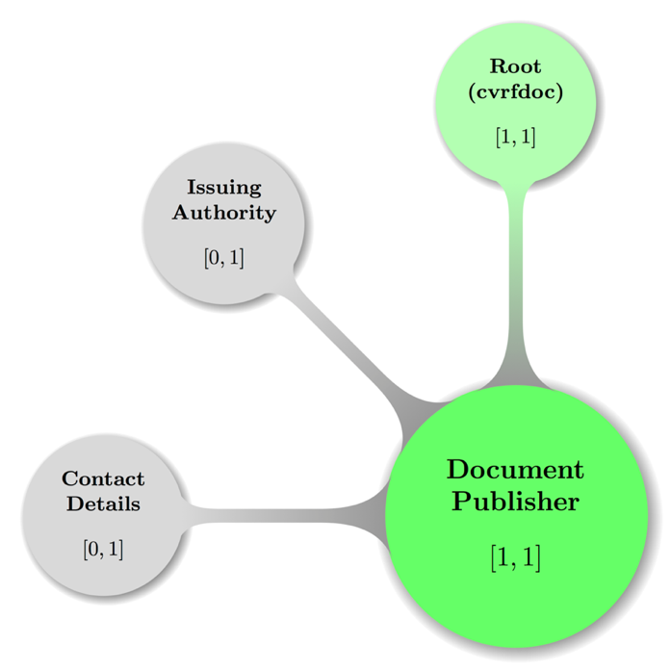

Some decent coloring has been applied to above graph to balance visual hints with accessibility. The mathematical closed interval notation has been used to annotate the minimum and maximum occurrences of elements.

Non-normative comment:

At the time of this writing, OID issuance by FIRST is still a work in progress, thus some samples are provided below, that use OID’s from other standard MIB’s.

Example 16:

<DocumentPublisher Type="Vendor"/>

Example 17: Cisco Systems Inc. OID in dot notation (cf. <http://oid-info.com/get/1.3.6.1.4.1.9>):

<DocumentPublisher Type="Vendor" VendorID="1.3.6.1.4.1.9"/>

Example 18: Cisco Systems Inc. via OID-IRI notation (slash-separated Unicode labels from root of OID tree):

<DocumentPublisher Type="Vendor" VendorID=" /ISO/Identified-Organization/6/1/4/1/9"/>

Example 19: Cisco Systems Inc. MIB entry in ASN.1:

<DocumentPublisher Type="Vendor" VendorID="{iso(1) identified-organization(3) dod(6) internet(1) private(4) enterprise(1) 9}"/>

### Document Publisher – Contact Details

Element cvrf:ContactDetails

« The cvrf:ContactDetails element contains as its only content a non-empty string and MUST be present zero or one time inside cvrf:DocumentPublisher to convey author contact information such as address, phone number, or email. » [CSAF-4.4.1-1]

Example 20:

<ContactDetails>  
 Name: Birgit Mustermensch\r\nOrganization: Internationale Sicherheit für Alle\r\n  
 Phone Number: 004912345678901\r\nFax Number: 004912345678902\r\n  
 Email Address: birgit.mustermensch@example.com  
</ContactDetails>

### Document Publisher – Issuing Authority

Element cvrf:IssuingAuthority

« The cvrf:IssuingAuthority element contains as its only content a non-empty string and MUST be used zero or once inside cvrf:DocumentPublisher to store the name of the issuing party and their authority to release the document, in particular, the party's constituency and responsibilities or other obligations. » [CSAF-4.4.2-1]

Non-normative comment:

This element is expected to also include instructions for contacting the issuer.

Example 21:

<IssuingAuthority>

The Juniper SIRT (Juniper Networks Security Incident Response Team) is the sole  
 authority regarding vulnerabilities in any Juniper Networks products or services,  
 and coordinates the handling of all aspects of such vulnerabilities from initial  
 discovery or report through public announcements and any subsequent follow-on  
 activities. Additional information is available at  
 http://www.juniper.net/support/security/report_vulnerability.html  
</IssuingAuthority>

## Document Tracking

Element cvrf:DocumentTracking

« The cvrf:DocumentTracking element required exactly once inside the cvrf:cvrfdoc root element and MUST contain the elements cvrf:Identificaton, cvrf:Status, cvrf:Version, cvrf:RevisionHistory, cvrf:InitialReleaseDate, and cvrf:CurrentReleaseDate all exactly once and in that order. » [CSAF-4.5-1]

« Following these child elements MUST be zero or one element cvrf:Generator.   
» [CSAF-4.5-2]

The element cvrf:DocumentTracking is a container designated to hold all management attributes necessary to track a CVRF document as a whole.

Following is the visual display of some valid **Document Tracking** configuration including the parent node cvrf:cvrfdoc (Document **Root**):

Figure 4: A topologically valid **Document Tracking** configuration.

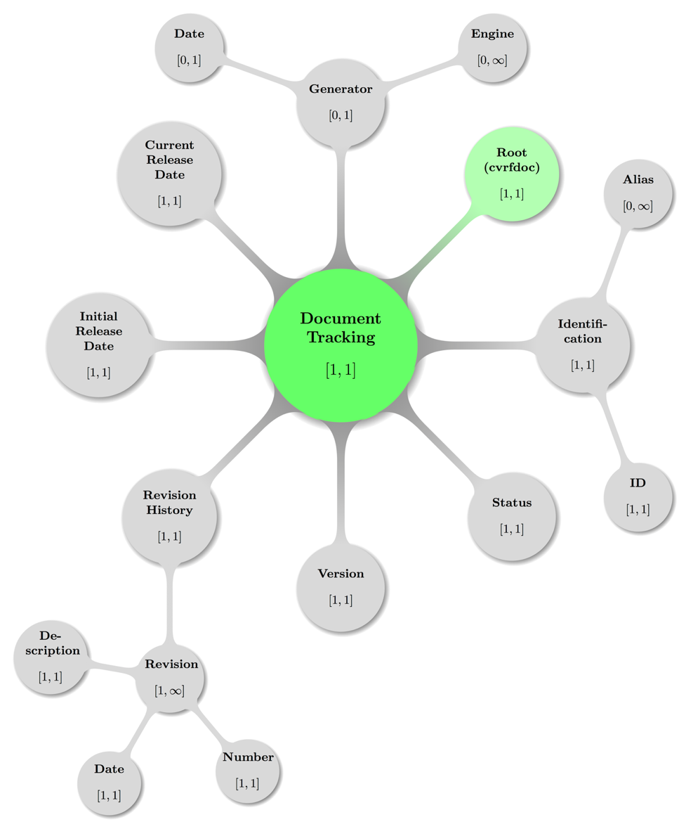

Some decent coloring has been applied to above graph to balance visual hints with accessibility. The mathematical closed interval notation has been used to annotate the minimum and maximum occurrences of elements, where the infinity symbol (∞) translates to the term unbounded in XML lingo.

### Document Tracking – Identification

Element cvrf:Identification

« The cvrf:Identification element is required exactly once inside the element cvrf:DocumentTracking and MUST contain the element cvrf:ID exactly once as first child. » [CSAF-4.5.1-1]

« Following this child element MUST be zero or more cvrf:Alias elements.   
» [CSAF-4.5.1-2]

The Document Tracking element cvrf:Identification is a container that holds all the identifiers for the CVRF document.

#### Document Tracking – Identification – ID

Element cvrf:ID

« The crvf:ID element MUST appear exactly once inside cvrf:Identification and its content MUST be a non-empty string that represents a short, unique identifier that allows to refer to the document unambiguously in any context. » [CSAF-4.5.1.1-1]

Its value refers to the condition of the document with regard to completeness and the likelihood of future editions.

The ID is a simple label. It is a string data type to provide for a wide range of numbering values, types, and schemes.

Its value SHOULD be assigned and maintained by the original document issuing authority.

Non-normative comment:

It is recommended that the ID contains monotonically increasing integer value parts, or is increasing in such a predictable manner that it does not contribute toward confusion or misinterpretation of numbering.

Common practice places a fixed producer acronym, the 4-digit year and a sequence integer number separated by e.g. dashes (-). So, for a fictitious producer Vendorix represented by the acronym VDX, and a security advisory number 42 produced in the calendar year 2017 this might result in an ID value of: VDX-2017-42

Careful consideration is required to ensure that construction of the ID does not contribute to confusion or collision with other labels.

#### Document Tracking – Identification – Alias

Element cvrf:Alias

« The crvf:Alias element MUST appear zero or more times inside cvrf:Identification. » [CSAF-4.5.1.2-1]

« If given every instance MUST contain a non-empty string that represents a distinct optional alternative ID used to refer to the document. » [CSAF-4.5.1.2-2]

Non-normative comment:

Many vendors have one or more alternative or secondary IDs for documents and the Alias presents an interface to publish those alongside the primary ID.

### Document Tracking – Status

Element cvrf:Status

« The crvf:Status element MUST appear exactly once in cvrf:DocumentTracking and its sole content MUST be a valid representative of the Status model documented in section 2.2.8 Status Type Model. » [CSAF-4.5.2-1]

Its value refers to the condition of the document with regard to completeness and the likelihood of future editions.

Non-normative comment:

Issuing parties are strongly recommended to set Status to “Draft” when initiating a new document and to implement procedures to ensure that the status is changed to the appropriate value before the document is released.

### Document Tracking – Version

Element cvrf:Version

« The crvf:Version element MUST appear exactly once in cvrf:DocumentTracking and its sole content MUST be a valid representative of the Version model documented in section 2.2.9 Version Type Model. » [CSAF-4.5.3-1]

Example 22: Only major and minor version numbers stated:

<Version>1.0</Version>

Example 23: Major (1), minor (2) and patch (3) version numbers given:

<Version>1.2.3</Version>

Example 24: Build number 9876 appended to version triple (1.0.0):

<Version>1.0.0.9876</Version>

### Document Tracking – Revision History

Element cvrf:RevisionHistory

« The cvrf:RevisionHistory element MUST be present exactly once inside cvrf:DocumentTracking, and MUST contain one or more cvrf:Revision elements. » [CSAF-4.5.4-1]

For every version or revision of the CSAF CVRF document, including the initial version it SHOULD hold matching cvrf:Revision elements.

#### Document Tracking – Revision History – Revision

Element cvrf:Revision

« The cvrf:Revision element MUST appear one or more times inside the element cvrf:RevisionHistory, and every instance MUST contain the elements cvrf:Number, cvrf:Date, and cvrf:Description all exactly once and in that order. » [CSAF-4.5.4.1-1]

The cvrf:Revision element contains all the information elements required to track the evolution of a CSAF CVRF document.

Non-normative comment:

Each change to a CSAF CVRF document should only be noteworthy, if accompanied by Number, Date, and Description information to be stored inside the child elements.

##### Document Tracking – Revision History – Revision – Number

Element cvrf:Number

« The crvf:Number element MUST appear exactly once in cvrf:Revision and its sole content MUST be a valid representative of the Version model documented in section 2.2.9 Version Type Model. » [CSAF-4.5.4.1.1-1]

Its value SHOULD contain the numeric version of the document.

The most recent cvrf:Number elements value should always match the value of the cvrf:Version element.

Minor revisions SHOULD be used for less-significant changes (for example, 1.0.0.0 to 1.0.0.1). Major, actionable changes SHOULD lead to a major increase of the version number (for example, 1.0 to 2.0).

Non-normative comment:

Examples of major or actionable changes include:

• Any change to severity or impact

• The announcement of additional vulnerabilities

• The announcement of additional vulnerable products

• A significant change in remediation status

##### Document Tracking – Revision History – Revision – Date

Element cvrf:Date

« The element cvrf:Date MUST appear exactly once in cvrf:Revision and SHOULD record the date the revision was made and MUST be valid representative of the Date and Time model documented in section 2.2.1 Date and Time. » [CSAF-4.5.4.1.2-1]

##### Document Tracking – Revision History – Revision – Description

Element cvrf:Description

« Theelementcvrf:Description MUST appear exactly once in cvrf:Revision and SHOULD hold a single non-empty string representing a short description of the changes. » [CSAF-4.5.4.1.3-1]

Non-normative comment:

It can describe the conditions that prompted the change or be a short list of the items changed.

Example 25:

<RevisionHistory>  
 <Revision>  
 <Number>1</Number>  
 <Date>2011-11-26T00:00:00+00:00</Date>  
 <Description>initial public release</Description>  
 </Revision>  
</RevisionHistory>

### Document Tracking – Initial Release Date

Element cvrf:InitialReleaseDate

« Theelementcvrf:InitialReleaseDateMUST appear exactly once inside cvrf:DocumentTracking and SHOULD record the date that the document was initially released by the issuing party and MUST be valid representative of the Date and Time model documented in section 2.2.1 Date and Time. » [CSAF-4.5.5-1]

Example 26:

<InitialReleaseDate>2011-11-26T00:00:00+00:00</InitialReleaseDate>

### Document Tracking – Current Release Date

Element cvrf:CurrentReleaseDate

« Theelementcvrf:CurrentReleaseDateMUST appear exactly once inside cvrf:DocumentTracking, SHOULD be the current date that the document was released by the issuing party, and MUST be a valid representative of the Date and Time model documented in section 2.2.1 Date and Time. » [CSAF-4.5.6-1]

Example 27:

<CurrentReleaseDate>2011-11-26T00:00:00+00:00</CurrentReleaseDate>

### Document Tracking – Generator

Element cvrf:Generator

« The cvrf:Generator element MUST appear zero or once in cvrf:DocumentTracking and MUST contain the elements cvrf:Engine and cvrf:Date all zero or once and in that order. » [CSAF-4.5.7-1]

It is a container to hold all elements related to the generation of the document. These items will reference when the document was actually created, including the date it was generated and the entity that generated it.

#### Document Tracking – Generator – Engine

Element cvrf:Engine

« The optional cvrf:Engine element if present MUST be in cvrf:Generator.   
» [CSAF-4.5.7.1-1]

« Any instance MUST contain a non-empty string**.** » [CSAF-4.5.7.1-2]

This string SHOULD represent the name of the engine that generated the CSAF CVRF document, and MAY additionally refer to its version.

#### Document Tracking – Generator – Date

Element cvrf:Date

« Theelementcvrf:DateMUST appear zero or once in cvrf:Generator, SHOULD be the current date that the document was generated, and MUST be a valid representative of the Date and Time model documented in section 2.2.1 Date and Time Model. » [CSAF-4.5.7.2-1]

Because documents are often generated internally by a document producer and exist for a nonzero amount of time before being released, this field MAY be different from the Initial Release Date.

Example 28: Generator entry with fictitious engine and date given as date time with offset:

<Generator>  
 <Engine>Magical Mitigation Machinery, version 1.2.3.42</Engine>  
 <Date>2017-03-27T01:23:45+00:00</Date>  
</Generator>

Example 29: Generator entry for another fictitious engine and date stated for AEST time zone (UTC+10) via offset

<Generator>  
 <Engine>AnotherSSLVulnAdvisor xsslcsaf 0.9.987</Engine>  
 <Date>2012-05-08T10:26:11+10:00</Date>  
</Generator>

Example 30: Generator entry from existing vendor documentation and date given with time zone UTC (via Z token)

<Generator>  
 <Engine>Red Hat rhsa-to-cvrf 1.0.1478</Engine>  
 <Date>2012-05-08T10:26:11Z</Date>  
</Generator>

Example 31: Full Document tracking element sample (with generator entry from previous example)

<DocumentTracking>  
 <Identification><ID>RHSA-2010:0888</ID></Identification>  
 <Status>Final</Status>  
 <Version>1</Version>  
 <RevisionHistory>  
 <Revision>  
 <Number>1</Number>  
 <Date>2010-11-16T11:08:00Z</Date>  
 <Description>Current version</Description>  
 </Revision>  
 </RevisionHistory>  
 <InitialReleaseDate>2010-11-16T11:08:00Z</InitialReleaseDate>  
 <CurrentReleaseDate>2010-11-16T11:08:00Z</CurrentReleaseDate>  
 <Generator>  
 <Engine>Red Hat rhsa-to-cvrf 1.0.1478</Engine>  
 <Date>2012-05-08T10:26:11Z</Date>  
 </Generator>  
</DocumentTracking>

## Document Notes

Element cvrf:DocumentNotes

« The cvrf:DocumentNotes element is an optional child of the document root element cvrf:cvrfdoc and if present MUST contain one or more cvrf:Note elements.   
» [CSAF-4.6-1]

It holds all of the document-level **Note** elements.

Following is a visual display of **Document Notes** including the parent element (**Document root**) in some valid configuration:

Figure 5: A topologically valid **Document Notes** configuration.

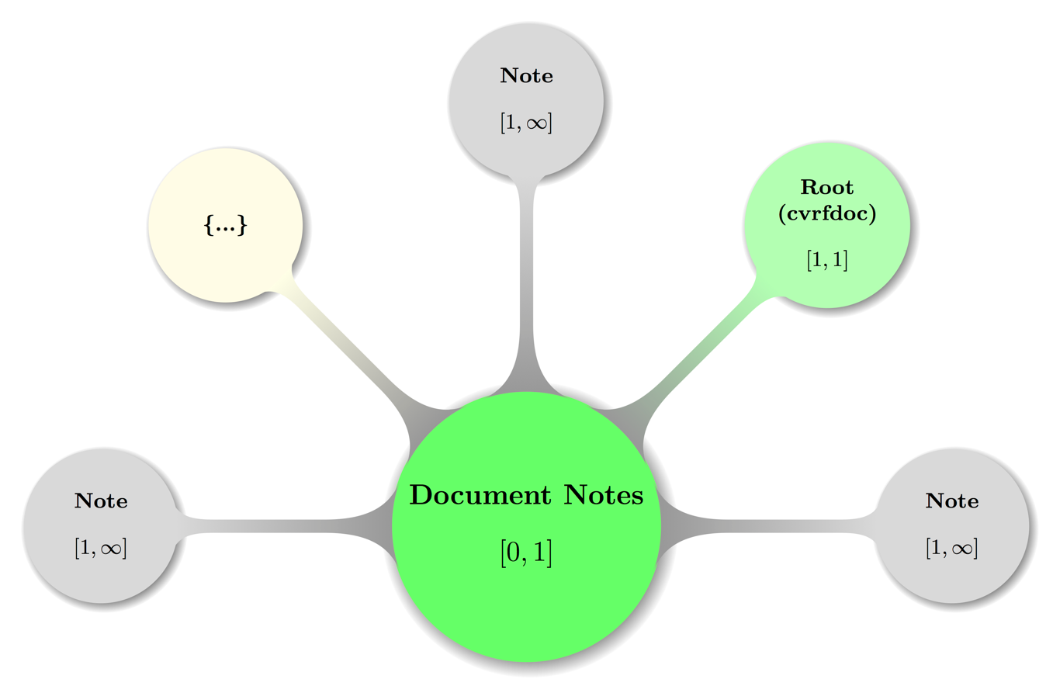

Again, some decent coloring has been applied to above graph to balance visual hints with accessibility. The mathematical closed interval notation has been used to annotate the minimum and maximum occurrences of elements, where the infinity symbol (∞) translates to the term unbounded in XML lingo.

The node carrying an ellipsis (…) shall hint at possible further **Note** elements.

### Document Notes – Note

Element cvrf:Note

« The cvrf:Note element MUST occur one or more times inside the cvrf:DocumentNotes element. » [CSAF-4.6.1-1]

« Any instance MUST contain a non-empty string representing a **Note.** » [CSAF-4.6.1-2]

« It MUST provide a Type and an Ordinal. » [CSAF-4.6.1-3]

It MAY provide Title and Audience attributes.

The element cvrf:Note is a place to put all manner of text blobs related to the document as a whole. For further details cf. section 2.2.2 Note Type Model.

Attribute Title

The optional Title attributes value is a string, that SHOULD not be empty, and the value SHOULD be aligned with the annotations described in section 2.2.2 Note Type Model .

Attribute Audience

The optional Audience attributes value is a string, that SHOULD not be empty, and the value SHOULD be aligned with the annotations described in section 2.2.2 Note Type Model .

Attribute Type

« The required Type attribute MUST be a string with a valid enumeration value of the Note Type model as defined in section 2.2.2 Note Type Model . » [CSAF-4.6.1-4]

Attribute Ordinal

« The required Ordinal attribute MUST hold a **Positive Integer**. » [CSAF-4.6.1-5]

In addition to its domain the attribute value represents a mandatory, locally significant value used to track notes inside a CSAF CVRF document at the root (document) level.

Every Ordinal that tracks a cvrf:Note inside the cvrf:Notes is completely independent from an Ordinal tracking a Note in a different namespace e.g. inside vuln:Notes.

It is provided to uniquely identify a Note. There should be exactly one of these values per every cvrf:Note inside the cvrf:Notes container element.

The ascendingly ordered set of all such Ordinal values SHOULD be identical to the subset of Positive Integers smaller or equal to the length of the set.

Non-normative comment:

For example, when Type is “General”, Title is “executive summary”, and Audience is “executives”, the note is a high-level overview designed for consumption by C-level decision makers. It should be brief and devoid of any technical details and jargon.

On the other hand, when Type is “Details”, Title is “technical summary”, and Audience is “operational management and system administrators”, the note will be more detailed in nature and will contain more operational information.

Example 32: A cvrf:Note with all attributes provided and adhering to value convention for Ordinal:

<DocumentNotes>  
 <Note Type="General" Ordinal="1" Title="Details" Audience="All">  
 These are some details about a CVRF document intended for  
 all stakeholders.  
 </Note>  
</DocumentNotes>

## Document Distribution

Element cvrf:DocumentDistribution

« The cvrf:DocumentDistribution element MUST be present zero times or once as a child of cvrf:cvrfdoc and its value MUST be a non-empty string. » [CSAF-4.7-1]

It should contain details about constraints, if any, for sharing the CSAF CVRF document with additional recipients.

These constraints MAY include instructions on how to reproduce, share, copy, or otherwise distribute the document.

Example 33:

<DocumentDistribution xml:lang="de">  
 Urheberrechtlich geschützt, 2017, Fiktive GmbH.  
 Keine Weitergabe ohne vorherige schriftliche Zustimmung;  
 Anzufragen via E-Mail unter cert@fg.example.com  
 Quelle für dieses Dokument: https://fg.example.com/sa/fg-sa-2017-123  
</DocumentDistribution>

Example 34:

<DocumentDistribution xml:lang="en">  
 Copyright © 2016 Previous Year Again, Inc. All rights reserved.  
</DocumentDistribution>

## Aggregate Severity

Element cvrf:AggregateSeverity

« The optional cvrf:AggregateSeverity element if present MUST be in cvrf:cvrfdoc.   
» [CSAF-4.8-1]

« Any instance MUST contain a non-empty string. » [CSAF-4.8-2]

It MAY provide a Namespace attribute.

The element cvrf:AggregateSeverity is a vehicle that is provided by the document producer to convey the urgency and criticality with which the one or more vulnerabilities reported should be addressed.

It is a document-level metric and applied to the document as a whole — not any specific vulnerability. The range of values in this field is defined according to the document producer's policies and procedures.

Attribute Namespace

The optional Namespace attribute’s value SHOULD be a URL (xs:anyURI) pointing to the namespace so referenced.

Non-normative comment:

These values can be understood only in the context of the document producer's stated practices. Therefore, the values may vary widely depending on the source of the document. The field is independent of—and in addition to—any other standard metric for determining the impact or severity of a given vulnerability (such as CVSS).

Example 35:

<AggregateSeverity Namespace="https://example.com/se/c/">Important</AggregateSeverity>

## Document References

Element cvrf:DocumentReferences

« The optional cvrf:DocumentReferences element if present MUST occur as if appended to the position that a cvrf:AggregateSeverity element will take inside the cvrf:cvrfdoc root element. » [CSAF-4.9-1]

« If present, cvrf:DocumentReferences MUST contain [1, ∞] instances of the element cvrf:DocumentReference**.** » [CSAF-4.9-2]

The cvrf:DocumentReferences element is a container that SHOULD provide a place in its children cvrf:DocumentReference elements to include references to any conferences, papers, advisories, and other resources that are related and considered to be of value to the document consumer.

### Document References – Reference

Element cvrf:Reference

« The cvrf:Reference element MUST occur one or more times inside the element cvrf:References. » [CSAF-4.9.1-1]

« Any instance MUST contain the elements cvrf:URL and cvrf:Description all exactly once and in that order**.** » [CSAF-4.9.1-2]

« It MUST provide either a Type attribute or a default will be taken instead. » [CSAF-4.9.1-3]

The element cvrf:Reference refers to resources related to the overall CSAF CVRF document. These may include a plaintext or HTML version of the advisory or other related documentation, such as white papers or mitigation documentation.

Attribute Type

« The required Type attribute is if not present understood per default as the enumeration value External or if given MUST be a string with a valid enumeration value of the Reference Type model as defined in section 2.2.7 Reference Type Model. » [CSAF-4.9.1-4]

The Type attribute denotes the type of the document reference relative to the given document and as described in section 2.2.7 Reference Type Model.

#### Document References – Reference – URL

Element cvrf:URL

« The cvrf:URL element MUST be present exactly once in cvrf:Reference and its content SHOULD be the fixed URL (xs:anyURI) or location of reference. » [CSAF-4.9.1.1-1]

#### Document References – Reference – Description

Element cvrf:Description

« The cvrf:Description element MUST occur exactly once in cvrf:Reference.   
» [CSAF-4.9.1.2-1]

« Any instance MUST contain a non-empty string representing the description of the related document**.** » [CSAF-4.9.1.2-2]

Non-normative comment:

This can be a descriptive title or the name of the referenced artifact.

Example 36:

<References>  
 <Reference Type="External">  
 <URL>http://example.com/bar/</URL>  
 <Description xml:lang="fr">C'est un test de référence</Description>  
 </Reference>  
</References>

## Acknowledgements

Element cvrf:Acknowledgements

« The optional cvrf:Acknowledgements element if present MUST be in cvrf:cvrfdoc.   
» [CSAF-4.10-1]

« An instance MUST contain one or more cvrf:Acknowledgement elements**.**   
» [CSAF-4.10-2]

The cvrf:Acknowledgements element is a container that SHOULD provide a place in the children cvrf:Acknowledgement elements to note recognition of external parties.

Following is a visual representation of some valid **Document Acknowledgements** configuration including the parent node cvrf:cvrfdoc (**Document** **Root**) — again with the node labeled {…} indicating further possible **Acknowledgement** subtrees:

Figure 6: A topologically valid **Document Acknowledgements** configuration.

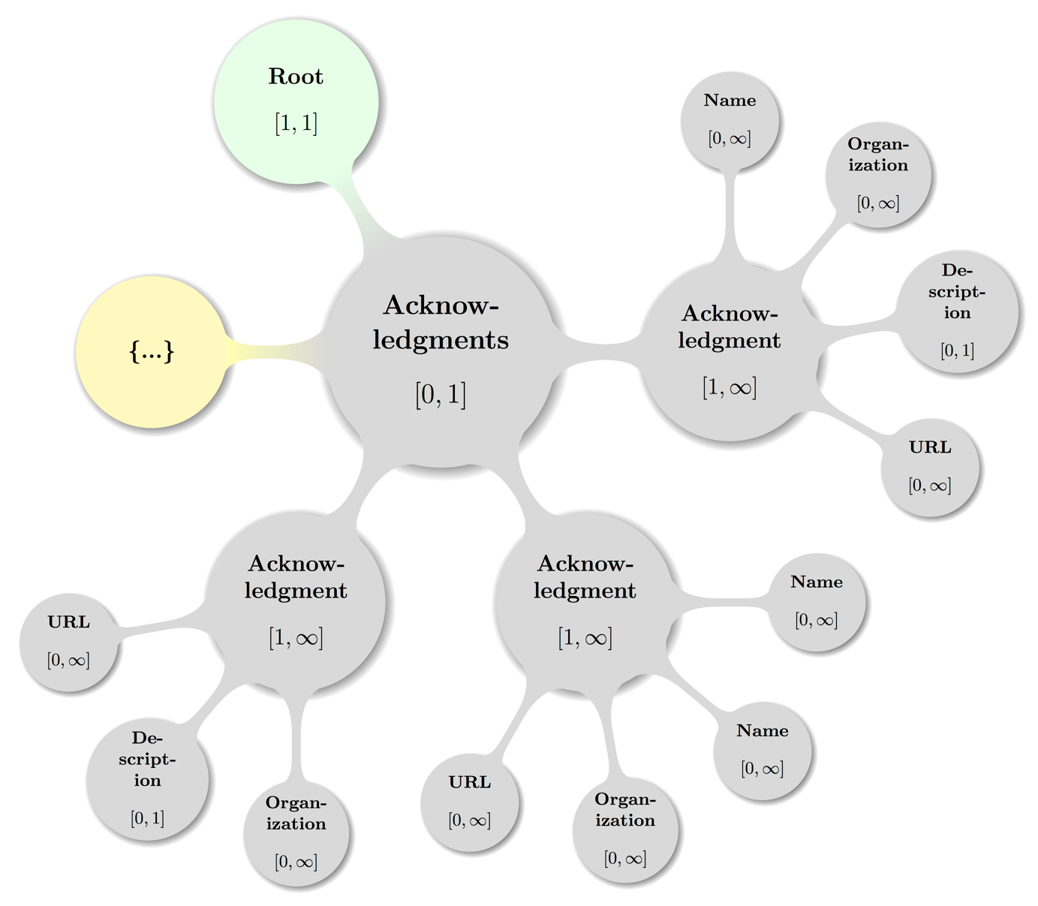

Non-normative comment:

This is the direct cvrf:cvrfdoc child element. For a sample display of the **Acknowledgements** container of a Vulnerability element cf. section 6.15).

### Acknowledgements – Acknowledgement

Element cvrf:Acknowledgement

« The cvrf:Acknowledgement element MUST occur one or more times inside the cvrf:Acknowledgements element. » [CSAF-4.10.1-1]

« Any instance MUST contain elements cvrf:Name [0, ∞], cvrf:Organization [0, ∞], cvrf:Description [0, 1], and cvrf:URL [0, ∞] with the given **Cardinality Ranges** and in that order**.** » [CSAF-4.10.1-2]

The element cvrf:Acknowledgement contains recognition of external parties that reported noncritical/low- severity security issues or provided information, observations, or suggestions that contributed to improved security or improved documentation in future releases of the document producer's products. This may also contain recognition to external parties that contributed toward producing this document.

#### Acknowledgements – Acknowledgement – Name

Element cvrf:Name

« The cvrf:Name element MUST occur zero or more times in cvrf:Acknowledgement.   
» [CSAF-4.10.1.1-1]

« Any instance MUST contain a non-empty string, that SHOULD contain the name of the party being acknowledged**.** » [CSAF-4.10.1.1-2]

#### Acknowledgements – Acknowledgement – Organization

Element cvrf:Organization

« The cvrf:Organization element MUST be present zero or more times inside any cvrf:Acknowledgement element. » [CSAF-4.10.1.2-1]

«Any instance MUST contain a non-empty string, that SHOULD contain the organization of the party or if cvrf:Name is omitted, the organization itself that is being acknowledged representing the description of the related document**.** » [CSAF-4.10.1.2-2]

#### Acknowledgements – Acknowledgement – Description

Element cvrf:Description

« The cvrf:Description element MUST be present zero or one time inside any cvrf:Acknowledgement element. » [CSAF-4.10.1.3-1]

« Any instance MUST contain a non-empty string, that SHOULD represent any contextual details the document producers wish to make known about the acknowledgment or acknowledged parties**.** » [CSAF-4.10.1.3-2]

If attributing to multiple organizations, each contributor should be grouped with that Organization within a single Acknowledgment container.

Non-normative comment:

An Organization-specific acknowledgment may be added within each Acknowledgment container using the Description element. If an overall general or aggregate acknowledgment is to be added, an Acknowledgment container that contains a single Description element may be used.

#### Acknowledgements – Acknowledgement – URL

Element cvrf:URL

« The cvrf:URL element MUST be contained zero or more times per any cvrf:Acknowledgement element and its content SHOULD give the optional URL (xs:anyURI) to the person, place, or thing being acknowledged. » [CSAF-4.10.1.4-1]

Example 37:

<Acknowledgments>  
 <Acknowledgment>  
 <Name>Johann Sebastian Bach</Name>  
 <Organization>Security Fugue LLC</Organization>  
 <Description>First analysis of Coordinated Multi-Stream Attack (CMSA)</Description>  
 <URL>https://secure-fugue.example.com/team/~jsb</URL>  
 </Acknowledgment>  
</Acknowledgments>

# Product Tree Schema Elements

Product information in CSAF CVRF is modeled as zero or one top-level Product Tree element instance of prod:ProductTree (defined in the product tree schema file within the prod namespace).

« The following 4 second-level elements are and MUST appear in the order listed if given as elements of the top-level element Product Tree:

1. **Branch**: prod:Branch
2. **Full Product Name:** prod:FullProductName
3. **Relationship**: prod:Relationship
4. **Product Groups**: prod:ProductGroups

» [CSAF-5-1]

The remaining sub sections will describe the above 5 first and second level elements together with their children and grandchildren, constraints on them as well as state recommendations and examples.

To avoid duplication of data and accommodate for the many possible complex relationships among real world products, the 4 above named elements maybe nested deeply (e.g. a **Branch** of a **Branch** ...) or are clearly useful in many places like the **Full Product Name**.

The sub sections introducing **Branch, Relationship**, and **Product Groups** try to further offer such topological usage information to aid the reader in creating or navigating the graph that can be spanned by instances of a **Product Tree**.

## Product Tree

Element prod:ProductTree

« The optional prod:ProductTree element MUST occur with cardinality [0, 1] as child of cvrf:cvrfdoc. » [CSAF-5.1-1]

« If given, the instance MUST contain prod:Branch [0, ∞], prod:FullProductName [0, ∞], prod:FullProductName [0, ∞], prod:ProductGroups [0, 1], elements with noted cardinalities and in that order. » [CSAF-5.1-2]

The optional elementprod:ProductTreeis a container for all fully qualified product names that can be referenced elsewhere in the document.

References to be named specifically when describing the products that are affected by a vulnerability using the **Product Statuses**, **Vulnerability Threats**, **Vulnerability** **CVSS Score Sets**, and **Vulnerability** **Remediation** containers.

The **Product Tree** can have as many branches as needed, but every endpoint of the tree must be terminated with a **Full Product Name** element, which represents a product that can be referenced elsewhere.

Example 38:

<prod:ProductTree>  
 <prod:Branch Name="Vendorix" Type="Vendor">  
 <prod:Branch Name="... Appliances" Type="Product Name">  
 <prod:Branch Name="1.0" Type="Product Version">  
 <prod:Branch Name=".0" Type="Service Pack">  
 <prod:FullProductName ProductID="CVRFPID-223152">  
 ... AppY 1.0.0  
 </prod:FullProductName>  
 </prod:Branch>  
 <prod:Branch Name="(2)" Type="Service Pack">  
 <prod:FullProductName ProductID="CVRFPID-223153">  
 ... AppY 1.0(2)  
 </prod:FullProductName>  
 </prod:Branch>  
 </prod:Branch>  
 <prod:Branch Name="1.1" Type="Product Version">  
 <prod:Branch Name=".0" Type="Service Pack">  
 <prod:FullProductName ProductID="CVRFPID-223155">  
 ... AppY 1.1.0  
 </prod:FullProductName>  
 </prod:Branch>  
 <prod:Branch Name="(1)" Type="Service Pack">  
 <prod:FullProductName ProductID="CVRFPID-223156">  
 ... AppY 1.1(1)  
 </prod:FullProductName>  
 </prod:Branch>  
 </prod:Branch>  
 </prod:Branch>  
 </prod:Branch>  
</prod:ProductTree>

Map of **Product Tree** including the parent node (**Document**) in some valid configuration spanning multiple sub trees:

Figure 7: A topologically valid **Product Tree** configuration.

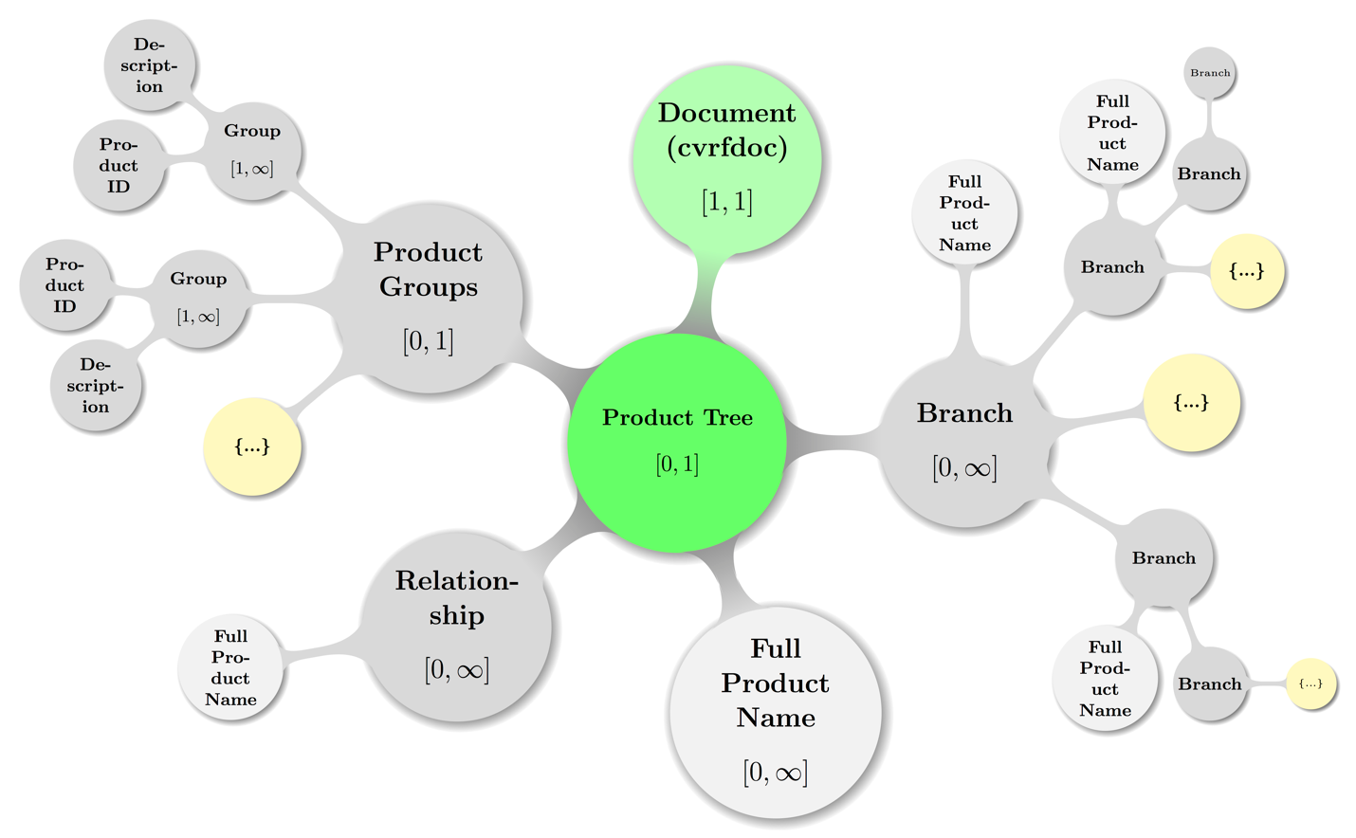

Again, some decent coloring has been applied to above graph to balance visual hints with accessibility. The mathematical closed interval notation has been used to annotate the minimum and maximum occurrences of elements, where the infinity symbol (∞) translates to the term unbounded in XML lingo.

The pale gray color of the **Full Product Name** representative nodes shall indicate that they are more used like labels all over the topology. The nodes carrying an ellipsis (…) shall hint at possible further deep nesting of the sub trees where they are attached.

### Product Tree – Branch

Element prod:Branch

« The optional prod:Branch choice element MUST occur with cardinality [0, ∞] inside the prod:ProductTree element or nested inside other prod:Branch instances.   
» [CSAF-5.1.1-1]

« An instance MUST contain either a prod:Branch or a prod:FullProductName element.  
» [CSAF-5.1.1-2]

The prod:FullProductName element has no children (is thus always a terminating or leaf element) while a prod:Branch can either contain further children or terminate its tree branch.

Attribute Name

The mandatory Nameattributeof the **Branch** element and its relation to the equally required Type attribute are documented in section 2.2.3 Product Branch Type Model.

Attribute Type

The required Typeattributeof the **Branch** element is documented in section 2.2.3 Product Branch Type Model.

Non-normative comment:

A choice element behaves as a regular container that can have different child elements, but with the difference that only exactly one child element can be chosen. It is similar in concept to the “union” programming construct in which one variable can have one of several different predefined data types.

Example 39: Nesting of **Branches** in a **Branch** subtree:

<prod:Branch Type="Vendor" Name="Microsoft">  
 <prod:Branch Type="Product Family" Name="Windows">  
 <prod:Branch Type="Product Name" Name="Vista">  
 <prod:Branch Type="Service Pack" Name="1">  
 <prod:FullProductName ProductID="CVRFPID-0001">  
 Microsoft Windows Vista Service Pack 1  
 </prod:FullProductName>  
 </prod:Branch>  
 <prod:Branch Type="Service Pack" Name="2">  
 <prod:FullProductName ProductID="CVRFPID-0002">  
 Microsoft Windows Vista Service Pack 2  
 </prod:FullProductName>  
 </prod:Branch>  
 </prod:Branch>  
 </prod:Branch>  
 <prod:Branch Type="Product Family" Name="Office">  
 <prod:Branch Type="Product Name" Name="Word 2010">  
 <prod:Branch Type="Service Pack" Name="0">  
 <prod:Branch Type="Architecture" Name="x86">  
 <prod:FullProductName ProductID="CVRFPID-0003">  
 Microsoft Word 2010 (32-bit editions)  
 </prod:FullProductName>  
 </prod:Branch>  
 </prod:Branch>  
 </prod:Branch>  
 </prod:Branch>  
</prod:Branch>

A more visual display of the same structure from above example is shown in the figure below (**Error! Reference source not found.**).

Map of **Branch** sub tree from above example of nested Branches including the parent node (**Product Tree** left out in XML source code example) with some textual hints to map the topologies:

Figure 8: A topologically valid **Branch** configuration

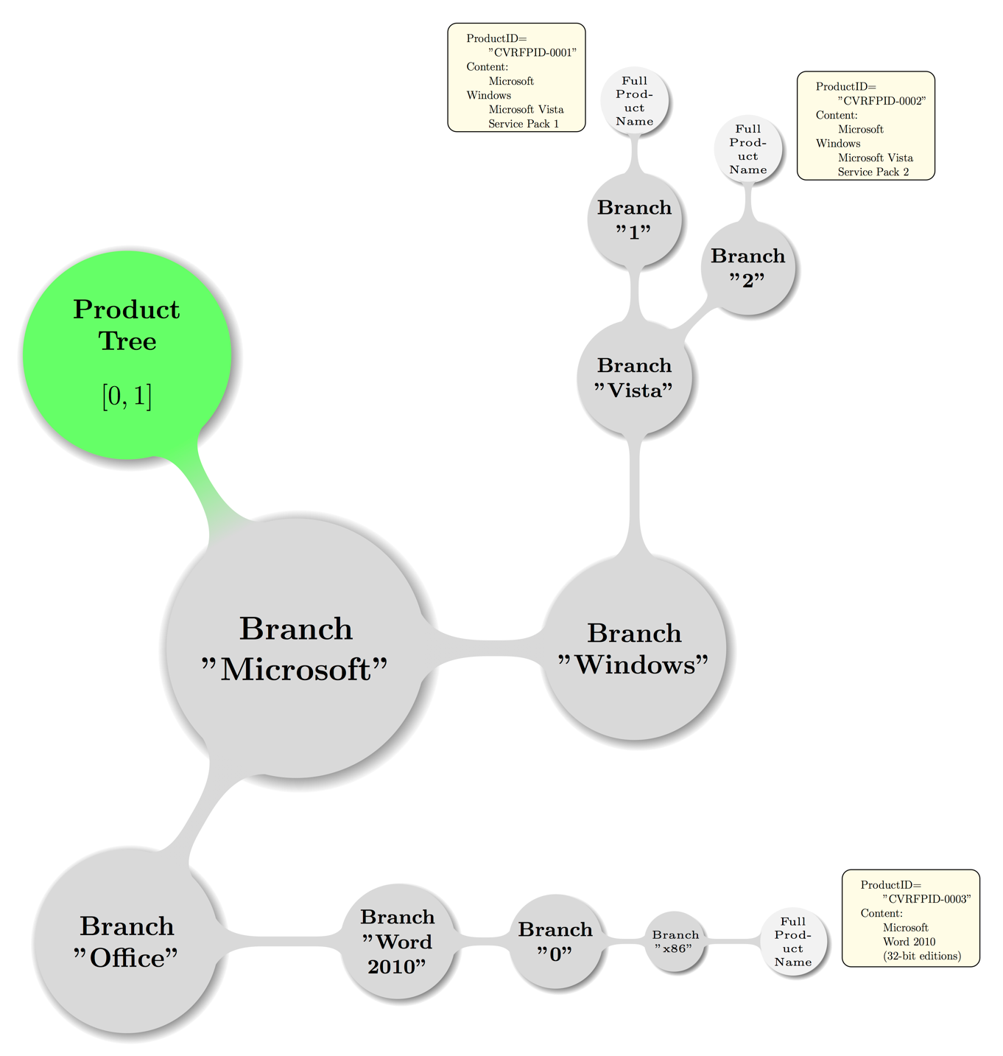

### Product Tree – Full Product Name

Element prod:FullProductName

« The prod:FullProductName element MUST be a child of cardinality [1, ∞] for all possible locations inside the product tree representation. » [CSAF-5.1.2-1]

This elements instances have multiple possible parent elements: prod:ProductTree, prod:Releationship, and prod:Branch.

The prod:FullProductNameelements define the endpoints of the **Product Tree** and occur either directly at the root level, at the branch level, or as the result of a relationship between two products.

The value of a **Full Product Name** element should be the product’s full canonical name, including version number and other attributes, as it would be used in a human-friendly document.

Attribute ProductID

The ProductIDattribute is a token required to identify a **Full Product Name** so that it can be referred to from other parts in the document.

There is no predefined or required format for the ProductIDas long as it uniquely identifies a product in the context of the current document.

Attribute CPE

The (Common Platform Enumeration) CPE attribute refers to a method for naming platforms external to CSAF CVRF.

« The CPE attribute if present MUST have a value, that is a valid cpe-lang:namePattern as defined in the external specification [CPE23_N] and related schemas. » [CSAF-5.1.2-2]

Non-normative comment:

Examples for ProductID values include incremental integers or Globally Unique Identifiers (GUIDs).

The structure for CPE as required for a valid CSAF CVRF document is described in its specification documents ([CPE23_N] et al.).

In short: The CPEcan be either an integer (if there exists a known entry for the platform in question) or a candidate string from the vendor if no commonly registered entry yet exists (at the NIST CPE registry site).

Example 40:

<FullProductName ProductID="CVRFPID-0004">  
 Microsoft Host Integration Server 2006 Service Pack 1  
</FullProductName>

Example 41:

<FullProductName ProductID="CVRFPID-0005">  
 Microsoft Office 2008 for Mac 12.3.1 Update  
</FullProductName>

### Product Tree – Relationship

Element prod:Relationship

« The prod:Relationship element MUST be present with cardinality [0, ∞] in prod:Tree and if given MUST contain one or more prod:FullProductName instances. » [CSAF-5.1.3-1]

The prod:Relationshipelement establishes a link between two existing **Full Product Name** elements, allowing the document producer to define a combination of two products that form a new **Full Product Name** entry.

As a **Relationship** connects two existing products with each other, there need to be at least two **Full Product Name** entries present in the **Product Tree** before a Relationship element can be created.

**Relationship** elements live at the root of a **Product Tree**, and they have three mandatory attributes: ProductReference and RelatesToProductReference each contain the ProductIDtoken for the two products that will form the relationship, and the RelationType attribute defines how the products are related.

Attribute ProductReference

The required ProductReference attribute contains the ProductIDtoken of one of the two products that will form the relationship. For directed relationships the producer SHOULD associate correctly.

Attribute RelationType

The allowed values of the required RelationType attributeare of an enumeration type and as defined in 2.2.4 Product Relationship Type Model.

Attribute RelatesToProductReference

The required RelatesToProductReference attributecontains the ProductIDtoken of the other of the two products that will form the relationship. Again: For directed relationships the producer SHOULD associate correctly.

Non-normative comment:

The situation where a need for declaring a Relationship arises, is given when a product is e.g. vulnerable only when installed together with another, or to describe operating system components.

Example 42:

The first product is defined as:

<FullProductName ProductID="CVRFPID-0007">  
 Active Directory Lightweight Directory Service  
</FullProductName>

And the second product is defined as:

<FullProductName ProductID="CVRFPID-0008">  
 Windows Vista Service Pack 2  
</FullProductName>

And the relationship can then be defined as:

<Relationship ProductReference="CVRFPID-0007"  
 RelationType="Optional Component Of"  
 RelatesToProductReference="CVRFPID-0008">  
 <FullProductName ProductID=”CVRFPID-0009>  
 Active Directory Lightweight Directory Service as an optional component of   
 Windows Vista Service Pack 2  
 </FullProductName>  
</Relationship>

Example 43:

In another example, the first product is defined as:

<FullProductName ProductID="CVRFPID-0010">  
 Cisco AnyConnect Secure Mobility Client 2.3.185  
</FullProductName>

And the second product is defined as:

<FullProductName ProductID="CVRFPID-0011">Microsoft Windows</FullProductName>

And the relationship can then be defined as:

<Relationship ProductReference="CVRFPID-0010" RelationType="Installed On"  
 RelatesToProductReference="CVRFPID-0011">  
 <FullProductName ProductID=”CVRFPID-0012>  
 Cisco AnyConnect Secure Mobility Client 2.3.185 when installed on  
 Microsoft Windows  
 </FullProductName>  
</Relationship>

### Product Tree – Product Groups

Element prod:ProductGroups

« The prod:ProductGroups element MUST be present zero or one time inside a given prod:ProductTree element and if present MUST contain one or more prod:Group elements. » [CSAF-5.1.4-1]

The element prod:ProductGroupsis a container, that defines whether **Full Product Name** elements in the product tree will be grouped into logical groups.

If groups are defined, products can be referred to using the GroupID attribute in many other parts of the document, rather than repeatedly having to list all members individually.

Whether groups are defined or not, the ability to reference each product individually in other parts of the document is not affected. In fact, the creator of a document can choose to use either direct product references or group references.

Non-normative comment:

Given that a single product can be a member of more than one group, some areas of the CSAF CVRF document may prohibit product references by group to avoid ambiguity.

Example 44:

We create two groups, CVRFGID-0001 and CVRFGID-0002. Both groups have four members, and ProductID CVRFPID-0001 is a member of both groups:

<ProductGroups>  
 <Group GroupID="CVRFGID-0001">  
 <ProductID>CVRFPID-0001</ProductID>  
 <ProductID>CVRFPID-0002</ProductID>  
 <ProductID>CVRFPID-0003</ProductID>  
 <ProductID>CVRFPID-0004</ProductID>  
 </Group>  
 <Group GroupID="CVRFGID-0002">  
 <ProductID>CVRFPID-0001</ProductID>  
 <ProductID>CVRFPID-0010</ProductID>  
 <ProductID>CVRFPID-0011</ProductID>  
 <ProductID>CVRFPID-0099</ProductID>  
 </Group>  
</ProductGroups>

A visual map of some fictitious sample **Product Groups** sub tree including the parent node (**Product Tree**) with the node labeled {…} indicating further possible **Group** subtrees is depicted below.

Figure 9: A topologically valid **Product Groups** configuration

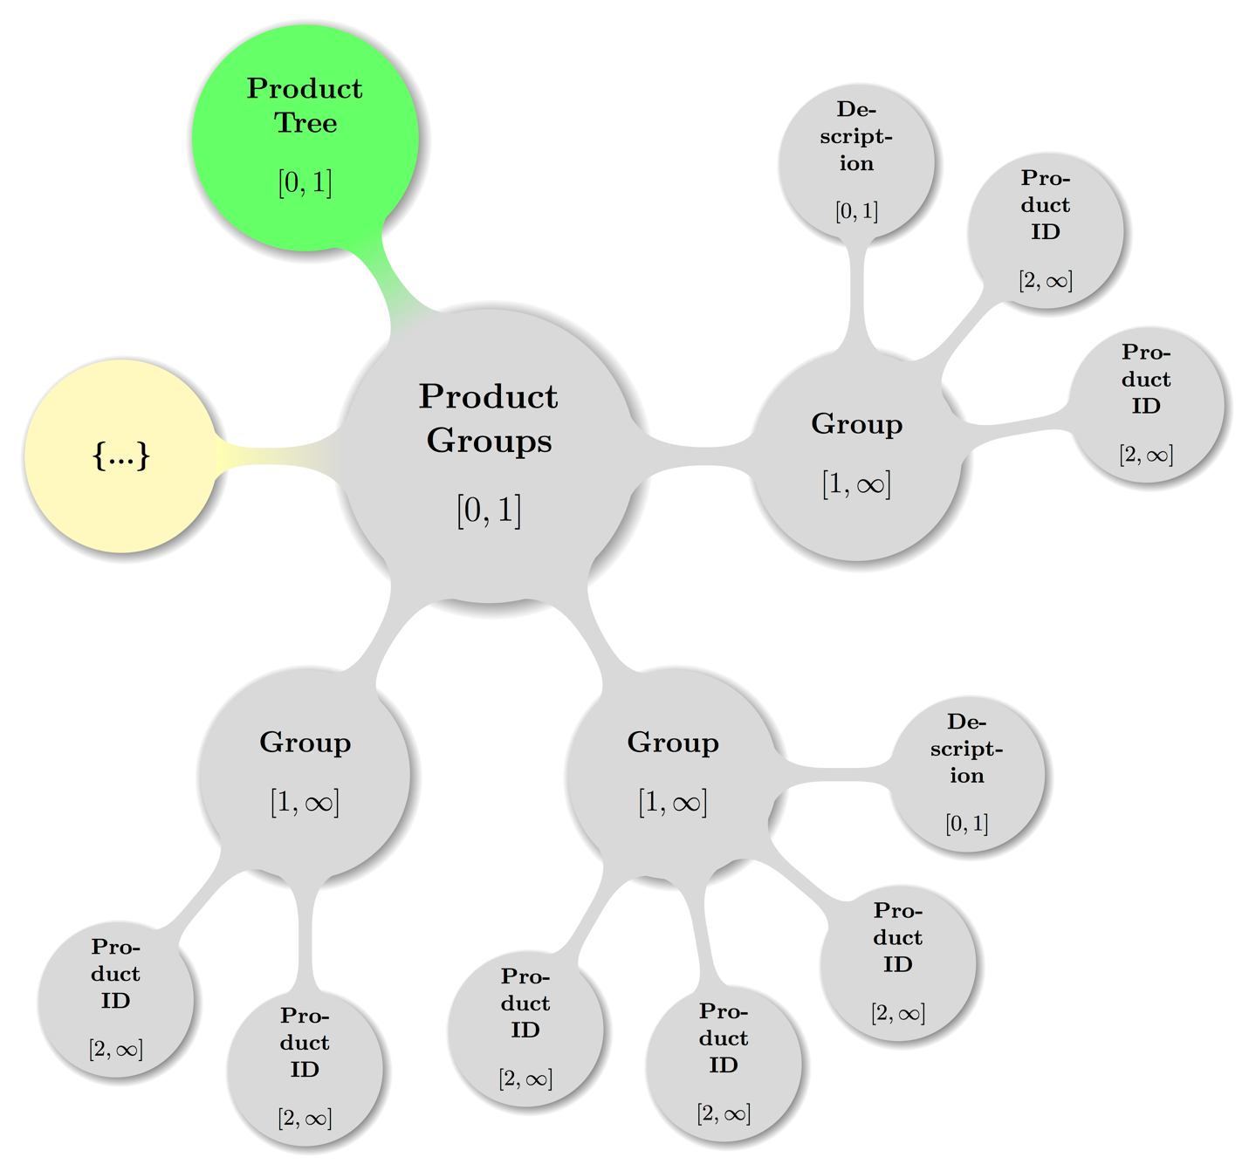

#### Product Tree – Product Groups – Group

Element prod:Group

« The prod:Group element MUST be present one or more times as child of the optional prod:ProductGroups element and MUST contain zero or one prod:Description and 2 or more prod:ProductID elements and in that order. » [CSAF-5.1.4.1-1]

The element prod:Groupis a container, that defines a new logical group of products that can then be referred to in other parts of the document to address a group of products with a single identifier.

**Group** members are defined by adding one **Product ID** element for every member of the group.

Attribute GroupID

The GroupIDattribute is required to identify a **Group** so that it can be referred to from other parts in the document.

There is no predefined or required format for the GroupIDas long as it uniquely identifies a group in the context of the current document.

Non-normative comment:

Examples for GroupIDattribute values include incrementing integers or GUIDs.

##### Product Tree – Product Groups – Group – Description

Element prod:Description

« The prod:Description element MUST be present zero or one time in prod:Group and if given is a short, optional description of the group. » [CSAF-5.1.4.1.1-1]

Example 45:

<ProductGroups>  
 <Group GroupID="CVRFGID-0001">  
 <Description>The x64 versions of the operating system.</Description>  
 <ProductID>CVRFPID-0001</ProductID>  
 <ProductID>CVRFPID-0002</ProductID>  
 <ProductID>CVRFPID-0003</ProductID>  
 <ProductID>CVRFPID-0004</ProductID>  
 </Group>  
</ProductGroups>

##### Product Tree – Product Groups – Group – Product ID

Element prod:ProductID

« The prod:ProductID element MUST be present 2 or more times in prod:Group elements and every instance defines a member of a group by referring to the unique ProductIDattribute of a **Full Product Name** element. » [CSAF-5.1.4.1.2-1]

Example 46:

If the two products “Microsoft Windows Vista Service Pack 1” and “Microsoft Windows Vista Service Pack 2” have been defined in the product tree as follows:

<FullProductName ProductID="CVRFPID-0001">  
 Microsoft Windows Vista Service Pack 1  
</FullProductName>  
<FullProductName ProductID="CVRFPID-0002">  
 Microsoft Windows Vista Service Pack 2  
</FullProductName>

They can both be made a member of the same group with Group ID “GRP-0001”:

<ProductGroups>  
 <Group GroupID="GRP-0001">  
 <ProductID>CVRFPID-0001</ProductID>  
 <ProductID>CVRFPID-0002</ProductID>  
 </Group>  
</ProductGroups>

Later in the document, both products can be referenced together using the Group ID:

<Remediations>  
 <Remediation Type="Vendor Fix">  
 <Description>Security Update for Windows Vista</Description>  
 <GroupID>GRP-0001</GroupID>  
 </Remediation>  
</Remediations>

The ability to reference both products individually will also be maintained (and in some cases required):

<Remediations>  
 <Remediation Type="Vendor Fix">  
 <Description>Security Update for Windows Vista</Description>  
 <ProductID>CVRFPID-0001</ProductID>  
 <ProductID>CVRFPID-0002</ProductID>  
 </Remediation>  
</Remediations>

# Vulnerability Schema Elements

Vulnerability information in CSAF CVRF is modeled as zero or more top-level Vulnerability element instances of vuln:Vulnerability (defined in the vulnerability schema file within the vuln namespace).

« The following listed 14 second-level elements MUST appear in the order listed if given as elements of the top-level element Vulnerability:

1. **Title**: vuln:Title
2. **ID**: vuln:ID
3. **Notes**: vuln:Notes
4. **Discovery Date**: vuln:DiscoveryDate
5. **Release Date**: vuln:ReleaseDate
6. **Involvements**: vuln:Involvements
7. **CVE**: vuln:CVE
8. **CWE**: vuln:CWE
9. **Product Statuses**: vuln:ProductStatuses
10. **Threats**: vuln:Threats
11. **CVSS Score Sets**: vuln:CVSSScoreSets
12. **Remediations**: vuln:Remediations
13. **References**: vuln:References
14. **Acknowledgements**: vuln:Acknowledgements

» [CSAF-6-1]

The remaining sub sections will describe the above 15 first and second level elements together with their children and grandchildren, constraints on them as well as state recommendations and examples.

## Vulnerability

Element vuln:Vulnerability

« The vuln:Vulnerability element MUST be present zero more times in cvrf:cvrfdoc and MUST contain the following child elements vuln:Title [0, 1], vuln:ID [0, 1], vuln:Notes [0, 1], vuln:DiscoveryDate [0, 1], vuln:ReleaseDate [0, 1], vuln:Involvements [0, 1], vuln:CVE [0, 1], vuln:CWE [0, ∞], vuln:ProductStatuses [0, 1], vuln:Threats [0, 1], vuln:CVSSScoreSets [0, 1], vuln:Remediation [0, 1], vuln:References [0, 1], and vuln:Acknowledgments [0, 1] as per given cardinalities and in that order. » [CSAF-6.1-1]

The optional elementvuln:Vulnerabilityis a container for the aggregation of all fields that are related to a single vulnerability in the document.

The cardinality allows to describe zero, one, or many vulnerabilities in a single CSAF CVRF document.

Attribute Ordinal

« The required attribute Ordinalis a locally significant value used to track vulnerabilities inside a CSAF CVRF document that MUST be an integer in the interval [1, ∞]. » [CSAF-6.1-2]

It is provided to enable specific vulnerabilities to be referenced from elsewhere in the document (or even outside the namespace of a document provided that a unique **Document Title** and **Revision** information are provided).

There SHOULD be one of these values for every **Vulnerability** container in a document, and it is recommended that Ordinalshould be instantiated as a monotonically increasing counter, indexed from 1.

Example 47:

<Vulnerability Ordinal="1"   
 xmlns="http://docs.oasis-open.org/csaf/ns/csaf-cvrf/v1.2/vuln">  
 <!-- ... All children optional, ; sample valid, albeit otherwise useless -->  
</Vulnerability>

A visual map of **Vulnerability** element including the parent node (**Document**) in some valid configuration spanning multiple sub trees is given below.

Figure 10: A topologically valid **Vulnerability** configuration.

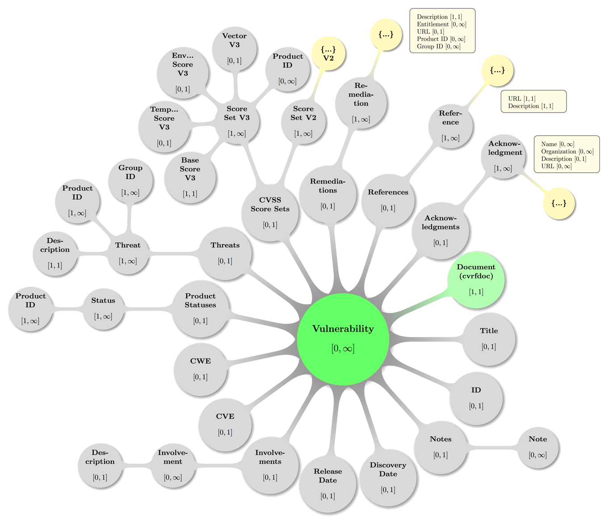

As before, some decent coloring has been applied to above graph as usual to balance visual hints with accessibility. Also, the mathematical closed interval notation has been used to annotate the minimum and maximum occurrences of elements, where the infinity symbol (∞) translates to the term unbounded in XML lingo.

The nodes carrying an ellipsis (…) here are to be read combined with the rounded edge rectangles, as the latter list the represented leaf elements that did not well fit into the picture.

## Vulnerability – Title

Element vuln:Title

« The vuln:Title element MUST be present zero or one time in vuln:Vulnerability and if present gives the document producer the ability to apply a canonical name or title to the vulnerability. » [CSAF-6.2-1]

To avoid confusion, it is recommended that, if employed, this element commensurately match the nomenclature used by any numbering or cataloging systems references elsewhere, such as the **Document Title** or **CVE.**

Example 48:

<Title>February 2011 TelePresence Vulnerability Bundle</Title>

## Vulnerability – ID

Element vuln:ID

« The vuln:ID element MUST be present zero or one time in vuln:Vulnerability and if present gives the document producer a place to publish a unique label or tracking ID for the vulnerability (if such information exists). » [CSAF-6.3-1]

The value domain for vuln:ID elements is further documented in section 2.2.14 Vulnerability ID Type Model.

The attribute SystemName is required.

Attribute SystemName

The required attribute SystemNameindicates the name of the vulnerability tracking or numbering system that this **ID** comes from.

Every **ID** value SHOULD have exactly one SystemName.

Non-normative comment:

It is helpful if document producers use unique and consistent system names.

Example 49:

<Vulnerability>  
 <ID SystemName="Cisco Bug ID">CSCso66472</ID>  
</Vulnerability>

## Vulnerability – Notes

Element vuln:Notes

« The vuln:Notes element MUST be present zero or one time in vuln:Vulnerability and if present contain one or more vuln:Note elements.   
» [CSAF-6.4-1]

The elementvuln:Notesis a container that holds all vulnerability-level **Note** elements.

### Vulnerability – Notes – Note

Element vuln:Note

« The vuln:Note element MUST be present one or more times in vuln:Notes and is a place to put all manner of text blobs related to the vulnerability. » [CSAF-6.4.1-1]

Text should be limited to talking about the impacts, vectors, or caveats of this node and should not contain details to other vulnerabilities in the document. It is, however, acceptable to refer to a vulnerability that is not in the document for the purposes of pointing out a regression.

The vuln:Note element has four attributes, two of them are required: Type and Ordinal.

Titleand Audienceare the two optional attributes to give human readers context around what they are about to read.

Akin to the **Document Notes** element, the note SHOULD contain a compartmentalized textual discussion constrained by its Typeattribute.

Attribute Type

« The value of the attribute TypeMUST be one of the enumeration values as described in section 2.2.2 Note Type Model. » [CSAF-6.4.1-2]

Attribute Ordinal

Ordinalis a mandatory, locally significant value used to track notes inside a CVRF document at the vulnerability level.

It is provided to uniquely identify a **Note**.

There should be one of these values for every **Note** inside **Vulnerability Notes** and it is recommended that OrdinalSHOULD be instantiated as a monotonically increasing counter, indexed from 1.

Every Ordinalthat tracks a **Note** inside **Vulnerability Notes** is completely independent from any Ordinaltracking a **Note** inside **Document Notes**.

Attribute Title

The optional attribute TitleSHOULD be a concise description of what is contained in the text.

Attribute Audience

The optional attribute Audience SHOULD indicate who is intended to read it.

Example 50:

<vuln:Notes>  
 <vuln:Note Type="General" Ordinal="1" Title="Details" Audience="All">  
 These are some details about a vulnerability intended for  
 all stakeholders.  
 </vuln:Note>  
</vuln:Notes>

## Vulnerability – Discovery Date

Element vuln:DiscoveryDate

« The vuln:DiscoveryDate element MUST be present zero or one time inside any vuln:Vulnerability instance element and if given holds the date and time the vulnerability was originally discovered. » [CSAF-6.5-1]

All date like values in CSAF CVRF require a date and a time (cf. section 2.2.1 Date and Time).

Example 51:

<DiscoveryDate>2010-11-03T00:00:00Z</DiscoveryDate>

## Vulnerability – Release Date

Element vuln:ReleaseDate

« The vuln:ReleaseDate element MUST be present zero or one time inside any vuln:Vulnerability instance element and if given holds the date and time the vulnerability was originally released into the wild. » [CSAF-6.6-1]

All date like values in CSAF CVRF require a date and a time (cf. section 2.2.1 Date and Time).

Example 52:

<ReleaseDate>2010-11-16T00:00:00Z</ReleaseDate>

## Vulnerability – Involvements

Element vuln:Involvements

« The vuln:Involvements MUST be present zero or one time inside any vuln:Vulnerability element and if present contain one or more vuln:Involvement elements. » [CSAF-6.7-1]

The optional elementvuln:Involvementsis a container that holds one or more **Involvement** containers, which allow the document producers (or third parties) to comment on their level of involvement in the vulnerability identification, scoping, and remediation process.

Matching the possibly multiple **Involvements** containers, multiple parties can comment on their levels of involvement.

### Vulnerability – Involvements – Involvement

Element vuln:Involvement

« The vuln:Involvment element MUST be present one or more times in vuln:Involvements and MUST contain zero or one vuln:Description elements. » [CSAF-6.7.1-1]

Theelementvuln:Involvement is a container, thatallows the document producers to comment on their level of Involvement (or engagement) in the vulnerability identification, scoping, and remediation process.

The two attributes Party and Status are both required.

Attribute Party

The attribute Partyindicates the type of the producer issuing the status.

It is identical to the **Document Publisher** attribute Type.

Most of the time, both attributes will be the same because document producers will issue an **Involvement** status on their own behalf.

However, if the document producer wants to issue a status on behalf of a third party and use a different type from that used in **Document Publisher**, that use is allowed by the schema.

If this is the case, **Description** should contain additional context regarding what is going on.

« The value of the attribute PartyMUST be as defined in section 2.2.6 Publisher Type Model.   
» [CSAF-6.7.1-2]

Attribute Status

« The attribute Statusindicates the level of involvement of (the) Party and the enumeration value MUST be as defined in section 2.2.15 Vulnerability Involvement Type Model.   
» [CSAF-6.7.1-3]

#### Vulnerability – Involvements – Involvement – Description

Element vuln:Description

« The vuln:Description element MUST occur zero or one time in vuln:Involvment and if present contains a string value, that represents a thorough human-readable discussion of the **Involvement**. » [CSAF-6.7.1.1-1]

Example 53:

<Involvements>  
 <Involvement Party="Vendor" Status="In Progress">  
 <Description>  
 Cisco acknowledges that the IronPort Email Security Appliances (ESA)   
 and Cisco IronPort Security Management Appliances (SMA) contain a  
 vulnerability that may allow a remote, unauthenticated attacker to  
 execute arbitrary code with elevated privileges.  
 A Mitigation is available.  
 </Description>  
 </Involvement>  
</Involvements>

Example 54:

<Involvements>  
 <Involvement Party="Researcher" Status="Contact Attempted">  
 <Description>  
 We emailed the vendor on February 14, 2012 when the vulnerability was  
 first discovered by our team.   
 </Description>  
 </Involvement>  
</Involvements>

Example 55:

<Involvements>  
 <Involvement Party="Vendor" Status="Completed"></Involvement>  
</Involvements>

## Vulnerability – CVE

Element vuln:CVE

« The vuln:CVE element MUST be present zero or one time in any vuln:Vulnerability and if present its value holds the MITRE standard Common Vulnerabilities and Exposures (CVE) tracking number for the vulnerability and this value MUST match the pattern documented in section 2.2.10 Vulnerability CVE Type Model. » [CSAF-6.8-1]

Non-normative comment:

CVE is a standard for vulnerability naming that provides improved tracking of vulnerabilities over time across different reporting sources. More information about CVE domain values can be found in section 2.2.10 Vulnerability CVE Type Model.

Example 56:

<CVE>CVE-2010-3864</CVE>

## Vulnerability – CWE

Element vuln:CWE

« The vuln:CWE element MUST be present zero or one time in any vuln:Vulnerability and if present it contains the MITRE standard Common Weakness Enumeration (CWE) and this value MUST match the pattern documented in section 2.2.13 Vulnerability CWE Type Model. » [CSAF-6.9-1]

Non-normative comment:

The CWE domain value type is described in section 2.2.13 Vulnerability CWE Type Model.

Example 57:

<CWE ID="CWE-601">URL Redirection to Untrusted Site ('Open Redirect')</CWE>

Example 58:

<CWE ID="CWE-602">Client-Side Enforcement of Server-Side Security</CWE>

## Vulnerability – Product Statuses

Element vuln:ProductStatuses

« The vuln:ProductStatuses element MUST be present zero or one time in any vuln:Vulnerability and if present it MUST contain one or more vuln:Status elements which contain a subset of products chosen from **Product Tree**. » [CSAF-6.10-1]

Every affected (and unaffected) product relating to the vulnerability is referenced here, inside one or more **Status** containers.

There is a constraint in place to prevent a single product from being assigned two different (conflicting) **Status** elements within the scope of **Vulnerability**.

Likewise, a **Status** child container cannot be tied to a **Product Group** due to the fact that a single product can be a member of more than one product group.

Non-normative comment:

Without this constraint, it would be possible to assign conflicting status information to one and the same product.

### Vulnerability – Product Statuses – Status

Element vuln:Status

« The vuln:Status element MUST be present with cardinality [1, ∞] in vuln:ProductStatuses and MUST contain one or more vuln:ProductID elements. » [CSAF-6.10.1-1]

Attribute Type

The allowed values of the Typeattribute of a vuln:Status element are documented in section 2.2.16 Vulnerability Product Affected Status Type Model. Theelementvuln:Status contains one or more products as chosen from the **Product Tree**, and defines the status of this product in the mandatory *Status* attribute.

#### Vulnerability – Product Statuses – Status – Product ID

Element vuln:ProductID

« The vuln:ProductID element MUST be present one or more times inside a vuln:Status element and defines a product as having the status defined in the parent element’s Typeattribute. » [CSAF-6.10.1.1-1]

The reference is made via value by using the unique ProductIDattribute of a **Full Product Name** element that is defined in the **Product Tree**.

« A single **Product ID** MUST not be assigned more than one status type within the same **Vulnerability**. » [CSAF-6.10.1.1-2]

Example 59:

The three products “Microsoft Windows Vista (RTM)”, “Microsoft Windows Vista Service Pack 1”, and “Microsoft Windows Vista Service Pack 2” have been defined in the product tree as follows:

<ProductTree>  
 <FullProductName ProductID="CVRFPID-0000">  
 Microsoft Windows Vista (RTM)  
 </FullProductName>  
 <FullProductName ProductID="CVRFPID-0001">  
 Microsoft Windows Vista Service Pack 1  
 </FullProductName>  
 <FullProductName ProductID="CVRFPID-0002">  
 Microsoft Windows Vista Service Pack 2  
 </FullProductName>  
</ProductTree>

If Windows Vista RTM and Service Pack 1 are known to be affected, and Service Pack 2 is known not to be affected, it can be documented as follows:

<Vulnerability Ordinal="1">  
 <Product Statuses>  
 <Status Type="KnownAffected">  
 <ProductID>CVRFPID-0000</ProductID>  
 <ProductID>CVRFPID-0001</ProductID>  
 </Status>  
 <Status Type="KnownNotAffected">  
 <ProductID>CVRFPID-0002</ProductID>  
 </Status>  
 </Product Statuses>  
</Vulnerability>

## Vulnerability – Threats

Element vuln:Threats

« The vuln:Threats element MUST be present zero or one time inside any vuln:Vulnerability and if present it MUST contain one or more vuln:Threat elements which contain information about a vulnerability that can change with time. » [CSAF-6.11-1]

Non-normative comment:

Threat information about a vulnerability that can change with time is also called “vulnerability kinetics”.

A visual map of some valid **Threats** configuration including the parent node (**Vulnerability**) — again with the node labeled {…} indicating further possible **Threat** subtrees follows below.

Figure 11: A topologically valid **Threats** configuration.

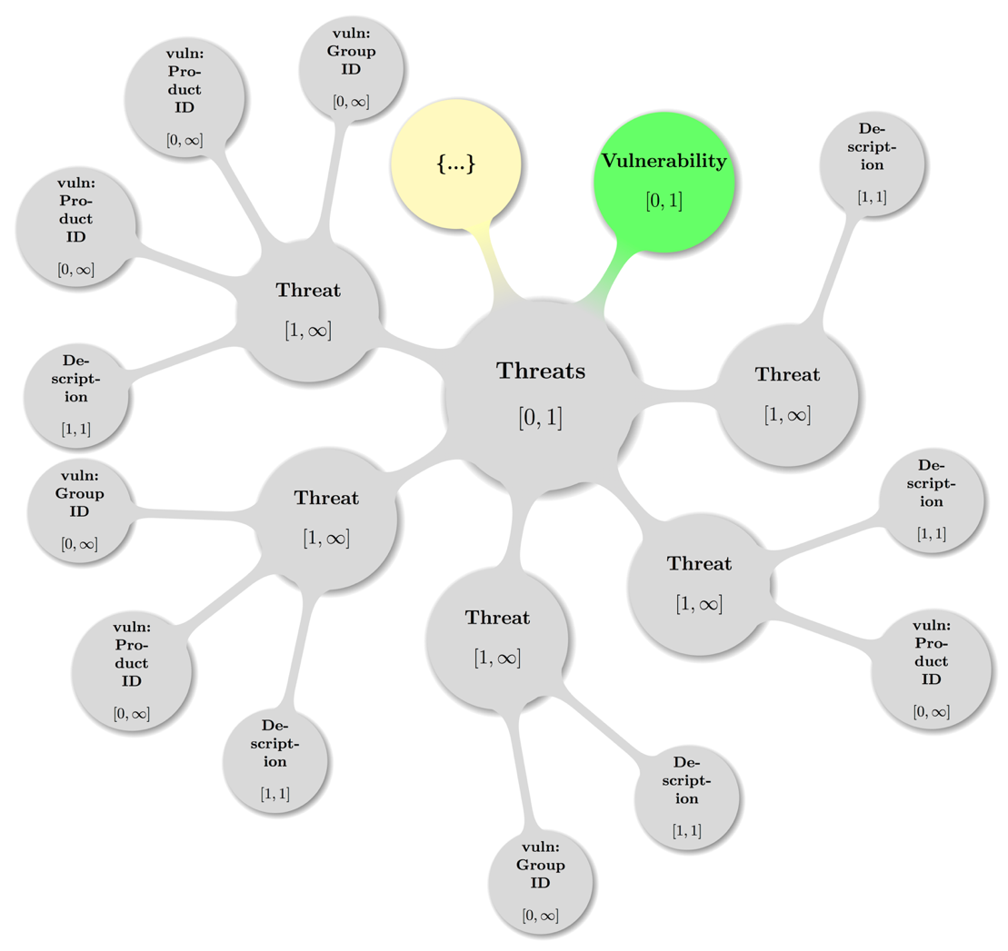

### Vulnerability – Threats – Threat

Element vuln:Threat

« The vuln:Threat element MUST be present with cardinality [1, ∞] as in vuln:Threats and MUST contain exactly one vuln:Description element and zero or more vuln:ProductID and vuln:GroupID elements and in that order. » [CSAF-6.11.1-1]

Theelementvuln:Threat contains the vulnerability kinetic information. This information can change as the vulnerability ages and new information becomes available.

The attribute Type is required and categorizes the threat according to the rules in section 2.2.18 Vulnerability Threat Type Model.

A **Threat** container is tied to one or more specific products by referencing these products using either the **Product ID** or **Group ID** child elements.

If the **Threat** is meant to be general or nonspecific for all products, the **Product ID** and **Group ID** child elements SHOULD be omitted.

Attribute Type

The allowed enumerated values for the Type attribute are documented in section 2.2.18 Vulnerability Threat Type Model.

Attribute Date

The Date attribute is optional, but if given it must contain a date time value as documented in section 2.2.1 Date and Time.

#### Vulnerability – Threats – Threat – Description

Element vuln:Description

« The vuln:Description element MUST be present exactly once in vuln:Threat and the string content represents a thorough human-readable discussion of the **Threat**. » [CSAF-6.11.1.1-1]

Example 60: Impact:

<Threat Type="Impact">  
 <Description>complete compromise of the integrity of affected machines </Description>  
</Threat>

Example 61: Exploit Status:

<Threat Type="Exploit Status">  
 <Description>none</Description>  
 <Date>2011-11-26T00:00:00+00:00</Date>  
 <ProductID>CVRFPID-0000</ProductID>  
</Threat>

Example 62: Exploit Status without Product ID:

<Threat Type="Exploit Status">  
 <Description>proof of concept</Description>  
 </Date>2011-11-26T00:00:00+00:00</Date>  
</Threat>

Example 63: Target Set:

<Threat Type="Target Set">  
 <Description>Financial Institutions</Description>  
</Threat>

Example 64: Target Set variation of content:

<Threat Type="Target Set">  
 <Description>US Government Agencies</Description>  
</Threat>

Example 65: Target Set with another variation of content:

<Threat Type="Target Set">  
 <Description>All versions of BIND</Description>  
</Threat>

#### Vulnerability – Threats – Threat – Product ID

Element vuln:ProductID

« The vuln:ProductID element MUST be present with the cardinality [0, ∞] in vuln:Threat element and if given represents a reference by value to the related product via the unique ProductID attribute of the matching **Full Product Name** element.  
» [CSAF-6.11.1.2-1]

If a **Threat** applies to more than one Product, either additional **Product ID** elements or **Group ID** elements (replacing/combining those) SHOULD be added.

#### Vulnerability – Threats – Threat – Group ID

Element vuln:GroupID

« The vuln:GroupID element MUST be present with the cardinality [0, ∞] in a vuln:Threat element and if given represents a reference by value to the related products via the unique GroupIDattribute of a **Group** element that is defined in the **Product Tree**. » [CSAF-6.11.1.3-1]

If the **Threat** pertains to several products that have been logically grouped into a **Product Group** optional elementvuln:GroupIDrepresents a reference to that group of products.

If a **Threat** applies to more than one group of products, multiple **Group ID** elements are added accordingly.

## Vulnerability – CVSS Score Sets

Element vuln:CVSSScoreSets

« The vuln:CVSSScoreSets element MUST present zero or one time per and inside any vuln:Vulnerability and holds one or more of the vuln:ScoreSetV2 (deprecated) orvuln:ScoreSetV3 (preferred) container elements and in that order if instances of both are present. » [CSAF-6.12-1]

A visual map of some valid **CVSS Score Sets** configuration including the parent node (**Vulnerability**) — again the node with label {…} indicates further possible **Score Set V3** (preferred) or ***Score Set V2*** (deprecated) subtrees is shown below:

Figure 12 A topologically valid **CVSS Score Sets** configuration.

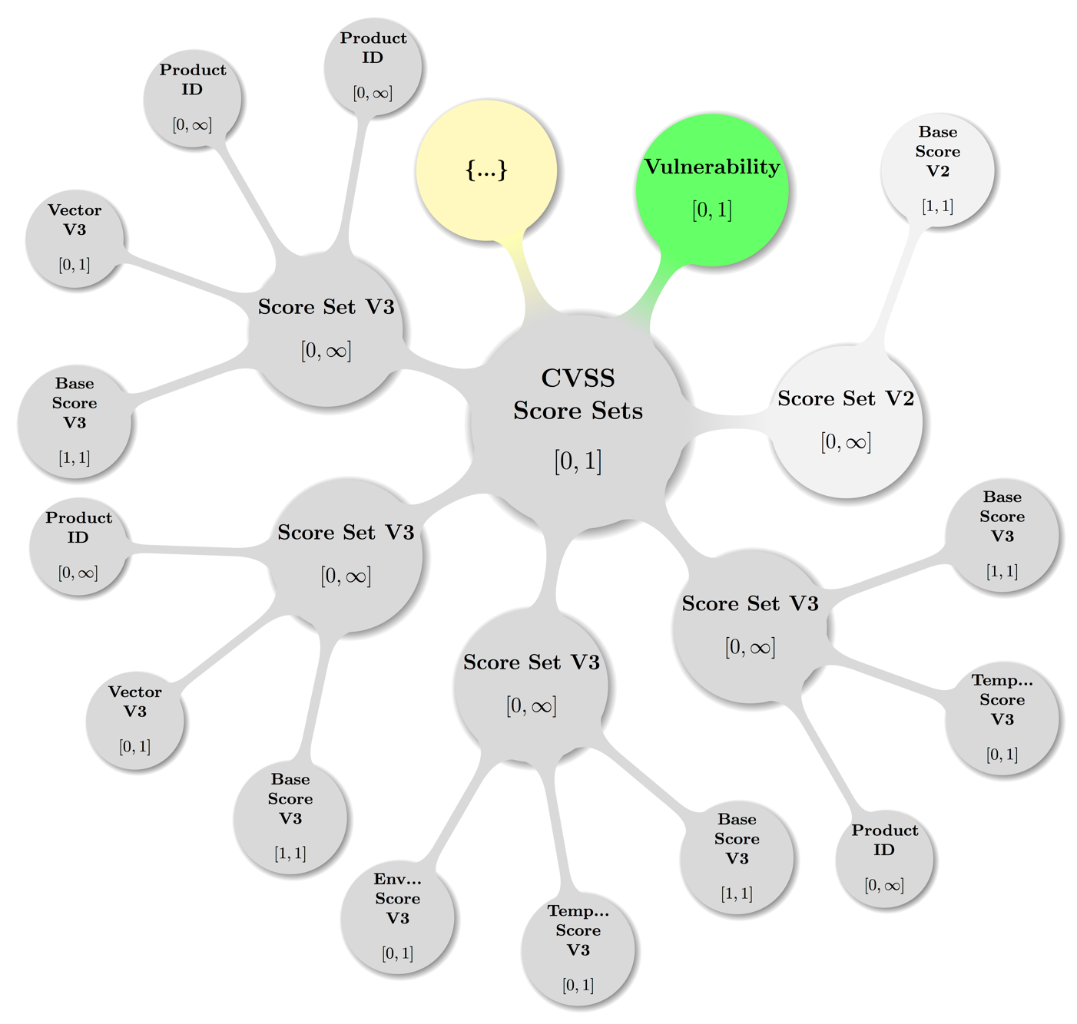

### Vulnerability – CVSS Score Sets – Score Set V2

Element vuln:ScoreSetV2

« The vuln:ScoreSetV2 element MUST be present with cardinality [0, ∞] inside vuln:CVSSScoreSets and if given, every instance MUST hold at least exactly one vuln:BaseScoreV2 element. » [CSAF-6.12.1-1]

« Any vuln:ScoreSetV2 instance MAY additionally provide the further children: vuln:TemporalScoreV2 [0, 1], vuln:EnvironmentalScoreV2 [0, 1], vuln:VectorV2 [0, 1], vuln:ProductID [0, ∞] and in that order. » [CSAF-6.12.1-2]

If a value of the temporal or environmental score is set to “not defined”, the corresponding elements SHOULD be omitted.

The allowed values for the children of the vuln:ScoreSetV2 element are documented in section 2.2.11 Vulnerability CVSS Version 2 Type Model.

Non-normative comment:

If given, instances hold the actual CVSS version 2 metrics [CVSS2]

See also section 2.2.11 Vulnerability CVSS Version 2 Type Model for further information and constraints on the values of the containers components.

A **Score Set V2** container can be tied to one or more specific products by referencing these products using the **Product ID** child element. If the **Score Set V2** is meant to be applied for all products, the *Product ID* attribute should be omitted.

Note there is a constraint in place to prevent having a single product assigned to two different score sets within the scope of a **Vulnerability**. Likewise, a **Score Set V2** cannot be tied to a **Product Group** due to the fact that a single product can be a member of more than one product group. Without this constraint, it would be possible to assign conflicting base score information to one and the same product.

#### Vulnerability – CVSS Score Sets – Score Set V2 – Base Score V2

Element vuln:BaseScoreV2

« The vuln:BaseScoreV2 element MUST be present exactly once inside every vuln:ScoreSetV2 and contains the numeric value of the computed CVSS version 2 base score.   
» [CSAF-6.12.1.1-1]

The finite set of allowed values the vuln:BaseScoreV2 element is documented in section 2.2.11 Vulnerability CVSS Version 2 Type Model.

#### Vulnerability – CVSS Score Sets – Score Set V2 – Temporal Score V2

Element vuln:TemporalScoreV2

« The vuln:TemporalScoreV2 element MUST be present zero or one time inside any vuln:ScoreSetV2 and if given contains the numeric value of the computed CVSS version 2 temporal score. » [CSAF-6.12.1.2-1]

The finite set of allowed values for the vuln:TemporalScoreV2 element is documented in section 2.2.11 Vulnerability CVSS Version 2 Type Model.

#### Vulnerability – CVSS Score Sets – Score Set V2 – Environmental ScoreV2

Element vuln:EnvironmentalScoreV2

« The vuln:EnvironmentalScoreV2 element MUST be present zero or one time inside any vuln:ScoreSetV2 and if given contains the numeric value of the computed CVSS version 2 environmental score. » [CSAF-6.12.1.3-1]

The finite set of allowed values for the vuln:EnvironmentalScoreV2 element are documented in section 2.2.11 Vulnerability CVSS Version 2 Type Model.

Non-normative comment:

This metric is typically reserved for use by the end user and is specific to the environment in which the affected product is deployed. See also section 2.2.11 Vulnerability CVSS Version 2 Type Model for further information and constraints on this element.

#### Vulnerability – CVSS Score Sets – Score Set V2 – Vector V2

Element vuln:VectorV2

« The vuln:VectorV2 element MUST be present zero or one time inside any vuln:ScoreSetV2 and if present contains the official string notation that displays all the values used to compute the CVSS version 2 base, temporal, and environmental scores. » [CSAF-6.12.1.4-1]

The allowed values for the vuln:VectorV3 element are documented in section 2.2.11 Vulnerability CVSS Version 2 Type Model.

Example 66:

<VectorV2>AV:N/AC:L/Au:N/C:P/I:P/A:C/E:P/RL:O/RC:C/CDP:H/TD:M/CR:H/IR:H/AR:H<VectorV2>

#### Vulnerability – CVSS Score Sets – Score Set V2 – Product ID

Element vuln:ProductID

« The vuln:ProductID element MUST be present with cardinality [0, ∞| inside any vuln:ScoreSetV2 element and per instance value references to unique ProductIDattributes of **Full Product Name** elements defined in the **Product Tree** are noted.   
» [CSAF-6.12.1.5-1]

If a **Score Set V2** applies to more than one product, you can add multiple **Product ID** elements as references accordingly.

Any single **Product ID** is to be assigned to exactly none or one **Score Set V2** within the same **Vulnerability**.

### Vulnerability – CVSS Score Sets – Score Set V3

Element vuln:ScoreSetV3

« The vuln:ScoreSetV3 element MUST be present with cardinality [0, ∞] inside vuln:CVSSScoreSets and if given, every instance MUST hold at least exactly one vuln:BaseScoreV3 element. » [CSAF-6.12.2-1]

« Any vuln:ScoreSetV3 instance MAY additionally provide the further children: vuln:TemporalScoreV3 [0, 1], vuln:EnvironmentalScoreV3 [0, 1], vuln:VectorV3 [0, 1], vuln:ProductID [0, ∞] and in that order. » [CSAF-6.12.2-2]

If a value of the temporal or environmental score is set to “not defined”, the corresponding elements SHOULD be omitted.

The allowed values for the children of the vuln:ScoreSetV3 element are documented in section 2.2.12 Vulnerability CVSS Version 3 Type Model.

Non-normative comment:

If given, instances hold the actual CVSS version 3 metrics [CVSS3].

See also section 2.2.12 Vulnerability CVSS Version 3 Type Model for further information and constraints on the values of the containers components.

A **Score Set V3** container can be tied to one or more specific products by referencing these products using the **Product ID** child element. If the **Score Set V3** is meant to be applied for all products, the *Product ID* attribute should be omitted.

Note there is a constraint in place to prevent having a single product assigned to two different score sets within the scope of a **Vulnerability**. Likewise, a **Score Set V2** cannot be tied to a **Product Group** due to the fact that a single product can be a member of more than one product group. Without this constraint, it would be possible to assign conflicting base score information to one and the same product.

#### Vulnerability – CVSS Score Sets – Score Set V3 – Base Score V3

Element vuln:BaseScoreV3

« The vuln:BaseScoreV3 element MUST be present exactly once inside every vuln:ScoreSetV3 and contains the numeric value of the computed CVSS version 3 base score. » [CSAF-6.12.2.1-1]

The finite set of allowed values for the vuln:BaseScoreV3 element is documented in section 2.2.12 Vulnerability CVSS Version 3 Type Model.

#### Vulnerability – CVSS Score Sets – Score Set V3 – Temporal Score V3

Element vuln:TemporalScoreV3

« The vuln:TemporalScoreV3 element MUST be present zero or one time inside any vuln:ScoreSetV3 and if given contains the numeric value of the computed CVSS version 3 temporal score. » [CSAF-6.12.2.2-1]

The finite set of allowed values for the vuln:TemporalScoreV3 element is documented in section 2.2.12 Vulnerability CVSS Version 3 Type Model.

#### Vulnerability – CVSS Score Sets – Score Set V3 – Environmental ScoreV3

Element vuln:EnvironmentalScoreV3

« The vuln:EnvironmentalScoreV3 element MUST be present zero or one time inside any vuln:ScoreSetV3 and if given contains the numeric value of the computed CVSS version 3 environmental score. » [CSAF-6.12.2.3-1]

The finite set of allowed values for the vuln:EnvironmentalScoreV3 element are documented in section 2.2.12 Vulnerability CVSS Version 3 Type Model.

Non-normative comment:

This metric is typically reserved for use by the end user and is specific to the environment in which the affected product is deployed. See also section 2.2.12 Vulnerability CVSS Version 3 Type Model for further information and constraints on this element.

#### Vulnerability – CVSS Score Sets – Score Set V3 – Vector V3

Element vuln:VectorV3

« The vuln:VectorV3 element MUST be present zero or one time inside any vuln:ScoreSetV3 and if present contains the official string notation that displays all the values used to compute the CVSS version 3 base, temporal, and environmental scores. » [CSAF-6.12.2.4-1]

The allowed values for the vuln:VectorV3 element are documented in section 2.2.12 Vulnerability CVSS Version 3 Type Model.

Example 67:

<VectorV3>CVSS:3.0/AV:N/AC:L/PR:H/UI:N/S:U/C:L/I:L/A:N<VectorV3>

Example 68:

<VectorV3>CVSS:3.0/S:U/AV:N/AC:L/PR:H/UI:N/C:L/I:L/A:N/E:F/RL:X<VectorV3>

#### Vulnerability – CVSS Score Sets – Score Set V3 – Product ID

Element vuln:ProductID

« The vuln:ProductID element MUST be present with cardinality [0, ∞| inside any vuln:ScoreSetV3 element and per instance value references to unique ProductIDattributes of **Full Product Name** elements defined in the **Product Tree** are noted.   
» [CSAF-6.12.2.5-1]

If a **Score Set V3** applies to more than one product, you can add multiple **Product ID** elements as references accordingly.

Any single **Product ID** is to be assigned to exactly none or one **Score Set V3** within the same **Vulnerability**.

## Vulnerability – Remediations

Element vuln:Remediations

« The vuln:Remediations element MUST be present with cardinality [0, 1] inside vuln:Vulnerability and it holds [1, ∞] vuln:Remediation child elements.   
» [CSAF-6.13-1]

These **Remediation** containers will have details on how to remediate a vulnerability.

Visual display of a map of some valid **Remediations** configuration including the parent node (**Vulnerability**) — again with the node labeled {…} indicating further possible **Remediation** subtrees — follows below.

Figure 13: A topologically valid **Remediations** configuration.

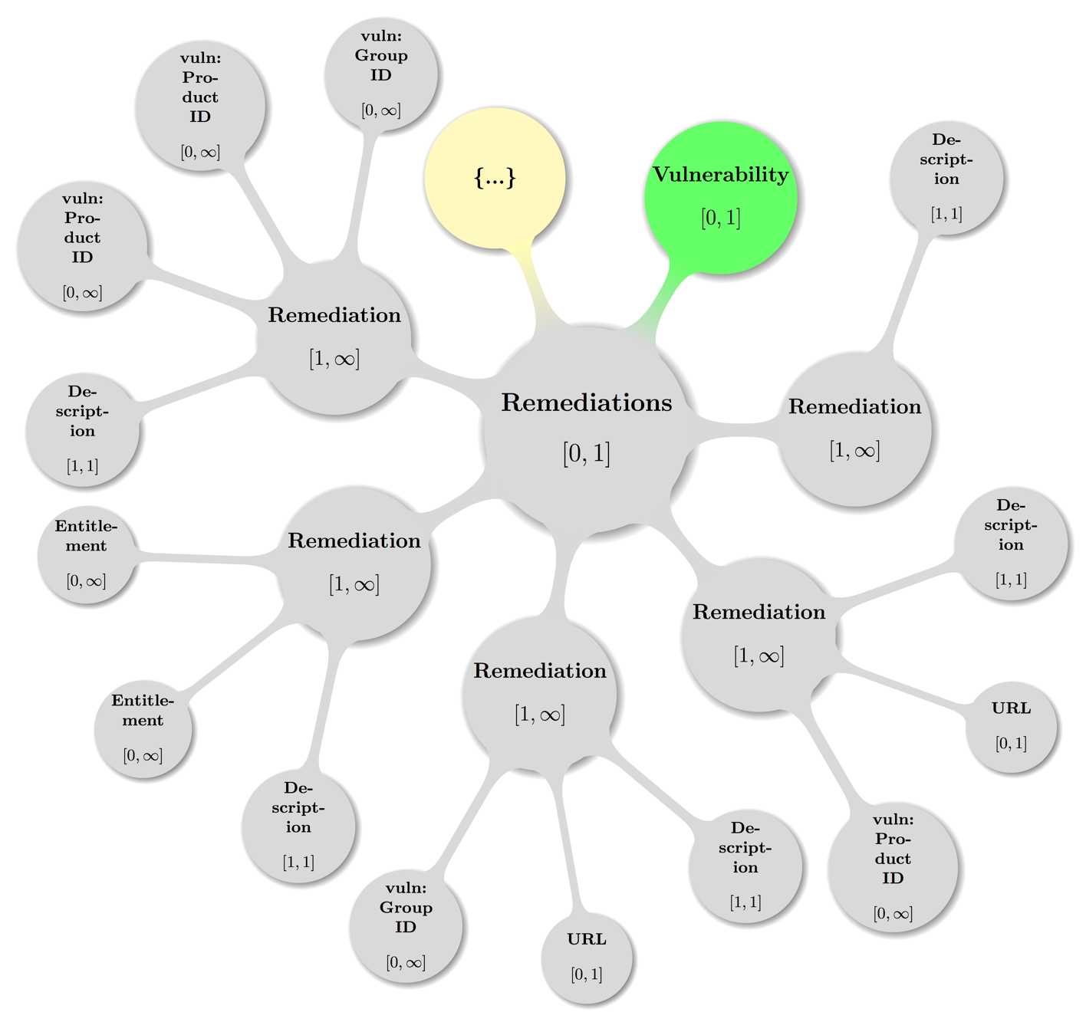

### Vulnerability – Remediations – Remediation

Element vuln:Remediation

« The vuln:Remediation element MUST be present with cardinality [1, ∞] in vuln:Remediations and MUST contain the following child elements vuln:Description [1, 1], vuln:Entitlement [0, ∞], vuln:URL [0, 1], vuln:ProductID [0, ∞], and vuln:GroupID [0, ∞] in that order. » [CSAF-6.13.1-1]

The elementvuln:Remediationis a container that holds specific details on how to handle (and presumably, fix) a vulnerability.

A **Remediation** container can be tied to one or more specific products by referencing these products using either the **Product ID** or **Group ID** child elements.

If the **Remediation** is meant to be general or nonspecific for all products, the **Product ID** and **Group ID** child elements should be omitted.

Optionally, **Remediation** can contain information and constraints about how to obtain fixes via the **Entitlement** element.

Attribute Type

The allowed values for the required Type attribute are documented in section 2.2.17 Vulnerability Remediation Type Model.

#### Vulnerability – Remediations – Remediation – Description

Element vuln:Description

« The vuln:Description element MUST be present exactly once in vuln:Remediation and it contains a thorough human-readable discussion of the **Remediation**.   
» [CSAF-6.13.1.1-1]

#### Vulnerability – Remediations – Remediation – Entitlement

Element vuln:Entitlement

« The vuln:Entitlement element MUST be present with cardinality [0, ∞] inside vuln:Remediation and it contains any possible vendor-defined constraints for obtaining fixed software or hardware that fully resolves the vulnerability. » [CSAF-6.13.1.2-1]

Non-normative comment:

This element will often contain information about service contracts or service-level agreements that is directed toward customers of large vendors.

Example 69:

<Entitlement>  
 Cisco customers with service contracts that entitle them to regular software updates   
 should obtain security fixes through their usual update channels, generally from the   
 Cisco website. Cisco recommends contacting the TAC only with specific and imminent   
 problems or questions.\r\nAs a special customer service, and to improve the overall   
 security of the Internet, Cisco may offer customers free of charge software updates to   
 address security problems. If Cisco has offered a free software update to address a   
 specific issue, noncontract customers who are eligible for the update may obtain it by   
 contacting the Cisco TAC using any of the means described in the Contact Summary   
 section of this document. To verify their entitlement, individuals who contact the TAC   
 should have available the URL of the Cisco document that is offering the   
 upgrade.\r\nAll aspects of this process are subject to change without notice and on a   
 case-by-case basis. No particular level of response is guaranteed for any specific   
 issue or class of issues.  
</Entitlement>

#### Vulnerability – Remediations – Remediation – URL

Element vuln:URL

« The vuln:URL element MUST be present with cardinality [0, 1] in vuln:Remediation and it contains the URL to the **Remediation**. » [CSAF-6.13.1.3-1]

#### Vulnerability – Remediations – Remediation – Product ID

Element vuln:ProductID

« The vuln:ProductID element MUST be present with cardinality [0, ∞] inside vuln:Remediation and the content of the instances are tokens that are references to products through the value of a **Full Product Name**’s ProductID attribute.   
» [CSAF-6.13.1.4-1]

If the **Remediation** pertains to a specific product, a vuln:ProductIDrepresents the reference to that product.

The reference is made using the unique ProductIDattribute of a **Full Product Name** element that is defined in the **Product Tree**.

If a **Remediation** applies to more than one Product, multiple **Product ID** elements SHOULD be added accordingly, or the **Group ID** element (see below) instead.

Example 70:

<Remediation Type="Vendor Fix">  
 <Description>  
 this is an official fix for Test Product and here are the details...  
 </Description>  
 <URL>http://foo.example.com/bar/</URL>  
 <Product ID>CVRFPID-0000</Product ID>  
</Remediation>

#### Vulnerability – Remediations – Remediation – Group ID

Element vuln:GroupID

« The vuln:GroupID element MUST be present with cardinality [0, ∞] inside vuln:Remediation and the content of the instances are tokens that are references to groups of products. » [CSAF-6.13.1.5-1]

If the **Remediation** pertains to several products that have been logically grouped into a **Product Group**, a vuln:GroupID element can be added to reference that group of products. The reference is made using the unique GroupIDattribute of a **Group** element that is defined in the **Product Tree**.

If a **Remediation** applies to more than one group of products, one can add multiple **Group ID** elements accordingly.

## Vulnerability – References

Element vuln:References

« The vuln:References element MUST be present with cardinality [0, 1] inside vuln:Vulnerability parent at last position or before any Acknowledgements if these exist. » [CSAF-6.14-1]

Theoptionalelementvuln:Referencesis a container that SHOULD include citations to any conferences, papers, advisories, and other resources that are specific to the vulnerability section and considered to be of value to the document consumer.

« If present, the vuln:References MUST contain [1, ∞] vuln:Reference child element instances. » [CSAF-6.14-2]

A visual map of some valid **References** configuration including the parent node (**Vulnerability**) — again with the node labeled {…} indicating further possible **Reference** subtrees is provided below:

Figure 14: A topologically valid **Vulnerability** **References** configuration.

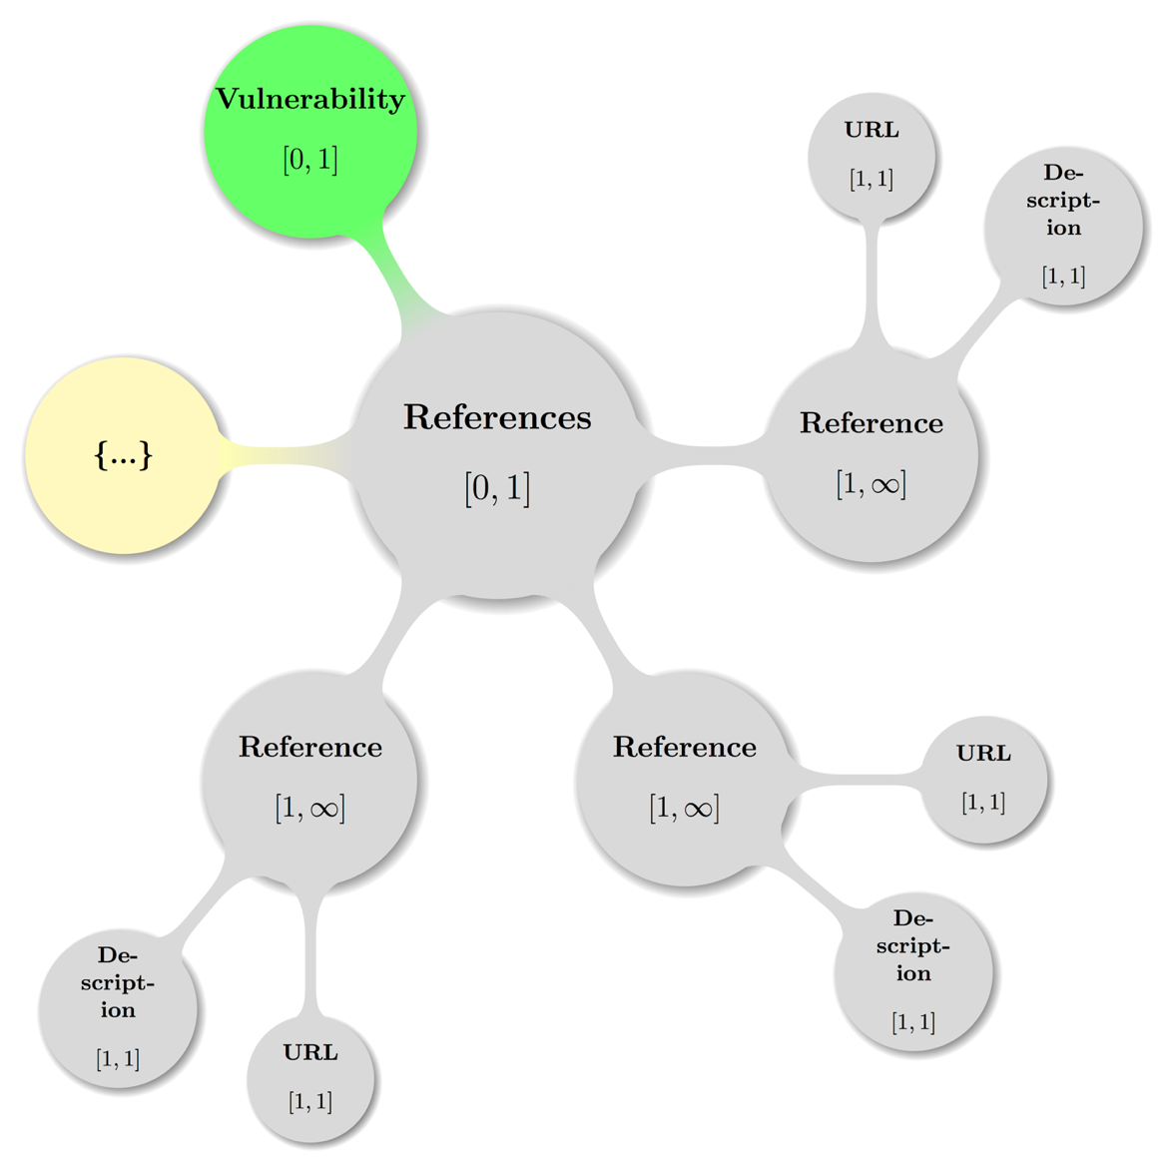

### Vulnerability – References – Reference

Element vuln:Reference

« The vuln:Reference element MUST be present with cardinality [1, ∞] inside vuln:References and every instance MUST have exactly one vuln:URL and onevuln:Description child element and in that order. » [CSAF-6.14.1-1]

Theelementvuln:Referencecontains a description of a related document specific to a vulnerability section of a CVRF document.

Attribute Type

« The Attribute Type if not present is taken to be the enumeration value External and if present MUST be one of the values documented in section 2.2.7 Reference Type Model. » [CSAF-6.14.1-2]

This attributes value denotes the type of the document reference relative to the CSAF CVRF document itself

Non-normative comment:

This may include a plaintext or HTML version of the advisory or other related documentation, such as white papers or mitigation documentation.

#### Vulnerability – References – Reference – URL

Element vuln:URL

« The vuln:URL element MUST be present exactly once in vuln:Reference and contains the fixed URL or location of the reference. » [CSAF-6.14.1.1-1]

#### Vulnerability – References – Reference – Description

Element vuln:Description

« The vuln:Description MUST be present exactly once in vuln:Reference and holds a descriptive title or name of the reference. » [CSAF-6.14.1.2-1]

Example 71:

<References>  
 <Reference Type="External">  
 <URL>http://foo.foo/bar/</URL>  
 <Description xml:lang="fr">C'est un test de référence</Description>  
 </Reference>  
</References>

## Vulnerability – Acknowledgements

Element vuln:Acknowledgements

« The vuln:Acknowledgements element MUST be present with cardinality [0, 1] inside vuln:Vulnerability element and MUST contain one or more vuln:Acknowledgement child elements, which in turn either contain(s) recognition of external parties or is empty. » [CSAF-6.15-1]

Non-normative comment:

This **Acknowledgments** container is different from the one at the document level because it is specifically related to the vulnerability in context**.**

Following is a map of a valid **Acknowledgements** configuration including the parent node (**Vulnerability**) — again with the node labeled {…} indicating further possible **Acknowledgement** subtrees:

Figure 15: A topologically valid **Vulnerability** **Acknowledgements** configuration.

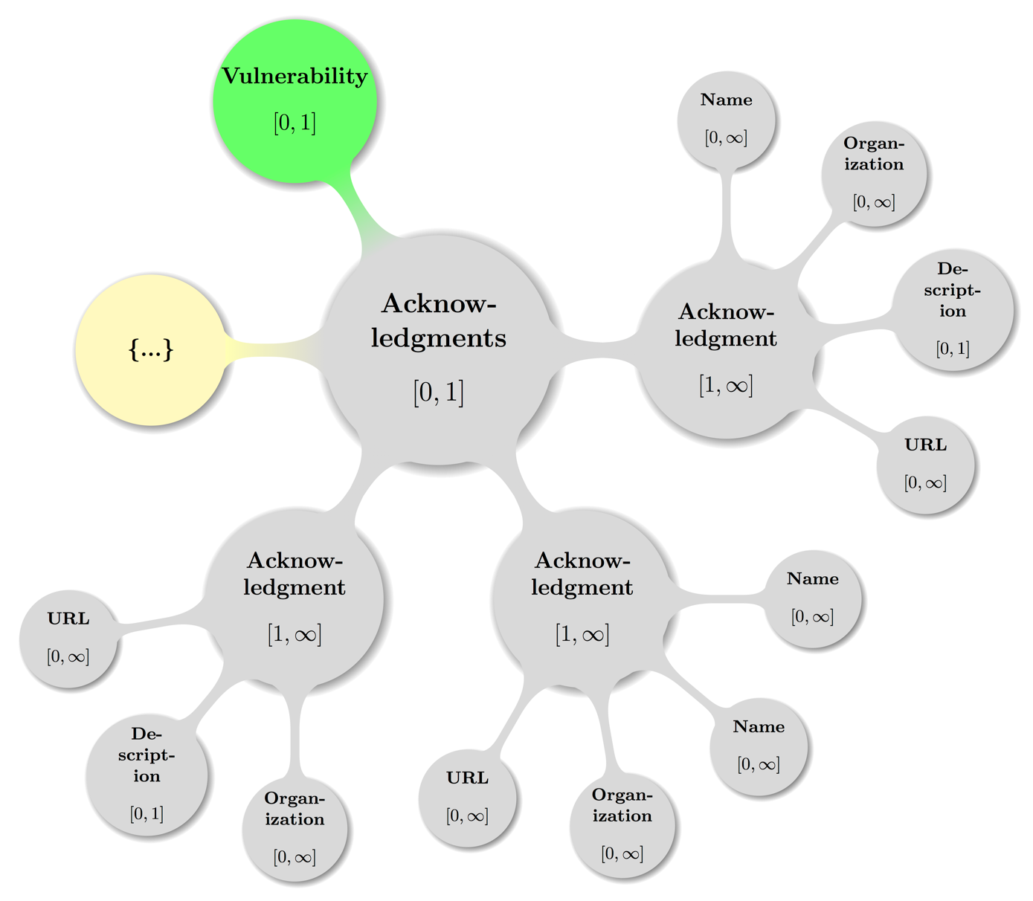

### Vulnerability – Acknowledgements – Acknowledgement

Element vuln:Acknowledgement

« The vuln:Acknowledgement element MUST be present with cardinality [1, ∞] inside vuln:Acknowledgments and MUST contain the following child elements vuln:Name [0, ∞] times, vuln:Organization [0, ∞] times, vuln:Description [0, 1] times, and vuln:URL [0, ∞] times and in that order. » [CSAF-6.15.1-1]

Theelementvuln:Acknowledgementcontains recognition of external parties who were instrumental in the discovery of, reporting of, and response to the vulnerability. This element indicates collaboration with the security community in a positive fashion and is an important part of a notice or advisory.

Non-normative comment:

Care should be taken to ensure that individuals would like to be acknowledged before they are included.

External parties who have worked with the document producer may be recognized for their work. This should be applied liberally; if someone reports an issue and then discloses it publicly, that party might still be credited.

If the original discoverer is not concerned with recognition, or the issue was discovered internally by the document producer, this field can be omitted.

#### Vulnerability – Acknowledgements – Acknowledgement – Name

Element vuln:Name

« The vuln:Name MUST be present with cardinality [1, ∞] in vuln:Acknowledgment and every instance given contains the name of the party being acknowledged. » [CSAF-6.15.1.1-1]

#### Vulnerability – Acknowledgements – Acknowledgement – Organization

Element vuln:Organization

« The vuln:Organization MUST be present with cardinality [0, ∞] inside vuln:Acknowledgment. » [CSAF-6.15.1.2-1]

Theelementvuln:Organizationcontains the organization of the party or, if the Name is omitted, the organization itself that is being acknowledged.

#### Vulnerability – Acknowledgements – Acknowledgement – Description

Element vuln:Description

« The vuln:Description element MUST be present with cardinality [0, 1] inside vuln:Acknowledgment and if given contains any contextual details the document producers wish to make known about the acknowledgment or acknowledged parties. » [CSAF-6.15.1.3-1]

If attributing to multiple organizations, each contributor SHOULD be grouped with that **Organization** within a single **Acknowledgment** container.

An **Organization**-specific acknowledgment MAY be added within each **Acknowledgment** container by the **Description** element.

If an overall general or aggregate acknowledgment is to be added, an **Acknowledgment** container that contains a single **Description** element MAY be used.

#### Vulnerability – Acknowledgements – Acknowledgement – URL

Element vuln:URL

« The vuln:URL MUST be present with cardinality [0, ∞] inside vuln:Acknowledgment and every instance contains the URL or location of the reference to be acknowledged.   
» [CSAF-6.15.1.4-1]

Example 72:Taking Isaac Newton, Jeanne D’Arc, and Alan Turing as names for fictitious people, and Acme, as well as Things as such organizations and some vendor Vendorix:

<Acknowledgments>  
 <Acknowledgment>  
 <Name>Isaac Newton</Name>  
 <Name>Jeanne D’Arc</Name>  
 <Organization>Acme</Organization>  
 <URL>http://acme.example.com/IsaacAndJeanne/</URL>  
 </Acknowledgment>  
 <Acknowledgment>  
 <Name>Alan Turing</Name>  
 <Organization>Things</Organization>  
 <Description>  
 Vendorix would like to thank Alan Turing from Things for reporting this issue.  
 </Description>  
 <URL>http://things.example.com/JustAlan/</URL>  
 </Acknowledgment>  
 <Acknowledgment>  
 <Description>  
 Vendorix would like to thank the following researchers for their contributions to   
 making this project more secure: Isaac Newton, Jeanne D’Arc, Alan Turing  
 </Description>  
 <URL>http://white-hats.example.com/AllOfThemAgain/</URL>  
 </Acknowledgment>  
</Acknowledgments>

# Conformance

## Conformance as a CSAF CVRF version 1.2 document

To ease communication and subsequent resolution of any specific partial conformance violation, the preceding chapters already provide minimal requirements, that a specific instance component must fulfill, to permit conformance of the complete CSAF CVRF version 1.2 document.

The following clause offers a simple seven step process, to either prove or disprove the conformance of a complete XML document (formulated in terms specific to that implementation language) to this version of CSAF CVRF:

« A document instance conforms to this specification as a CSAF CVRF document if it meets all of the following three conditions:

1. Is well-formed XML.
2. Consists of a single cvrf:cvrfdoc element instance as defined in   
   the namespace http://docs.oasis-open.org/csaf/ns/csaf-cvrf/v1.2/cvrf.
3. Is valid XML.

» [CSAF-7.1-1] **and** the date and version values fulfill the following four additional requirements:

1. Requirement CSAF-2.2.1-1: “Adherence to ISO 8601 [ISO8601]” (cf. 2.2.1 Date and Time Model)
2. Requirement CSAF-2.2.1-2: “Offset to UTC convention” (cf. 2.2.1 Date and Time Model)
3. Requirement CSAF-2.2.1-3: “T Separator of Date and Time” (cf. 2.2.1 Date and Time Model)
4. Requirement CSAF-2.2.9-1: “Version field increment convention” (cf. 2.2.9 Version Type Model)
5. Acknowledgments

The following individuals were members of the OASIS CSAF Technical Committee during the creation of this specification and their contributions are gratefully acknowledged:

Adam Montville, CIS Rupert Wimmer, Siemens AG

Allan Thomson, LookingGlass Sanjiv Kalkar, Individual

Anthony Berglas, Cryptsoft Pty Ltd. Sean Barnum, Mitre Corporation

Art Manion, Carnegie Mellon University Stefan Hagen, Individual

Aukjan van Belkum, EclecticIQ Ted Bedwell, Cisco Systems

Ben Sooter, Electric Power Research Institute Thomas Schreck, Siemens AG

Bernd Grobauer, Siemens AG Tim Hudson, Cryptsoft Pty Ltd.

Beth Pumo, Kaiser Permanente Tony Cox, Cryptsoft Pty Ltd.

Bret Jordan, Symantec Corp. Trey Darley, "Kingfisher Operations, sprl"

Bruce Rich, Cryptsoft Pty Ltd. Troy Fridley, Cisco Systems

Chet Ensign, OASIS Vincent Danen, Red Hat

Chok Poh, Oracle Zach Turk, Microsoft

Chris Rouland, Individual

David Waltermire, NIST

Denny Page, TIBCO Software Inc.

Doron Shiloach, IBM

Duncan Sparrell, sFractal Consulting LLC

Eric Johnson, TIBCO Software Inc.

Feng Cao, Oracle

Greg Reaume, TELUS

Greg Scott, Cryptsoft Pty Ltd.

Harold Booth, NIST

Jamison Day, LookingGlass

Jared Semrau, "FireEye, Inc."

Jason Masters, TELUS

Jerome Athias, Individual

Jessica Fitzgerald-McKay, National Security Agency

Jonathan Bitle, Kaiser Permanente

Justin Corlett, Cryptsoft Pty Ltd.

Karen Scarfone, Individual

Kazuo Noguchi, "Hitachi, Ltd."

Kent Landfield, McAfee

Lothar Braun, Siemens AG

Louis Ronnau, Cisco Systems

Mark Davidson, NC4

Mark-David McLaughlin, Cisco Systems

Masato Terada, "Hitachi, Ltd."

Masood Nasir, TELUS

Nicole Gong, Mitre Corporation

Omar Santos, Cisco Systems

Patrick Maroney, Wapack Labs LLC

Paul Patrick, "FireEye, Inc."

Peter Allor, IBM

Phillip Boles, "FireEye, Inc."

Ravi Balupari, Netskope

Rich Reybok, ServiceNow

Richard Struse, DHS Office of Cybersecurity and Communications (CS&C)

Ritwik Ghoshal, Oracle

Robert Coderre, VeriSign

Robin Cover, OASIS

1. Table of XML Elements and Attributes

Element cvrf:cvrfdoc 30

Element cvrf:DocumentTitle 30

Element cvrf:DocumentType 31

Element cvrf:DocumentPublisher 32

Attribute Type 32

Attribute VendorID 32

Element cvrf:ContactDetails 33

Element cvrf:IssuingAuthority 33

Element cvrf:DocumentTracking 34

Element cvrf:Identification 35

Element cvrf:ID 35

Element cvrf:Alias 35

Element cvrf:Status 35

Element cvrf:Version 36

Element cvrf:RevisionHistory 37

Element cvrf:Revision 37

Element cvrf:Number 37

Element cvrf:Date 37

Element cvrf:Description 38

Element cvrf:InitialReleaseDate 38

Element cvrf:CurrentReleaseDate 38

Element cvrf:Generator 39

Element cvrf:Engine 39

Element cvrf:Date 39

Element cvrf:DocumentNotes 41

Element cvrf:Note 42

Attribute Title 42

Attribute Audience 42

Attribute Type 42

Attribute Ordinal 42

Element cvrf:DocumentDistribution 43

Element cvrf:AggregateSeverity 43

Attribute Namespace 43

Element cvrf:DocumentReferences 44

Element cvrf:Reference 44

Attribute Type 44

Element cvrf:URL 44

Element cvrf:Description 45

Element cvrf:Acknowledgements 45

Element cvrf:Acknowledgement 46

Element cvrf:Name 47

Element cvrf:Organization 47

Element cvrf:Description 47

Element cvrf:URL 47

Element prod:ProductTree 48

Element prod:Branch 51

Attribute Name 51

Attribute Type 51

Element prod:FullProductName 53

Attribute ProductID 53

Attribute CPE 53

Element prod:Relationship 54

Attribute ProductReference 54

Attribute RelationType 54

Attribute RelatesToProductReference 54

Element prod:ProductGroups 55

Element prod:Group 57

Attribute GroupID 57

Element prod:Description 57

Element prod:ProductID 57

Element vuln:Vulnerability 60

Attribute Ordinal 60

Element vuln:Title 61

Element vuln:ID 62

Attribute SystemName 62

Element vuln:Notes 63

Element vuln:Note 63

Attribute Type 63

Attribute Ordinal 63

Attribute Title 63

Attribute Audience 63

Element vuln:DiscoveryDate 64

Element vuln:ReleaseDate 64

Element vuln:Involvements 65

Element vuln:Involvement 65

Attribute Party 65

Attribute Status 65

Element vuln:Description 65

Element vuln:CVE 66

Element vuln:CWE 66

Element vuln:ProductStatuses 67

Element vuln:Status 67

Attribute Type 67

Element vuln:ProductID 67

Element vuln:Threats 68

Element vuln:Threat 69

Attribute Type 70

Attribute Date 70

Element vuln:Description 70

Element vuln:ProductID 71

Element vuln:GroupID 71

Element vuln:CVSSScoreSets 72

Element vuln:ScoreSetV2 73

Element vuln:BaseScoreV2 73

Element vuln:TemporalScoreV2 73

Element vuln:EnvironmentalScoreV2 73

Element vuln:VectorV2 74

Element vuln:ProductID 75

Element vuln:ScoreSetV3 75

Element vuln:BaseScoreV3 75

Element vuln:TemporalScoreV3 76

Element vuln:EnvironmentalScoreV3 76

Element vuln:VectorV3 76

Element vuln:ProductID 77

Element vuln:Remediations 77

Element vuln:Remediation 79

Attribute Type 79

Element vuln:Description 79

Element vuln:Entitlement 79

Element vuln:URL 80

Element vuln:ProductID 80

Element vuln:GroupID 81

Element vuln:References 81

Element vuln:Reference 83

Attribute Type 83

Element vuln:URL 83

Element vuln:Description 83

Element vuln:Acknowledgements 84

Element vuln:Acknowledgement 85

Element vuln:Name 85

Element vuln:Organization 85

Element vuln:Description 85

Element vuln:URL 86

1. List of Figures

Figure 1: **CSAF CVRF Document Root** (cvrf:cvrfdoc) with children and grandchildren. 28

Figure 2: A topologically valid **CSAF CVRF Document Root** configuration. 29

Figure 3: A topologically valid **Document Publisher** configuration. 32

Figure 4: A topologically valid **Document Tracking** configuration. 34

Figure 5: A topologically valid **Document Notes** configuration. 41

Figure 6: A topologically valid **Document Acknowledgements** configuration. 45

Figure 7: A topologically valid **Product Tree** configuration. 50

Figure 8: A topologically valid **Branch** configuration 52

Figure 9: A topologically valid **Product Groups** configuration 56

Figure 10: A topologically valid **Vulnerability** configuration. 60

Figure 11: A topologically valid **Threats** configuration. 68

Figure 12 A topologically valid **CVSS Score Sets** configuration. 72

Figure 13: A topologically valid **Remediations** configuration. 77

Figure 14: A topologically valid **Vulnerability** **References** configuration. 81

Figure 15: A topologically valid **Vulnerability** **Acknowledgements** configuration. 84

1. Demo of a Document Schema Migration

To estimate the efforts required for a migration from a CVRF version 1.1 to a CSAF CVRF version 1.2 document, members of the committee have transformed a large body of existing CVRF v1.1 documents into the new format.

Some typical procedures and real world diffs (edited for brevity) are given in this appendix and as service to the reader.

* 1. Transform A — Producer transports CVSSv3 in v1.1 ScoreSet

As many vendors already started scoring the vulnerabilities under the CVSS v3 ruling, there was a need to transport these values in the CVRF v1.1 context. It is common practice of producers thus to announce “out of band” somewhere and prominently that the scores communicated are CVSS version 3 scores and then expect the consumers to interpret the content of CVRF version 1.2 document’s ScoreSet elements to be interpreted this way.

A minor complication could be, that a) CVSS version 3 vectors are expected to have the constant version prefix (which is sometimes missing in these documents) and that b) it is possible, that a version3 CVSS vector does not fit inside the CVRF 1.1 length limit for the Vector element.

Care has been taken during the design phase of CSAF CVRF version 1.2 to add both CVSS score set “universes” (v2 and v3) side by side and renaming the v2 variant from CVRF 1.1 into ScoreSetV2 with the children BaseScoreV2, EnvironmentalScoreV2, TemporalScoreV2 and VectorV2 — and correspondingly with the a V3 postfix the CVSSv3 elements.

* + 1. The actual CVSS Score Set V2/3 transform procedure

For every document (if and only if the values represent CVSSv3 scores!):

1. Map the /cvrfdoc/Vulnerability/CVSSScoreSets/ScoreSet   
   into /cvrfdoc/Vulnerability/CVSSScoreSets/ScoreSetV3
2. Map the /cvrfdoc/Vulnerability/CVSSScoreSets/ScoreSetV3/BaseScore   
   into /cvrfdoc/Vulnerability/CVSSScoreSets/ScoreSetV3/BaseScoreV3
3. Map any /cvrfdoc/Vulnerability/CVSSScoreSets/ScoreSetV3/EnvironmentalScore   
   into /cvrfdoc/Vulnerability/CVSSScoreSets/ScoreSetV3/EnvironmentalScoreV3
4. Map any /cvrfdoc/Vulnerability/CVSSScoreSets/ScoreSetV3/TemporalScore   
   into /cvrfdoc/Vulnerability/CVSSScoreSets/ScoreSetV3/TemporalScoreV3
5. Map any /cvrfdoc/Vulnerability/CVSSScoreSets/ScoreSetV3/Vector   
   into /cvrfdoc/Vulnerability/CVSSScoreSets/ScoreSetV3/VectorV3
6. Transform any non-prefixed VectorV3 content into the correct CVSSv3 form.
   1. Transform B — Empty v1.1 Acknowledgement/Organization

In CVRF v1.1 documents, it is allowed – albeit redundant – to have an empty Organization element inside of an Acknowledgement element (instead of simply leaving it out).

In CSAF CVRF v1.2 an empty Organization element inside of an Acknowledgement element is invalid.

* + 1. The actual removal transform procedure

For every document:

1. Remove any occurrence of empty /cvrfdoc/Acknowledgements/Acknowledgement/Organization.
2. Complete Examples

Some real-world examples of CVRF version 1.2 advisories in XML format are given in this appendix and in the hope, they are useful (major edits on text content to emphasize structure).

* 1. Sample Security Advisory A

Security advisory from the year 2017:

<?xml version="1.0" encoding="UTF-8"?>  
<cvrfdoc   
  xmlns:cpe="http://cpe.mitre.org/language/2.0"  
  xmlns:cvrf="http://docs.oasis-open.org/csaf/ns/csaf-cvrf/v1.2/cvrf"  
  xmlns:cvrf-common="http://docs.oasis-open.org/csaf/ns/csaf-cvrf/v1.2/common"  
  xmlns:cvssv2="http://scap.nist.gov/schema/cvss-v2/1.0"  
  xmlns:cvssv3="https://www.first.org/cvss/cvss-v3.0.xsd"  
  xmlns:dc="http://purl.org/dc/elements/1.2/"  
  xmlns:ns0="http://purl.org/dc/elements/1.1/"  
  xmlns:prod="http://docs.oasis-open.org/csaf/ns/csaf-cvrf/v1.2/prod"  
  xmlns:scap-core="http://scap.nist.gov/schema/scap-core/1.0"  
  xmlns:sch="http://purl.oclc.org/dsdl/schematron"  
  xmlns:vuln="http://docs.oasis-open.org/csaf/ns/csaf-cvrf/v1.2/vuln"  
  xmlns:xsi="http://www.w3.org/2001/XMLSchema-instance  
 xmlns="http://docs.oasis-open.org/csaf/ns/csaf-cvrf/v1.2/cvrf"  
  >  
  <!-- Document wide context information -->  
 <DocumentTitle>AppY Stream Control Transmission Protocol</DocumentTitle>  
 <DocumentType>Security Advisory</DocumentType>  
 <DocumentPublisher Type="Vendor">  
 <ContactDetails>Emergency Support: ...</ContactDetails>  
 <IssuingAuthority>... Team (PSIRT)....</IssuingAuthority>  
 </DocumentPublisher>  
 <DocumentTracking>  
 <Identification>  
 <ID>vendorix-sa-20170301-abc</ID>  
 </Identification>  
 <Status>Final</Status>  
 <Version>1.0</Version>  
 <RevisionHistory>  
 <Revision>  
 <Number>1.0</Number>  
 <Date>2017-03-01T14:58:48</Date>  
 <Description>Initial public release.</Description>  
 </Revision>  
 </RevisionHistory>  
 <InitialReleaseDate>2017-03-01T16:00:00</InitialReleaseDate>  
 <CurrentReleaseDate>2017-03-01T14:58:48</CurrentReleaseDate>  
 <Generator>  
 <Engine>TVCE</Engine>  
 </Generator>  
 </DocumentTracking>  
 <DocumentNotes>  
 <Note Title="Summary" Type="General" Ordinal="1">A vulnerability...</Note>  
 <Note Title="CVSS 3.0 Notice" Type="Other" Ordinal="2">... </Note>  
 </DocumentNotes>  
 <DocumentReferences>  
 <Reference Type="Self">  
 <URL>https://example.com/sec/vendorix-sa-20170301-abc</cvrf:URL>  
 <Description>Vendorix Foo AppY...</Description>  
 </Reference>  
 </DocumentReferences>

  <!-- Product tree section -->  
 <prod:ProductTree xmlns="http://docs.oasis-open.org/csaf/ns/csaf-cvrf/v1.2/prod">  
 <Branch Name="Vendorix" Type="Vendor">  
 <Branch Name="... Appliances" Type="Product Name">  
 <Branch Name="1.0" Type="Product Version">  
 <Branch Name=".0" Type="Service Pack">  
 <FullProductName ProductID="CVRFPID-223152">...  
 AppY 1.0.0</FullProductName>  
 </Branch>  
 <Branch Name="(2)" Type="Service Pack">  
 <FullProductName ProductID="CVRFPID-223153">...   
 AppY 1.0(2)</FullProductName>  
 </Branch>  
 </Branch>  
 <Branch Name="1.1" Type="Product Version">  
 <Branch Name=".0" Type="Service Pack">  
 <FullProductName ProductID="CVRFPID-223155">...   
 AppY 1.1.0</FullProductName>  
 </Branch>  
 <Branch Name="(1)" Type="Service Pack">  
 <FullProductName ProductID="CVRFPID-223156">...   
 AppY 1.1(1)</FullProductName>  
 </Branch>  
 </Branch>  
 </Branch>  
 </Branch>  
 </ProductTree>  
  <!-- Vulnerability section -->  
 <vuln:Vulnerability Ordinal="1"   
 xmlns="http://docs.oasis-open.org/csaf/ns/csaf-cvrf/v1.2/vuln">  
 <Title>... Transmission Protocol ...</Title>  
 <ID SystemName="Vendorix Bug ID">VDXvc83320</ID>  
 <Notes>  
 <Note Title="Summary" Type="Summary" Ordinal="1">A vuln ...</Note>  
 <Note Title="Vendorix Bug IDs" Type="Other" Ordinal="3">  
 VDXvc83320</Note>  
 </Notes>  
 <CVE>CVE-2017-3826</CVE>  
 <ProductStatuses>  
 <Status Type="Known Affected">  
 <ProductID>CVRFPID-223152</ProductID>  
 <ProductID>CVRFPID-223153</ProductID>  
 <ProductID>CVRFPID-223155</ProductID>  
 <ProductID>CVRFPID-223156</ProductID>  
 </Status>  
 </ProductStatuses>  
 <CVSSScoreSets>  
 <ScoreSetV3>  
 <BaseScoreV3>7.5</BaseScoreV3>  
 <VectorV3>CVSS:3.0/AV:N/AC:L/PR:N/UI:N/S:U/C:N/I:N/A:H</VectorV3>  
 </ScoreSetV3>  
 </CVSSScoreSets>  
 <Remediations>  
 <Remediation Type="Workaround">  
 <Description>There are no workarounds that ...</vuln:Description>  
 </Remediation>  
 </Remediations>  
 <References>  
 <Reference Type="Self">  
 <URL>https://example.com/sec/vendorix-sa-20170301-abc</URL>  
 <Description>... AppY Stream ...</Description>  
 </Reference>  
 </References>  
 </Vulnerability>  
  <!-- No more elements to follow -->  
</cvrfdoc>

* 1. Sample Security Advisory B

Another security advisory from the year 2017 as issued by Red Hat and migrated to CSAF CVRF 1.2 from the source CVRF 1.1 by simply updating the namespaces and prefixing all elements with the corresponding namespace of either cvrf, prod, or vuln. Additionally, 4 comments were added, to visually separate the three semantic top level elements **Document** Context, **Product Tree**, and **Vulnerability**):

Example 73:

<?xml version="1.0" encoding="utf-8"?>  
<cvrfdoc xmlns:cpe="http://cpe.mitre.org/language/2.0"  
 xmlns:cvrf="http://docs.oasis-open.org/csaf/ns/csaf-cvrf/v1.2/cvrf"  
 xmlns:cvrf-common="http://docs.oasis-open.org/csaf/ns/csaf-cvrf/v1.2/common"  
 xmlns:cvssv2="http://scap.nist.gov/schema/cvss-v2/1.0"  
 xmlns:cvssv3="https://www.first.org/cvss/cvss-v3.0.xsd"  
 xmlns:dc="http://purl.org/dc/elements/1.1/"  
 xmlns:prod="http://docs.oasis-open.org/csaf/ns/csaf-cvrf/v1.2/prod"  
 xmlns:scap-core="http://scap.nist.gov/schema/scap-core/1.0"  
 xmlns:sch="http://purl.oclc.org/dsdl/schematron"  
 xmlns:vuln="http://docs.oasis-open.org/csaf/ns/csaf-cvrf/v1.2/vuln"  
 xmlns:xsi=<http://www.w3.org/2001/XMLSchema-instance>  
 xmlns="http://docs.oasis-open.org/csaf/ns/csaf-cvrf/v1.2/cvrf"  
 >  
 <!-- Document wide context information -->  
 <DocumentTitle xml:lang="en">Red Hat Security Advisory: python-oslo-middleware security update</DocumentTitle>  
 <DocumentType>Security Advisory</DocumentType>  
 <DocumentPublisher Type="Vendor">  
 <ContactDetails>secalert@redhat.com</ContactDetails>  
 <IssuingAuthority>Red Hat Product Security</IssuingAuthority>  
 </DocumentPublisher>  
 <DocumentTracking>  
 <Identification>  
 <ID>RHSA-2017:0435</ID>  
 </Identification>  
 <Status>Final</Status>  
 <Version>1</Version>  
 <RevisionHistory>  
 <Revision>  
 <Number>1</Number>  
 <Date>2017-03-02T21:13:00Z</Date>  
 <Description>Current version</Description>  
 </Revision>  
 </RevisionHistory>  
 <InitialReleaseDate>2017-03-02T21:13:00Z</InitialReleaseDate>  
 <CurrentReleaseDate>2017-03-02T21:13:00Z</CurrentReleaseDate>  
 <Generator>  
 <Engine>Red Hat rhsa-to-cvrf 2.0</Engine>  
 <Date>2017-03-04T05:06:05Z</Date>  
 </Generator>  
 </DocumentTracking>  
 <DocumentNotes>  
 <Note Title="Topic" Type="Summary" Ordinal="1" xml:lang="en">  
An update for python-oslo-middleware is now available for Red Hat OpenStack Platform 9.0 (Mitaka).  
  
Red Hat Product Security has rated this update as having a security impact of Moderate. A Common Vulnerability Scoring System (CVSS) base score, which gives a detailed severity rating, is available for each vulnerability from the CVE link(s) in the References section. </Note>  
 <Note Title="Details" Type="General" Ordinal="2" xml:lang="en">  
The OpenStack Oslo Middleware library provides components that can be injected into WSGI pipelines to intercept request and response flows. The base class can be enhanced with functionality like adding or updating HTTP headers, or to offer support for limiting size or connections.  
  
Security Fix(es):  
  
* An information-disclosure flaw was found in oslo.middleware. Software using the CatchError class could include sensitive values in a traceback's error message. System users could exploit this flaw to obtain sensitive information from OpenStack component error logs (for example, keystone tokens). (CVE-2017-2592)

Red Hat would like to thank the OpenStack project for reporting this issue. Upstream acknowledges Divya K Konoor (IBM) as the original reporter. </Note>  
 <Note Title="Terms of Use" Ordinal="3" Type="Legal Disclaimer" xml:lang="en">Please see https://www.redhat.com/footer/terms-of-use.html</Note>  
 </DocumentNotes>  
 <DocumentDistribution xml:lang="en">Copyright © 2017 Red Hat, Inc. All rights reserved.</DocumentDistribution>  
 <AggregateSeverity Namespace="https://access.redhat.com/security/updates/classification/">Moderate</AggregateSeverity>  
 <DocumentReferences>  
 <Reference Type="Self">  
 <URL>https://rhn.redhat.com/errata/RHSA-2017-0435.html</URL>  
 <Description>https://rhn.redhat.com/errata/RHSA-2017-0435.html</Description>  
 </Reference>  
 <Reference>  
 <URL>https://access.redhat.com/security/updates/classification/#moderate</URL>  
 <Description>https://access.redhat.com/security/updates/classification/#moderate</Description>  
 </Reference>  
 </DocumentReferences>  
 <!-- Product tree section -->  
 <prod:ProductTree xmlns="http://docs.oasis-open.org/csaf/ns/csaf-cvrf/v1.2/prod">  
 <Branch Type="Product Family" Name="Red Hat Enterprise Linux OpenStack Platform">  
 <Branch Type="Product Name" Name="Red Hat OpenStack Platform 9.0">  
 <FullProductName ProductID="7Server-RH7-RHOS-9.0">Red Hat OpenStack Platform 9.0</FullProductName>  
 </Branch>  
 </Branch>  
 <Branch Type="Product Version" Name="python-oslo-middleware-3.7.0-2.el7ost">  
 <FullProductName ProductID="python-oslo-middleware-3.7.0-2.el7ost">python-oslo-middleware-3.7.0-2.el7ost.src.rpm</prod:FullProductName>  
 </Branch>  
 <Relationship ProductReference="python-oslo-middleware-3.7.0-2.el7ost"  
 RelationType="Default Component Of" RelatesToProductReference="7Server-RH7-RHOS-9.0">  
 <FullProductName ProductID="7Server-RH7-RHOS-9.0:python-oslo-middleware-3.7.0-2.el7ost">python-oslo-middleware-3.7.0-2.el7ost as a component of Red Hat OpenStack Platform 9.0</FullProductName>  
 </Relationship>  
 </ProductTree>  
 <!-- Vulnerability section -->  
 <vuln:Vulnerability Ordinal="1"   
 xmlns="http://docs.oasis-open.org/csaf/ns/csaf-cvrf/v1.2/vuln">  
 <Notes>  
 <Note Title="Vulnerability Description" Type="General" Ordinal="1" xml:lang="en">An information-disclosure flaw was found in oslo.middleware. Software using the CatchError class could include sensitive values in a traceback's error message. System users could exploit this flaw to obtain sensitive information from OpenStack component error logs (for example, keystone tokens). </Note>  
 </Notes>  
 <DiscoveryDate>2017-01-18T00:00:00Z</DiscoveryDate>  
 <ReleaseDate>2017-01-26T00:00:00Z</ReleaseDate>  
 <Involvements>  
 <Involvement Party="Vendor" Status="Completed"/>  
 </Involvements>  
 <CVE>CVE-2017-2592</CVE>  
 <ProductStatuses>  
 <Status Type="Fixed">  
 <ProductID>7Server-RH7-RHOS-9.0:python-oslo-middleware-3.7.0-2.el7ost</ProductID>  
 </Status>  
 </ProductStatuses>  
 <Threats>  
 <Threat Type="Impact">  
 <Description>Moderate</Description>  
 </Threat>  
 </Threats>

<Remediations>  
 <Remediation Type="Vendor Fix">  
 <Description xml:lang="en">  
For details on how to apply this update, which includes the changes described in this advisory, refer to:  
  
https://access.redhat.com/articles/11258 </Description>  
 <URL>https://rhn.redhat.com/errata/RHSA-2017-0435.html</URL>  
 </Remediation>  
 </Remediations>  
 <References>  
 <Reference>  
 <URL>https://access.redhat.com/security/cve/CVE-2017-2592</URL>  
 <Description>CVE-2017-2592</vuln:Description>  
 </Reference>  
 <Reference>  
 <URL>https://bugzilla.redhat.com/show_bug.cgi?id=1414698</URL>  
 <Description>bz#1414698: CVE-2017-2592 python-oslo-middleware: CatchErrors leaks sensitive values into error logs</Description>  
 </Reference>  
 </References>  
 <Acknowledgments>  
 <Acknowledgment>  
 <Description>Red Hat would like to thank the OpenStack project for reporting this issue. Upstream acknowledges Divya K Konoor (IBM) as the original reporter.</Description>  
 </Acknowledgment>  
 </Acknowledgments>  
 </Vulnerability>  
 <!-- No more elements to follow -->  
</cvrfdoc>

* 1. Sample Security Advisory C

Yet another security advisory from the year 2017 as issued by Cisco and migrated to CSAF CVRF 1.2 from the source CVRF 1.1 by simply updating the namespaces and prefixing all elements with the corresponding namespace of either cvrf or vuln. Additionally, 3 comments are added, to visually separate the three semantic top level elements **Document** Context, and **Vulnerability** (Note: This advisory has no Product Tree instance!):

Example 74:

<?xml version="1.0" encoding="UTF-8"?>  
<cvrfdoc xmlns:xsd="http://www.w3.org/2001/XMLSchema"  
 xmlns:xsi="http://www.w3.org/2001/XMLSchema-instance"  
 xmlns:cvrf="http://docs.oasis-open.org/csaf/ns/csaf-cvrf/v1.2/cvrf"  
 xmlns:cvrf-common="http://docs.oasis-open.org/csaf/ns/csaf-cvrf/v1.2/common"  
 xmlns:prod="http://docs.oasis-open.org/csaf/ns/csaf-cvrf/v1.2/prod"  
 xmlns:vuln="http://docs.oasis-open.org/csaf/ns/csaf-cvrf/v1.2/vuln"  
 xmlns=="http://docs.oasis-open.org/csaf/ns/csaf-cvrf/v1.2/cvrf"  
 >  
 <!-- Document wide context information -->  
 <DocumentTitle>Apache Struts2 Jakarta Multipart Parser File Upload Code Execution Vulnerability Affecting Cisco Products<DocumentTitle>  
 <DocumentType>Cisco Security Advisory<DocumentType>  
 <DocumentPublisher Type="Vendor">  
 <ContactDetails>Emergency Support:   
+1 877 228 7302 (toll-free within North America)  
+1 408 525 6532 (International direct-dial)  
Non-emergency Support:  
Email: [psirt@cisco.com](mailto:psirt@cisco.com)  
Support requests that are received via e-mail are typically acknowledged within 48 hours.</ContactDetails>  
 <IssuingAuthority>Cisco product security incident response is the responsibility of the Cisco Product Security Incident Response Team (PSIRT). The Cisco PSIRT is a dedicated, global team that manages the receipt, investigation, and public reporting of security vulnerability information that is related to Cisco products and networks. The on-call Cisco PSIRT works 24x7 with Cisco customers, independent security researchers, consultants, industry organizations, and other vendors to identify possible security issues with Cisco products and networks.  
More information can be found in Cisco Security Vulnerability Policy available at http://www.cisco.com/web/about/security/psirt/security_vulnerability_policy.html</cvrf:IssuingAuthority>  
 </DocumentPublisher>  
 <DocumentTracking>  
 <Identification>  
 <ID>cisco-sa-20170310-struts2</ID>  
 </Identification>  
 <Status>Interim</Status>  
 <Version>1.4</Version>  
 <RevisionHistory>  
 <Revision>  
 <Number>1.0</Number>  
 <Date>2017-03-10T20:43:55</Date>  
 <Description>Initial public release.</Description>  
 </Revision>  
 <Revision>  
 <Number>1.1</Number>  
 <Date>2017-03-11T23:37:26</Date>  
 <Description>Updated product lists.</Description>  
 </Revision>  
 <Revision>  
 <Number>1.2</Number>  
 <Date>2017-03-13T00:06:20</Date>  
 <Description>Updated product lists.</Description>  
 </Revision>  
 <Revision>  
 <Number>1.3</Number>  
 <Date>2017-03-13T22:24:49</Date>  
 <Description>Updated product lists.</Description>  
 </Revision>

<Revision>  
 <Number>1.4</Number>  
 <Date>2017-03-14T21:03:12</Date>  
 <Description>Updated product lists.</Description>  
 </Revision>  
 </RevisionHistory>  
 <InitialReleaseDate>2017-03-10T19:30:00</InitialReleaseDate>  
 <CurrentReleaseDate>2017-03-14T21:03:12</CurrentReleaseDate>  
 <Generator>  
 <Engine>TVCE</Engine>  
 </Generator>  
 </DocumentTracking>  
 <DocumentNotes>  
 <Note Title="Summary" Type="General" Ordinal="1">On March 6, 2017, Apache disclosed a vulnerability in the Jakarta multipart parser used in Apache Struts2 that could allow an attacker to execute commands remotely on the targeted system using a crafted Content-Type header value.  
  
This vulnerability has been assigned CVE-ID CVE-2017-5638.  
  
This advisory is available at the following link:  
https://tools.cisco.com/security/center/content/CiscoSecurityAdvisory/cisco-sa-20170310-struts2 ["https://tools.cisco.com/security/center/content/CiscoSecurityAdvisory/cisco-sa-20170310-struts2"]</Note>  
 <Note Title="CVSS 3.0 Notice" Type="Other" Ordinal="2">Although CVRF version 1.1 does not support CVSS version 3, the CVSS score in this CVRF file is a CVSSv3 base and temporal score, as Cisco is now scoring vulnerabilities in CVSSv3.</Note>  
 </DocumentNotes>  
 <DocumentReferences>  
 <Reference Type="Self">  
 <URL>https://tools.cisco.com/security/center/content/CiscoSecurityAdvisory/cisco-sa-20170310-struts2</URL>  
 <Description>Apache Struts2 Jakarta Multipart Parser File Upload Code Execution Vulnerability Affecting Cisco Products</Description>  
 </Reference>  
 </DocumentReferences>  
 <!-- Vulnerability section -->  
 <Vulnerability Ordinal="1"   
 xmlns="http://docs.oasis-open.org/csaf/ns/csaf-cvrf/v1.2/vuln">  
 <Title>Apache Struts Jakarta Multipart Parser File Upload Code Execution Vulnerability</Title>  
 <Notes>  
 <Note Title="Summary" Type="Summary" Ordinal="1">A vulnerability in the Jakarta multipart parser of Apache Struts could allow an unauthenticated, remote attacker to execute arbitrary code on an affected system.  
  
  
  
The vulnerability is due to improper handling of the Content-Type header value when performing a file upload based on the Jakarta multipart parser of the affected software. An attacker could exploit this vulnerability by persuading a targeted user to upload a malicious file. Once the Jakarta multipart parser of the affected application uploads the file, the attacker could have the ability to execute arbitrary code.</Note>  
 </Notes>  
 <CVE>CVE-2017-5638</CVE>  
 <Remediations>  
 <Remediation Type="Workaround">  
 <Description>Any workarounds, when available, are documented in the Cisco bugs, which are accessible through the Cisco Bug Search Tool ["https://bst.cloudapps.cisco.com/bugsearch/bug/BUGID"].</Description>  
 </Remediation>  
 </Remediations>

<References>  
 <Reference Type="Self">  
 <vuln:URL>https://tools.cisco.com/security/center/content/CiscoSecurityAdvisory/cisco-sa-20170310-struts2</vuln:URL>  
 <Description>Apache Struts2 Jakarta Multipart Parser File Upload Code Execution Vulnerability Affecting Cisco Products</Description>  
 </Reference>  
 </References>  
 </Vulnerability>  
 <!-- No more elements to follow -->  
</cvrfdoc>

* 1. Sample Security Advisory D

Minimal valid CSAF CVRF version 1.2 document (neither **Product Tree** nor **Vulnerability** noted, but nevertheless well-formed and valid):

<?xml version="1.0" encoding="UTF-8"?>  
<cvrfdoc xmlns:cvrf="http://docs.oasis-open.org/csaf/ns/csaf-cvrf/v1.2/cvrf">  
  <DocumentTitle>DocumentTitle0</DocumentTitle>  
  <DocumentType>DocumentType0</DocumentType>  
  <DocumentPublisher Type="Vendor">  
  </DocumentPublisher>  
  <DocumentTracking>  
    <Identification>  
      <ID>ID0</ID>  
    </Identification>  
    <Status>Draft</Status>  
    <Version>1</Version>  
    <RevisionHistory>  
      <Revision>  
        <Number>1.0</Number>  
        <Date>2038-05-04T18:13:51.0</Date>  
        <Description>Something wrong with some product</Description>  
      </Revision>  
      <Revision>  
        <Number>1.1</Number>  
        <Date>2038-05-04T18:13:52.0</Date>  
        <Description>We excluded some products, but still in the fog</Description>  
      </Revision>  
    </RevisionHistory>  
    <InitialReleaseDate>2038-05-04T18:13:51.0</InitialReleaseDate>  
    <CurrentReleaseDate>2038-05-04T18:13:52.0</CurrentReleaseDate>  
  </DocumentTracking>  
</cvrfdoc>

* 1. Sample Security Advisory E

A “Minimal Viable Product” like fictitious sample valid CSAF CVRF version 1.2 document is given in the following example.

The vendor is assumed to be named ACME Inc., and DNS-wise only hosted on a subdomain of example.com i.e. <https://acme.example.com/> and per time zone offset 6 hours “behind” UTC.

A product foo is declared to be available on platforms bar and baz alike and in version 1.9 and 2.1.

The CVE is made up and uses the new format (as it exceeds the historic 9999 limit of early years, in the hope, that in 2017 there will never be a real CVE-2017-99999.

No CWE is given. A CVSS Score is given in CVSSv3 and this is repeated in the human readable portions (maybe because the vendor uses this as accessibility feature).

Some possible combinations of vulnerability and mitigation states are realized i.e.:

* Product foo is always known to be affected on platform bar.
* Product foo is always known not to be affected on platform baz.

A remediation page is offered at <https://acme.example.com/sa/acme-2017-42-1-1.html> an everyone is entitled, but this fact is written in Italian: “Tutte le persone su questo pianeta” (English: “All people on this planet”).

The source of the CSAF CVRF version 1.2 security advisory (XML) is offered at <https://acme.example.com/sa/acme-2017-42-1-1.xml> and an also fictitious variant (for now vendor private) in JSON at <https://acme.example.com/sa/acme-2017-42-1-1.json>.

Note also the two revisions (in total), maybe the initial release of the security advisory did not take into account, that the product when installed on the baz platform is unaffected, or there was given the wrong exploit byte value (not the current 0x42 without access to the initial revision, and no explanation in the release notes, the world will never know (only that something has been corrected).

The acknowledgment was maybe chosen by the company lawyers to not list the real name of the external contributor where the below sample content states “Some One (not to be named explicitly)” – and no dummy Organization is added.

The complexity of the Affected/Non-Affected mixture may have forced the publisher to not take the internal usual product IDs but instead append the interesting dimension in a simple serialization as:  
 “-on-bar” and “-on-baz” respectively. In a real life advisory, these simple platform names might have become fully fledged product entries themselves with relationship link elements between them.

Albeit speculating here, there might have been some time pressure on the publishing vendor Acme Inc. of the products foo version 1.9 and 2.1, as sending the byte 0x42 to some port seems to be cheap on the attacker side … at least for the effect of it, when the products are hosted on platform baz.

Example 75:

<?xml version='1.0' encoding='UTF-8'?>  
<cvrfdoc xmlns:cpe="http://cpe.mitre.org/language/2.0"  
 xmlns:cvrf="http://docs.oasis-open.org/csaf/ns/csaf-cvrf/v1.2/cvrf"  
 xmlns:cvrf-common="http://docs.oasis-open.org/csaf/ns/csaf-cvrf/v1.2/common"  
 xmlns:cvssv2="http://scap.nist.gov/schema/cvss-v2/1.0"  
 xmlns:cvssv3="https://www.first.org/cvss/cvss-v3.0.xsd"  
 xmlns:dc="http://purl.org/dc/elements/1.2/"  
 xmlns:ns0="http://purl.org/dc/elements/1.1/"  
 xmlns:prod="http://docs.oasis-open.org/csaf/ns/csaf-cvrf/v1.2/prod"  
 xmlns:scap-core="http://scap.nist.gov/schema/scap-core/1.0"  
 xmlns:sch="http://purl.oclc.org/dsdl/schematron"  
 xmlns:vuln="http://docs.oasis-open.org/csaf/ns/csaf-cvrf/v1.2/vuln"  
 xmlns:xsi="http://www.w3.org/2001/XMLSchema-instance"  
 xmlns="http://docs.oasis-open.org/csaf/ns/csaf-cvrf/v1.2/cvrf">

<!-- Document wide context information -->  
 <DocumentTitle xml:lang="en">Acme Security Advisory for foo on bar - March 2017 - CSAF CVRF</DocumentTitle>  
 <DocumentType xml:lang="en">Acme Security Advisory</DocumentType>  
 <DocumentPublisher Type="Vendor"/>  
 <DocumentTracking>  
 <Identification>  
 <ID>acme-2017-42</ID>  
 </Identification>  
 <Status>Final</Status>  
 <Version>1.0</Version>  
 <RevisionHistory>  
 <Revision>  
 <Number>1.0</Number>  
 <Date>2017-03-17T12:34:56-06:00</Date>  
 <Description>Initial Distribution</Description>  
 </Revision>  
 <Revision>  
 <Number>1.1</Number>  
 <Date>2017-03-18T01:23:45-06:00</Date>  
 <Description>Corrected Distribution</Description>  
 </Revision>  
 </RevisionHistory>  
 <InitialReleaseDate>2017-01-17T12:34:56-06:00</InitialReleaseDate>  
 <CurrentReleaseDate>2017-01-18T01:23:34-06:00</CurrentReleaseDate>  
 </DocumentTracking>  
 <DocumentNotes>  
 <Note Audience="All" Ordinal="1" Title="Summary" Type="Summary" xml:lang="en">  
 This document contains descriptions of Acme product security vulnerabilities with details on impacted and non-impacted platform product combinations.  
 Additional information regarding these vulnerabilities including fix distribution information can be found at the Acme sites referenced in this document.</Note>  
 </DocumentNotes>  
 <DocumentDistribution>This document is published at: https://acme.example.com/sa/acme-2017-42-1-1.xml</DocumentDistribution>  
 <DocumentReferences>  
 <Reference Type="External">  
 <URL>https://acme.example.com/sa/acme-2017-42-1-1.json</URL>  
 <Description>URL to JSON version of Advisory</Description>  
 </Reference>  
 </DocumentReferences>  
 <Acknowledgments>  
 <Acknowledgment>  
 <Name>Some One (not to be named explicitly)</Name>  
 </Acknowledgment>  
 <Acknowledgment>  
 <Name>Jane Employee</Name>  
 <Organization>Acme Inc.</Organization>  
 </Acknowledgment>  
 </Acknowledgments>

<!-- Product tree section -->  
 <ProductTree xmlns="http://docs.oasis-open.org/csaf/ns/csaf-cvrf/v1.2/prod">  
 <Branch Name="Acme" Type="Vendor">  
 <Branch Name="Acme Things" Type="Product Family">  
 <Branch Name="Things On bar" Type="Product Name">  
 <Branch Name="1.9" Type="Product Version">  
 <FullProductName ProductID="AC-FOO-1.9-on-bar">Foo 1.9 on bar</FullProductName>  
 </Branch>  
 <Branch Name="2.1" Type="Product Version">  
 <FullProductName ProductID="AC-FOO-2.1-on-bar">Foo 2.1 on bar</FullProductName>  
 </Branch>  
 </Branch>  
 <Branch Name="Things On baz" Type="Product Name">  
 <Branch Name="1.9" Type="Product Version">  
 <FullProductName ProductID="AC-FOO-1.9-on-baz">Foo 1.9 on baz</FullProductName>  
 </Branch>  
 <Branch Name="2.1" Type="Product Version">  
 <FullProductName ProductID="AC-FOO-2.1-on-baz">Foo 2.1 on baz</FullProductName>  
 </Branch>  
 </Branch>  
 </Branch>  
 </Branch>  
 </ProductTree>

<!-- Vulnerability sections -->  
 <Vulnerability Ordinal="1" xmlns="http://docs.oasis-open.org/csaf/ns/csaf-cvrf/v1.2/vuln">  
 <Title>Vulnerability in the TCP component of Acme foo (CVE-2017-99999)</Title>  
 <Notes>  
 <Note Audience="All" Ordinal="1" Title="Details" Type="Details">  
 Vulnerability in the TCP component of Acme foo.   
 Supported versions that are affected are 1.9, and 2.0 when installed on bar but not affected when on baz.   
 Easily exploitable vulnerability allows unauthenticated attacker with network access via a single 0x42 value payload byte to compromise Acme foo.  
 Successful attacks of this vulnerability can result in unauthorized read access to a subset of Acme foo accessible data and unauthorized ability to cause a complete denial of service (DOS) of Acme foo.   
 CVSS 3.0 Base Score 9.8 (Confidentiality and Availability impacts).   
 CVSS Vector: CVSS:3.0/AV:N/AC:L/PR:N/UI:N/S:U/C:H/I:H/A:H).</Note>  
 </Notes>  
 <Involvements>  
 <Involvement Party="Vendor" Status="Completed">  
 <Description>Fix has been released</Description>  
 </Involvement>  
 </Involvements>  
 <CVE>CVE-2017-99999</CVE>  
 <ProductStatuses>  
 <Status Type="Known Affected">  
 <ProductID>AC-FOO-1.9-on-bar</ProductID>  
 <ProductID>AC-FOO-2.1-on-bar</ProductID>  
 </Status>  
 <Status Type="Known Not Affected">  
 <ProductID>AC-FOO-1.9-on-baz</ProductID>  
 <ProductID>AC-FOO-2.1-on-baz</ProductID>  
 </Status>  
 </ProductStatuses>  
 <CVSSScoreSets>  
 <ScoreSetV3>  
 <BaseScoreV3>9.8</BaseScoreV3>  
 <VectorV3>CVSS:3.0/AV:N/AC:L/PR:N/UI:N/S:U/C:H/I:H/A:H</VectorV3>  
 </ScoreSetV3>  
 </CVSSScoreSets>  
 <Remediations>  
 <Remediation Type="Vendor Fix">  
 <Description>acme-2017-42</Description>  
 <Entitlement xml:lang="it">Tutte le persone su questo pianeta</Entitlement>  
 <URL>https://acme.example.com/sa/acme-2017-42-1-1.html</URL>  
 <ProductID>AC-FOO-1.9-on-bar</ProductID>  
 <ProductID>AC-FOO-2.1-on-bar</ProductID>  
 </Remediation>  
 </Remediations>  
 </Vulnerability>  
 <!-- No more elements to follow -->  
</cvrfdoc>

1. Index

**Advisory**, 8, 9

**CPE**, 9

CSAF, 9

CVRF, 9

**CVSS**, 8, 9, 10

ISO8601, 10

**Product**, 8, 9, 44

**UTC**, 10, 35

**Vulnerability**, 8, 9, 55, 73

Remediations, 73

1. Revision History

|  |  |  |  |
| --- | --- | --- | --- |
| **Revision** | **Date** | **Editor** | **Changes Made** |
| Working Draft 01 | 2017-03-24 | Stefan Hagen | Combined and migrated CVRF version 1.1 contribution to OASIS CSAF CVRF version 1.2 and added feedback from TC members. |
| Committee Specification Draft 01 | 2017-05-24 | Stefan Hagen | Package for public review. |

1. Deprecated CVSS v2 provided for compatibility; some vendors switched to CVSS v3 in 2016 already.
2. Here we deviate from ISO8601 where in section 4.3.2 “Complete representations” at the start of the first paragraph after the initial list that: “The zone designator is empty if use is made of local time ...” is stated.